UNITED STATES
SECURITIES AND EXCHANGE COMMISSION
Washington, D.C. 20549

FORM 10-Q

Quarterly report pursuant to Section 13 or 15(d) of the Securities Exchange Act of 1934

For the quarterly period ended August 2, 2026

Commission file number 000-25349

HOOKER FURNISHINGS CORPORATION
(Exact name of registrant as specified in its charter)

Virginia |  | 54-0251350
(State or other jurisdiction of  incorporation or organization) |  | (IRS employer  identification no.)

440 East Commonwealth Boulevard, Martinsville, VA 24112
(Address of principal executive offices, zip code)

(276) 632-2133
(Registrant’s telephone number, including area code)

Indicate by check mark whether the registrant (1) has filed all reports required to be filed by Section 13 or 15(d) of the Securities Exchange Act of 1934 during the preceding 12 months (or for such shorter period that the registrant was required to file such reports), and (2) has been subject to such filing requirements for the past 90 days. Yes ☒ No ☐

Indicate by check mark whether the registrant has submitted electronically, every Interactive Data File required to be submitted pursuant to Rule 405 of Regulation S-T (Section 232.405 of this chapter) during the preceding 12 months (or for such shorter period that the registrant was required to submit such files). Yes ☒ No ☐

Indicate by check mark whether the registrant is a large accelerated filer, an accelerated filer, a non-accelerated filer, a smaller reporting company, or an emerging growth company. See the definitions of “large accelerated filer”, “accelerated filer”, “smaller reporting company”, and “emerging growth company” in Rule 12b-2 of the Exchange Act.

Large accelerated Filer ☐ | Accelerated filer ☒
Non-accelerated Filer ☐ | Smaller reporting company ☐
Emerging growth company ☐

If an emerging growth company, indicate by check mark if the registrant has elected not to use the extended transition period for complying with any new or revised financial accounting standards provided pursuant to Section 13(a) of the Exchange Act. ☐

Indicate by check mark whether the registrant is a shell company (as defined in Rule 12b-2 of the Exchange Act). Yes ☐ No ☒

Securities registered pursuant to Section 12(b) of the Act:

Title of each class |  | Trading Symbol(s) |  | Name of each exchange on which registered
Common Stock, no par value |  | HOFT |  | NASDAQ Global Select Market

As of September 4, 2026, there were 10,692,197 shares of the registrant’s common stock outstanding.

Table of Contents

PART I. FINANCIAL INFORMATION |  | 1
Item 1. | Financial Statements | 1
Item 2. | Management’s Discussion and Analysis of Financial Condition and Results of Operations | 20
Item 3. | Quantitative and Qualitative Disclosures about Market Risk | 32
Item 4. | Controls and Procedures | 32
PART II. OTHER INFORMATION |  | 33
Item 5. | Other Information | 33
Item 6. | Exhibits | 33
Signature |  | 34

i
Table of Contents

PART I. FINANCIAL INFORMATION

Item 1. Financial Statements

HOOKER FURNISHINGS CORPORATION AND SUBSIDIARIES
CONDENSED CONSOLIDATED BALANCE SHEETS
(In thousands)

 |  | August 2,
 |  | 2026 |  |  |  | February 1,
As of |  | (unaudited) |  |  |  | 2026
Assets
Current assets
Cash and cash equivalents |  | $ | 18,660 |  |  | $ | 1,112
Trade accounts receivable, net |  |  | 26,275 |  |  |  | 37,786
Inventories |  |  | 43,414 |  |  |  | 48,684
Income tax recoverable |  |  | - |  |  |  | 30
Prepaid expenses and other current assets |  |  | 5,729 |  |  |  | 5,283
Total current assets |  |  | 94,078 |  |  |  | 92,895
Property, plant and equipment, net |  |  | 22,181 |  |  |  | 25,207
Cash surrender value of life insurance policies |  |  | 31,491 |  |  |  | 30,422
Deferred taxes |  |  | 24,305 |  |  |  | 24,941
Operating leases right-of-use assets |  |  | 22,051 |  |  |  | 23,015
Intangible assets, net |  |  | 11,905 |  |  |  | 12,994
Goodwill |  |  | 575 |  |  |  | 575
Other assets |  |  | 17,856 |  |  |  | 15,842
Total non-current assets |  |  | 130,364 |  |  |  | 132,996
Total assets |  | $ | 224,442 |  |  | $ | 225,891
Liabilities and Shareholders’ Equity
Current liabilities
Trade accounts payable |  | $ | 12,180 |  |  | $ | 11,002
Accrued salaries, wages and benefits |  |  | 4,882 |  |  |  | 3,730
Accrued income taxes |  |  | 117 |  |  |  | 42
Customer deposits |  |  | 6,435 |  |  |  | 5,291
Current portion of operating lease liabilities |  |  | 5,089 |  |  |  | 5,445
Other accrued expenses |  |  | 2,327 |  |  |  | 2,083
Total current liabilities |  |  | 31,030 |  |  |  | 27,593
Long term debt |  |  | - |  |  |  | 3,223
Deferred compensation |  |  | 5,960 |  |  |  | 6,365
Operating lease liabilities |  |  | 18,865 |  |  |  | 19,468
Total long-term liabilities |  |  | 24,825 |  |  |  | 29,056
Total liabilities |  |  | 55,855 |  |  |  | 56,649
Shareholders’ equity
Common stock, no par value, 20,000 shares authorized, 10,727 and 10,764 shares issued and outstanding on each date |  |  | 51,311 |  |  |  | 51,361
Retained earnings |  |  | 117,028 |  |  |  | 117,603
Accumulated other comprehensive income |  |  | 248 |  |  |  | 278
Total shareholders’ equity |  |  | 168,587 |  |  |  | 169,242
Total liabilities and shareholders’ equity |  | $ | 224,442 |  |  | $ | 225,891

The accompanying notes are an integral part of the unaudited condensed consolidated financial statements.

1
Table of Contents

HOOKER FURNISHINGS CORPORATION AND SUBSIDIARIES
CONDENSED CONSOLIDATED STATEMENTS OF OPERATIONS
(In thousands, except per share data)
(Unaudited)

 |  | For the |  |  |  |  |  |  |  | For the
 |  | Thirteen Weeks Ended |  |  |  |  |  |  |  | Twenty-Six Weeks Ended
 |  | August 2, |  |  |  | August 3, |  |  |  | August 2, |  |  |  | August 3,
 |  | 2026 |  |  |  | 2025 |  |  |  | 2026 |  |  |  | 2025
Net sales |  | $ | 63,250 |  |  | $ | 69,243 |  |  | $ | 132,702 |  |  | $ | 140,427
Cost of sales |  |  | 43,151 |  |  |  | 52,001 |  |  |  | 92,011 |  |  |  | 105,250
Gross profit |  |  | 20,099 |  |  |  | 17,242 |  |  |  | 40,691 |  |  |  | 35,177
Selling and administrative expenses |  |  | 18,272 |  |  |  | 17,127 |  |  |  | 36,741 |  |  |  | 34,894
Intangible asset amortization |  |  | 544 |  |  |  | 625 |  |  |  | 1,089 |  |  |  | 1,292
Operating income / (loss) |  |  | 1,283 |  |  |  | (510 | ) |  |  | 2,861 |  |  |  | (1,009 | )
Other income, net |  |  | 376 |  |  |  | 22 |  |  |  | 349 |  |  |  | 120
Interest expense, net |  |  | 116 |  |  |  | 171 |  |  |  | 237 |  |  |  | 549
Income / (Loss) from continuing operations before income taxes |  |  | 1,543 |  |  |  | (659 | ) |  |  | 2,973 |  |  |  | (1,438 | )
Income tax expense / (benefit) |  |  | 338 |  |  |  | (114 | ) |  |  | 664 |  |  |  | (278 | )
Net income / (loss) from continuing operations |  |  | 1,205 |  |  |  | (545 | ) |  |  | 2,309 |  |  |  | (1,160 | )
Net income / (loss) from discontinued operations, net of taxes |  |  | 465 |  |  |  | (2,732 | ) |  |  | 422 |  |  |  | (5,169 | )
Net income / (loss) |  | $ | 1,670 |  |  | $ | (3,277 | ) |  | $ | 2,731 |  |  | $ | (6,329 | )
Basic:
Earnings / (Loss) from continuing operations per share |  | $ | 0.12 |  |  | $ | (0.06 | ) |  | $ | 0.21 |  |  | $ | (0.11 | )
Earnings / (Loss) from discontinued operations per share |  |  | 0.04 |  |  |  | (0.25 | ) |  |  | 0.04 |  |  |  | (0.49 | )
Basic earnings / (loss) per share |  | $ | 0.16 |  |  | $ | (0.31 | ) |  | $ | 0.25 |  |  | $ | (0.60 | )
Diluted:
Earnings / (Loss) from continuing operations per share |  | $ | 0.11 |  |  | $ | (0.06 | ) |  | $ | 0.21 |  |  | $ | (0.11 | )
Earnings / (Loss) from discontinued operations per share |  |  | 0.04 |  |  |  | (0.25 | ) |  |  | 0.04 |  |  |  | (0.49 | )
Diluted loss per share |  | $ | 0.15 |  |  | $ | (0.31 | ) |  | $ | 0.25 |  |  | $ | (0.60 | )
Weighted average shares outstanding:
Basic |  |  | 10,644 |  |  |  | 10,612 |  |  |  | 10,644 |  |  |  | 10,587
Diluted |  |  | 10,760 |  |  |  | 10,612 |  |  |  | 10,774 |  |  |  | 10,587
Cash dividends declared per share |  | $ | 0.115 |  |  | $ | 0.23 |  |  | $ | 0.230 |  |  | $ | 0.46

The accompanying notes are an integral part of the unaudited condensed consolidated financial statements.

2
Table of Contents

HOOKER FURNISHINGS CORPORATION AND SUBSIDIARIES
CONDENSED CONSOLIDATED STATEMENTS OF COMPREHENSIVE INCOME / (LOSS)
(In thousands)
(Unaudited)

 |  | For the
 |  | Thirteen Weeks Ended |  |  |  |  |  |  |  | Twenty-Six Weeks Ended
 |  | August 2, |  |  |  | August 3, |  |  |  | August 2, |  |  |  | August 3,
 |  | 2026 |  |  |  | 2025 |  |  |  | 2026 |  |  |  | 2025
Net income / (loss) |  | $ | 1,670 |  |  | $ | (3,277 | ) |  | $ | 2,731 |  |  | $ | (6,329 | )
Other comprehensive income:
Actuarial adjustments |  |  | (20 | ) |  |  | (45 | ) |  |  | (39 | ) |  |  | (89 | )
Income tax effect on adjustments |  |  | 5 |  |  |  | 11 |  |  |  | 9 |  |  |  | 21
Adjustments to net periodic benefit cost |  |  | (15 | ) |  |  | (34 | ) |  |  | (30 | ) |  |  | (68 | )
Total comprehensive income / (loss) |  | $ | 1,655 |  |  | $ | (3,311 | ) |  | $ | 2,701 |  |  | $ | (6,397 | )

The accompanying notes are an integral part of the unaudited condensed consolidated financial statements.

3
Table of Contents

HOOKER FURNISHINGS CORPORATION AND SUBSIDIARIES
CONDENSED CONSOLIDATED STATEMENTS OF CASH FLOWS
(In thousands)
(Unaudited)

 |  | For the
 |  | Twenty-Six Weeks Ended
 |  | August 2, |  |  |  | August 3,
 |  | 2026 |  |  |  | 2025
Operating Activities:
Net income / (loss) |  | $ | 2,731 |  |  | $ | (6,329 | )
Less: Income / (Loss) from discontinued operations, net of taxes |  |  | 422 |  |  |  | (5,169 | )
Adjustments to reconcile net income to net cash provided by operating activities:
Depreciation and amortization |  |  | 3,629 |  |  |  | 3,499
Deferred income tax expense / (benefit) |  |  | 645 |  |  |  | (1,990 | )
Noncash restricted stock and performance awards |  |  | 408 |  |  |  | 144
Provision for / (benefit from) doubtful accounts and sales allowances |  |  | 193 |  |  |  | (182 | )
Gain on life insurance policies |  |  | (874 | ) |  |  | (724 | )
Loss on disposal of assets |  |  | 7 |  |  |  | 15
Changes in assets and liabilities:
Trade accounts receivable |  |  | 10,706 |  |  |  | 13,008
Inventories |  |  | 5,270 |  |  |  | 10,225
Income tax recoverable |  |  | 30 |  |  |  | 482
Prepaid expenses and other assets |  |  | (787 | ) |  |  | (2,563 | )
Trade accounts payable |  |  | 584 |  |  |  | (1,284 | )
Accrued salaries, wages, and benefits |  |  | 1,153 |  |  |  | 614
Accrued income taxes |  |  | (47 | ) |  |  | (16 | )
Customer deposits |  |  | 1,144 |  |  |  | 1,125
Operating lease assets and liabilities |  |  | 5 |  |  |  | 124
Other accrued expenses |  |  | 106 |  |  |  | 38
Deferred compensation |  |  | (444 | ) |  |  | (431 | )
Net cash provided by operating activities |  | $ | 24,037 |  |  | $ | 20,924
Investing Activities:
Purchases of property and equipment |  |  | (1,094 | ) |  |  | (1,570 | )
Premiums paid on life insurance policies |  |  | (325 | ) |  |  | (326 | )
Proceeds received on life insurance policies |  |  | 540 |  |  |  | -
Proceeds from sales of assets |  |  | 6 |  |  |  | -
Net cash used in investing activities |  | $ | (873 | ) |  | $ | (1,896 | )
Financing Activities:
Proceeds from revolving credit facility |  |  | 3,216 |  |  |  | 32,440
Payments for long-term loans |  |  | (6,770 | ) |  |  | (48,956 | )
Cash dividends paid |  |  | (2,486 | ) |  |  | (5,011 | )
Purchase and retirement of common stock |  |  | (1,265 | ) |  |  | -
Debt issuance costs |  |  | - |  |  |  | (33 | )
Net cash used in financing activities |  | $ | (7,305 | ) |  | $ | (21,560 | )
Discontinued Operations
Cash provided by / (used in) operating activities |  |  | 1,689 |  |  |  | (2,818 | )
Cash used in investing activities |  |  | - |  |  |  | (124 | )
Cash provided by / (used in) discontinued operations |  | $ | 1,689 |  |  | $ | (2,942 | )
Net Increase / (decrease) in cash and cash equivalents |  |  | 17,548 |  |  |  | (5,474 | )
Cash and cash equivalents - beginning of year |  |  | 1,112 |  |  |  | 6,295
Cash and cash equivalents - end of quarter |  | $ | 18,660 |  |  | $ | 821
Supplemental schedule of cash flow information:
Income taxes paid / (refund), net |  | $ | 35 |  |  | $ | (443 | )
Interest paid, net |  |  | 6 |  |  |  | 609
Supplemental schedule of noncash investing activities:
Increase in lease liabilities arising from obtaining right-of-use assets |  | $ | 1,799 |  |  | $ | 10
Increase in property and equipment through accrued purchases |  |  | 41 |  |  |  | 152

The accompanying notes are an integral part of the unaudited condensed consolidated financial statements.

4
Table of Contents

HOOKER FURNISHINGS CORPORATION AND SUBSIDIARIES
CONSOLIDATED STATEMENTS OF SHAREHOLDERS’ EQUITY
(In thousands, except per share data)
(Unaudited)

 |  |  |  |  |  |  |  |  |  |  |  |  |  | Accumulated
 |  |  |  |  |  |  |  |  |  |  |  |  |  | Other |  |  |  | Total
 |  | Common Stock |  |  |  |  |  |  |  | Retained |  |  |  | Comprehensive |  |  |  | Shareholders’
 |  | Shares |  |  |  | Amount |  |  |  | Earnings |  |  |  | Income |  |  |  | Equity
Balance at May 4, 2025 |  |  | 10,712 |  |  | $ | 50,831 |  |  | $ | 147,787 |  |  | $ | 539 |  |  | $ | 199,157
Net loss for the 13 weeks ended August 3, 2025 |  |  |  |  |  |  |  |  |  |  | (3,277 | ) |  |  |  |  |  |  | (3,277 | )
Actuarial adjustments on defined benefit plan, net of tax of $11 |  |  |  |  |  |  |  |  |  |  |  |  |  |  | (34 | ) |  |  | (34 | )
Cash dividends paid and accrued ($0.23 per share) |  |  |  |  |  |  |  |  |  |  | (2,514 | ) |  |  |  |  |  |  | (2,514 | )
Restricted stock grants, net of forfeitures |  |  | 38 |  |  |  | - |  |  |  |  |  |  |  |  |  |  |  | -
Restricted stock compensation cost |  |  |  |  |  |  | 218 |  |  |  |  |  |  |  |  |  |  |  | 218
Performance-based restricted stock units cost |  |  |  |  |  |  | (430 | ) |  |  |  |  |  |  |  |  |  |  | (430 | )
Balance at August 3, 2025 |  |  | 10,750 |  |  | $ | 50,619 |  |  | $ | 141,996 |  |  | $ | 505 |  |  | $ | 193,120
Balance at May 3, 2026 |  |  | 10,770 |  |  | $ | 51,479 |  |  | $ | 117,352 |  |  | $ | 263 |  |  | $ | 169,094
Net income for the 13 weeks ended August 2, 2026 |  |  |  |  |  |  |  |  |  |  | 1,670 |  |  |  |  |  |  |  | 1,670
Actuarial adjustments on defined benefit plan, net of tax of $5 |  |  |  |  |  |  |  |  |  |  |  |  |  |  | (15 | ) |  |  | (15 | )
Cash dividends paid and accrued ($0.115 per share) |  |  |  |  |  |  |  |  |  |  | (1,232 | ) |  |  |  |  |  |  | (1,232 | )
Purchase and retirement of common stock |  |  | (84 | ) |  | $ | (421 | ) |  |  | (762 | ) |  |  |  |  |  |  | (1,183 | )
Restricted stock grants, net of forfeitures |  |  | 41 |  |  |  | (17 | ) |  |  |  |  |  |  |  |  |  |  | (17 | )
Restricted stock compensation cost |  |  |  |  |  |  | 343 |  |  |  |  |  |  |  |  |  |  |  | 343
Performance-based restricted stock units cost |  |  |  |  |  |  | (73 | ) |  |  |  |  |  |  |  |  |  |  | (73 | )
Balance at August 2, 2026 |  |  | 10,727 |  |  | $ | 51,311 |  |  | $ | 117,028 |  |  | $ | 248 |  |  | $ | 168,587

The accompanying notes are an integral part of the unaudited condensed consolidated financial statements.

5
Table of Contents

HOOKER FURNISHINGS CORPORATION AND SUBSIDIARIES
CONSOLIDATED STATEMENTS OF SHAREHOLDERS’ EQUITY (CONT.)
(In thousands, except per share data)
(Unaudited)

 |  |  |  |  |  |  |  |  |  |  |  |  |  | Accumulated
 |  |  |  |  |  |  |  |  |  |  |  |  |  | Other |  |  |  | Total
 |  | Common Stock |  |  |  |  |  |  |  | Retained |  |  |  | Comprehensive |  |  |  | Shareholders’
 |  | Shares |  |  |  | Amount |  |  |  | Earnings |  |  |  | Income |  |  |  | Equity
Balance at February 2, 2025 |  |  | 10,703 |  |  | $ | 50,474 |  |  | $ | 153,336 |  |  | $ | 573 |  |  | $ | 204,383
Net loss for the 26 weeks ended August 3, 2025 |  |  |  |  |  |  |  |  |  |  | (6,329 | ) |  |  |  |  |  |  | (6,329 | )
Actuarial adjustments on defined benefit plan, net of tax of $21 |  |  |  |  |  |  |  |  |  |  |  |  |  |  | (68 | ) |  |  | (68 | )
Cash dividends paid and accrued ($0.46 per share) |  |  |  |  |  |  |  |  |  |  | (5,011 | ) |  |  |  |  |  |  | (5,011 | )
Restricted stock grants, net of forfeitures |  |  | 47 |  |  |  | (211 | ) |  |  |  |  |  |  |  |  |  |  | (211 | )
Restricted stock compensation cost |  |  |  |  |  |  | 635 |  |  |  |  |  |  |  |  |  |  |  | 635
Performance-based restricted stock units cost |  |  |  |  |  |  | (279 | ) |  |  |  |  |  |  |  |  |  |  | (279 | )
Balance at August 3, 2025 |  |  | 10,750 |  |  | $ | 50,619 |  |  | $ | 141,996 |  |  | $ | 505 |  |  | $ | 193,120
Balance at February 1, 2026 |  |  | 10,764 |  |  | $ | 51,361 |  |  | $ | 117,603 |  |  | $ | 278 |  |  | $ | 169,242
Net income for the 26 weeks ended August 2, 2026 |  |  |  |  |  |  |  |  |  |  | 2,731 |  |  |  |  |  |  |  | 2,731
Actuarial adjustments on defined benefit plan, net of tax of $9 |  |  |  |  |  |  |  |  |  |  |  |  |  |  | (30 | ) |  |  | (30 | )
Cash dividends paid and accrued ($0.23 per share) |  |  |  |  |  |  |  |  |  |  | (2,486 | ) |  |  |  |  |  |  | (2,486 | )
Purchase and retirement of common stock |  |  | (92 | ) |  | $ | (458 | ) |  |  | (820 | ) |  |  |  |  |  |  | (1,278 | )
Restricted stock grants, net of forfeitures |  |  | 55 |  |  |  | (369 | ) |  |  |  |  |  |  |  |  |  |  | (369 | )
Restricted stock compensation cost |  |  |  |  |  |  | 687 |  |  |  |  |  |  |  |  |  |  |  | 687
Performance-based restricted stock units cost |  |  |  |  |  |  | 90 |  |  |  |  |  |  |  |  |  |  |  | 90
Balance at August 2, 2026 |  |  | 10,727 |  |  | $ | 51,311 |  |  | $ | 117,028 |  |  | $ | 248 |  |  | $ | 168,587

6
Table of Contents

HOOKER FURNISHINGS CORPORATION AND SUBSIDIARIES
NOTES TO CONDENSED CONSOLIDATED FINANCIAL STATEMENTS
(Dollar and share amounts in tables, except per share amounts, in thousands unless otherwise indicated)
(Unaudited)
For the Twenty-Six Weeks Ended August 2, 2026

 | 1. | Preparation of Interim Financial Statements

The condensed consolidated financial statements of Hooker Furnishings Corporation and subsidiaries (referred to as “we,” “us,” “our,” “Hooker” or the “Company”) have been prepared in accordance with the rules and regulations of the Securities and Exchange Commission (“SEC”). In the opinion of management these statements include all adjustments necessary for a fair statement of the results of all interim periods reported herein. All such adjustments are of a normal recurring nature. Certain information and footnote disclosures prepared in accordance with U.S. generally accepted accounting principles (“GAAP”) are condensed or omitted pursuant to SEC rules and regulations. However, we believe that the disclosures made are adequate for a fair presentation of our results of operations and financial position. These financial statements should be read in conjunction with the audited consolidated financial statements and accompanying notes included in our annual report on Form 10-K for the fiscal year ended February 1, 2026 (“2026 Annual Report”). The preparation of financial statements in conformity with GAAP requires us to make estimates and assumptions that affect both the reported amounts of assets and liabilities at the date of the financial statements and the reported amounts of revenues and expenses during the reporting period. Actual results could differ from our estimates. Operating results for the interim periods reported herein may not be indicative of the results expected for the fiscal year.

The financial statements contained herein are being filed as part of a quarterly report on Form 10-Q covering the 2027 fiscal year thirteen-week period (also referred to as “three months,” “three-month period,” “quarter,” “second quarter” or “quarterly period”) that began May 4, 2026, and the twenty-six week period (also referred to as “six months,” “six-month period” or “first half”) that began February 2, 2026, which both ended August 2, 2026. This report discusses our results of operations for these periods compared to the 2026 fiscal year thirteen-week period that began May 5, 2025 and the twenty-six week period that began February 3, 2025, which both ended August 3, 2025; and our financial condition as of August 2, 2026 compared to February 1, 2026.

References in these notes to the condensed consolidated financial statements of the Company to:

 | ◾ | the 2027 fiscal year and comparable terminology mean the fifty-two-week fiscal year that began February 2, 2026 and will end January 31, 2027; and

 | ◾ | the 2026 fiscal year and comparable terminology mean the fifty-two-week fiscal year that began February 3, 2025 and ended February 1, 2026.

 | 2. | Recently Adopted Accounting Policies

In November 2024, the FASB issued ASU 2024-03, “Disaggregation of income statement expenses”. The new guidance requires new tabular disclosures to disaggregate prescribed natural expenses underlying any income statement caption. ASU 2024-03 is effective for annual periods beginning after December 15, 2026 (our fiscal 2028). We are currently evaluating the impact that the adoption of this new guidance will have on our consolidated financial statements and will add necessary disclosures upon adoption.

We reviewed all other newly issued accounting pronouncements and concluded that they are either not applicable to our business or are not expected to have a material effect on our consolidated financial statements as a result of future adoption.

 | 3. | Discontinued Operations

During the third quarter of fiscal 2026, we determined that the Home Meridian segment no longer aligned with our long-term strategy to streamline our portfolio and enhance profitability by focusing on brands that generate consistent earnings. As a result, we initiated a process to sell two brands in the segment. On December 1, 2025, we entered into an Asset Purchase Agreement (the “Asset Purchase Agreement”) with a buyer to sell the Company’s Pulaski Furniture (“PFC”) and Samuel Lawrence (“SLF”) casegoods brands, including specified assets and liabilities associated with those brands. We retain the Samuel Lawrence brand in connection with the operation of its hospitality business.

7
Table of Contents

On December 12, 2025, the Company completed the sale and received cash proceeds of approximately $5.5 million, representing the estimated net book value of the assets at closing, less a holdback amount of approximately $0.6 million, in accordance with the terms of the purchase agreement. Final transaction pricing, including working capital adjustments, resulted in approximately $0.3 million below the estimated fair value less costs to sell determined at the measurement date and the final net proceeds received.

Following the sale, the Home Meridian segment was eliminated, with its remaining Samuel Lawrence Hospitality brand reclassified into the “All Other” category.

We believe this transaction represented a single disposal plan that constituted a strategic shift that materially affects our operations and financial results. Accordingly, the financial results of the PFC and SLF businesses are reflected in our consolidated financial statements as discontinued operations for all periods presented.

Although the divestiture was completed in the prior fiscal year, current-period activity in discontinued operations primarily reflected tariff recoveries the Company received during the second quarter of fiscal 2027 associated with the divested business. Approximately $612,000 to be credited to customers were recorded as a reduction of revenue, while $1.6 million recoveries of tariff costs previously recognized in cost of sales were recorded as a reduction of cost of sales. The Company also recorded $54,000 of interest income.

Current-period activity also included approximately $0.5 million of additional charges arising from the net settlement of various divestiture-related balances with the buyer. These charges consisted of a $327,000 reduction of revenue for sales allowances, a $132,000 increase in cost of sales and a $74,000 additional loss on the divestiture related to final working capital adjustments.

The following table represents summarized statements of operations information of carrying amounts of major classes of line items constituting pretax income or loss of discontinued operations included as part of discontinued operations:

 |  | For the |  |  |  |  |  |  |  | For the
 |  | Thirteen Weeks Ended |  |  |  |  |  |  |  | Twenty-Six Weeks Ended
 |  | August 2, |  |  |  | August 3, |  |  |  | August 2, |  |  |  | August 3,
 |  | 2026 |  |  |  | 2025 |  |  |  | 2026 |  |  |  | 2025
Net sales |  | $ | (939 | ) |  | $ | 12,905 |  |  | $ | (939 | ) |  | $ | 27,038
Cost of sales |  |  | (1,546 | ) |  |  | 13,095 |  |  |  | (1,503 | ) |  |  | 25,945
Gross profit / (loss) |  |  | 607 |  |  |  | (190 | ) |  |  | 564 |  |  |  | 1,093
Selling and administrative expenses |  |  | - |  |  |  | 3,455 |  |  |  | - |  |  |  | 7,557
Intangible asset amortization |  |  | - |  |  |  | 246 |  |  |  | - |  |  |  | 492
Other income items that are not major |  |  | (54 | ) |  |  | (70 | ) |  |  | (54 | ) |  |  | (98 | )
Pretax income / (loss) of discontinued operations related to major classes |  |  | 661 |  |  |  | (3,821 | ) |  |  | 618 |  |  |  | (6,858 | )
Loss on sale of the discontinued operations |  |  | 74 |  |  |  | - |  |  |  | 74 |  |  |  | -
Income / (Loss) from discontinued operations before income taxes |  |  | 587 |  |  |  | (3,821 | ) |  |  | 544 |  |  |  | (6,858 | )
Income tax expense / (benefit) |  |  | 122 |  |  |  | (1,089 | ) |  |  | 122 |  |  |  | (1,689 | )
Net income / (loss) from discontinued operations |  |  | 465 |  |  |  | (2,732 | ) |  |  | 422 |  |  |  | (5,169 | )

8
Table of Contents

The significant components included in our condensed consolidated statements of cash flows for the discontinued operations are as follows:

 |  | For the
 |  | Twenty-Six Weeks Ended
 |  | August 2, |  |  |  | August 3,
 |  | 2026 |  |  |  | 2025
Operating Activities:
Income / (Loss) from discontinued operations, net of tax |  | $ | 422 |  |  | $ | (5,169 | )
Depreciation and amortization |  |  | - |  |  |  | 876
Changes in assets and liabilities:
Trade accounts receivable, net |  |  | 612 |  |  |  | 4,055
Inventories |  |  |  |  |  |  | 1,999
Trade accounts payable |  |  | 533 |  |  |  | (4,752 | )
Other assets and liabilities |  |  | 122 |  |  |  | 173
Cash provided by / (used in) operating activities from discontinued operations |  | $ | 1,689 |  |  | $ | (2,818 | )
Investing Activities:
Purchase of properties and equipment |  |  | - |  |  |  | (124 | )
Cash used in investing activities from discontinued operations |  | $ | - |  |  | $ | (124 | )

 | 4. | Accounts Receivable

 |  | August 2, |  |  |  | February 1,
 |  | 2026 |  |  |  | 2026
Gross accounts receivable |  | $ | 31,635 |  |  | $ | 43,327
Customer allowances |  |  | (496 | ) |  |  | (354 | )
Allowance for doubtful accounts |  |  | (4,864 | ) |  |  | (5,187 | )
Trade accounts receivable |  | $ | 26,275 |  |  | $ | 37,786

 | 5. | Inventories

 |  | August 2, |  |  |  | February 1,
 |  | 2026 |  |  |  | 2026
Finished furniture |  | $ | 55,445 |  |  | $ | 61,178
Furniture in process |  |  | 1,581 |  |  |  | 1,497
Materials and supplies |  |  | 11,804 |  |  |  | 11,879
Inventories at FIFO |  |  | 68,830 |  |  |  | 74,554
Reduction to LIFO basis |  |  | (25,416 | ) |  |  | (25,870 | )
Inventories |  | $ | 43,414 |  |  | $ | 48,684

9
Table of Contents

 | 6. | Property, Plant and Equipment

 |  | Depreciable Lives |  |  |  | August 2, |  |  |  | February 1,
 |  | (In years) |  |  |  | 2026 |  |  |  | 2026
Buildings and land improvements |  |  | 15 - 30 |  |  | $ | 34,566 |  |  | $ | 34,566
Machinery and equipment |  |  | 10 |  |  |  | 11,872 |  |  |  | 11,852
Computer software and hardware |  |  | 3 - 10 |  |  |  | 8,232 |  |  |  | 8,286
Leasehold improvements |  |  | Term of lease |  |  |  | 7,659 |  |  |  | 7,630
Furniture and fixtures |  |  | 3 - 8 |  |  |  | 3,086 |  |  |  | 3,067
Other |  |  | 5 |  |  |  | 691 |  |  |  | 701
Total depreciable property at cost |  |  |  |  |  |  | 66,106 |  |  |  | 66,102
Less accumulated depreciation |  |  |  |  |  |  | (47,376 | ) |  |  | (46,060 | )
Total depreciable property, net |  |  |  |  |  |  | 18,730 |  |  |  | 20,042
Land |  |  |  |  |  |  | 1,077 |  |  |  | 1,077
Construction-in-progress |  |  |  |  |  |  | 2,374 |  |  |  | 4,088
Property, plant and equipment, net |  |  |  |  |  | $ | 22,181 |  |  | $ | 25,207

 | 7. | Internal-Use Software

Our internal-use software includes our Enterprise Resource Planning (“ERP”) system across all divisions, as well as our new website and integrated B2B online marketplace, which was placed into service at the beginning of fiscal 2027. The gross carrying amount of capitalized implementation costs related to our cloud computing hosting arrangements increased by $2.7 million during the first quarter of fiscal 2027, primarily due to the reclassification of costs associated with our new digital platform from implementation costs in process upon being placed into service. Based on the provisions of ASU 2018-15, Intangibles — Goodwill and Other — Internal-Use Software, we capitalize implementation costs associated with hosting arrangements that are service contracts. These costs are recorded in “other noncurrent assets” in our condensed consolidated balance sheets. We amortize these costs on a straight-line basis over a 10-year term. The amortization expenses are recorded as a component of selling and administrative expenses in our condensed consolidated statements of operations.

No material implementation costs or interest expense were capitalized in fiscal 2027. Implementation costs and interest expenses of $287,000 and $551,000 were capitalized in fiscal 2026 second quarter and first half, respectively. Amortization expense was $555,000 in the second quarter of fiscal 2027 and $368,000 in the second quarter of fiscal 2026, and $1.1 million and $735,000 for the respective six-month periods. The capitalized implementation costs at August 2, 2026 and February 1, 2026 were as follows:

 |  | August 2, 2026 |  |  |  |  |  |  |  | February 1, 2026
 |  | Gross  carrying  amount |  |  |  | Accumulated  amortization |  |  |  | Gross  carrying  amount |  |  |  | Accumulated  amortization
Implementation Costs |  | $ | 20,215 |  |  | $ | (4,003 | ) |  | $ | 17,479 |  |  | $ | (2,963 | )
Interest Expenses |  |  | 783 |  |  |  | (98 | ) |  |  | 782 |  |  |  | (49 | )

 | 8. | Fair Value Measurements

Fair value is the price that would be received upon the sale of an asset or paid upon the transfer of a liability (an exit price) in an orderly transaction between market participants on the applicable measurement date. We use a three-tier fair value hierarchy, which prioritizes the inputs used in measuring fair value. These tiers include:

 | ◾ | Level 1, defined as observable inputs such as quoted prices in active markets for identical assets and liabilities;

 | ◾ | Level 2, defined as inputs other than quoted prices in active markets that are either directly or indirectly observable; and

 | ◾ | Level 3, defined as unobservable inputs for which little or no market data exists, therefore requiring an entity to develop its own assumptions.

10
Table of Contents

As of August 2, 2026 and February 1, 2026, Company-owned life insurance was measured at fair value on a recurring basis based on Level 2 inputs. The fair value of the Company-owned life insurance is determined by inputs that are readily available in public markets or can be derived from information available in publicly quoted markets. Additionally, the fair value of the Company-owned life insurance is marked to market each reporting period and any change in fair value is reflected in income for that period.

Our assets measured at fair value on a recurring basis at August 2, 2026 and February 1, 2026, were as follows:

 |  | Fair value at August 2, 2026 |  |  |  |  |  |  |  |  |  |  |  |  |  |  |  | Fair value at February 1, 2026
Description |  | Level 1 |  |  |  | Level 2 |  |  |  | Level 3 |  |  |  | Total |  |  |  | Level 1 |  |  |  | Level 2 |  |  |  | Level 3 |  |  |  | Total
 |  | (In thousands)
Assets measured at fair value
Company-owned life insurance |  | $ | - |  |  | $ | 31,491 |  |  | $ | - |  |  | $ | 31,491 |  |  | $ | - |  |  | $ | 30,422 |  |  | $ | - |  |  | $ | 30,422

 | 9. | Intangible Assets

Our intangible assets with indefinite lives consist of: goodwill related to the Shenandoah and BOBO Intriguing Objects acquisitions; and trademarks and tradenames related to the acquisitions of Bradington-Young, Home Meridian and BOBO Intriguing Objects. Our intangible assets with definite lives are recorded in the Domestic Upholstery segment, consisting of Shenandoah and Sunset West trade names and customer relations. Details of our intangible assets are as follows:

 |  | August 2, 2026 |  |  |  |  |  |  |  | February 1, 2026
 |  | Gross  carrying  amount |  |  |  | Impairment /  Accumulated  Amortization |  |  |  | Gross  carrying  amount |  |  |  | Impairment /  Accumulated  Amortization
Intangible assets with indefinite lives:
Goodwill
Domestic Upholstery - Shenandoah * |  |  | 490 |  |  |  | - |  |  |  | 490 |  |  |  | -
All Other - BOBO Intriguing Objects |  |  | 85 |  |  |  | - |  |  |  | 85 |  |  |  | -
Goodwill |  |  | 575 |  |  |  | - |  |  |  | 575 |  |  |  | -
Trademarks and Trade names * |  |  | 2,019 |  |  |  | (1,114 | ) |  |  | 2,019 |  |  |  | (1,114 | )
Intangible assets with definite lives:
Customer Relationships |  |  | 23,601 |  |  |  | (13,648 | ) |  |  | 23,601 |  |  |  | (12,620 | )
Trademarks and Trade names |  |  | 2,334 |  |  |  | (1,286 | ) |  |  | 2,334 |  |  |  | (1,225 | )
Intangible assets, net |  |  | 27,954 |  |  |  | (16,048 | ) |  |  | 27,954 |  |  |  | (14,959 | )

*: | The amounts are net of impairment charges of $16.4 million related to Shenandoah goodwill; $5.7 million related to certain Home Meridian trade names unrelated to PFC and SLF, including $2.6 million recorded in fiscal 2021, $2.5 million recorded in fiscal 2025, and $558,000 recorded in fiscal 2026; and $556,000 related to the Bradington-Young trade name in the Domestic Upholstery segment.

Amortization expenses for intangible assets with definite lives were $544,000 and $625,000 for the second quarters of fiscal 2027 and 2026, and $1.1 million and $1.3 million for the first half of fiscal 2027 and 2026, respectively. For the remainder of fiscal 2027, amortization expense is expected to be approximately $1.1 million.

 | 10. | Leases

We have operating leases for warehouses, showrooms, manufacturing facilities, offices and equipment. Sub-lease income totaled $64,000 in the second quarter and $129,000 for the first half of fiscal 2027, compared with $119,000 and $200,000, respectively, in fiscal 2026 periods.

11
Table of Contents

The components of lease cost and supplemental cash flow information for leases for the second quarters and six-months of fiscal 2027 and 2026 were:

 |  | Thirteen Weeks Ended |  |  |  |  |  |  |  | Twenty-Six Weeks Ended
 |  | August 2,  2026 |  |  |  | August 3,  2025 |  |  |  | August 2,  2026 |  |  |  | August 3,  2025
Operating lease cost |  | $ | 1,708 |  |  | $ | 2,147 |  |  | $ | 3,366 |  |  | $ | 4,319
Variable lease cost |  |  | 103 |  |  |  | 74 |  |  |  | 182 |  |  |  | 163
Short-term lease cost |  |  | 47 |  |  |  | 49 |  |  |  | 94 |  |  |  | 99
Total operating lease cost |  | $ | 1,858 |  |  | $ | 2,270 |  |  | $ | 3,642 |  |  | $ | 4,581
Operating cash outflows |  | $ | 1,867 |  |  | $ | 2,223 |  |  | $ | 3,636 |  |  | $ | 4,456

The right-of-use assets and lease liabilities recorded on our condensed consolidated balance sheets as of August 2, 2026 and February 1, 2026 were as follows:

 |  | August 2,  2026 |  |  |  | February 1,  2026
Real estate |  | $ | 21,488 |  |  | $ | 22,328
Property and equipment |  |  | 563 |  |  |  | 687
Total operating leases right-of-use assets |  | $ | 22,051 |  |  | $ | 23,015
Current portion of operating lease liabilities |  | $ | 5,089 |  |  | $ | 5,445
Long term operating lease liabilities |  |  | 18,865 |  |  |  | 19,468
Total operating lease liabilities |  | $ | 23,954 |  |  | $ | 24,913

The weighted-average discount rate is 5.1%. The weighted-average remaining lease term is 5.4 years as of August 2, 2026.

The following table reconciles the undiscounted future lease payments for operating leases to the operating lease liabilities recorded in the condensed consolidated balance sheets on August 2, 2026:

Undiscounted
Future
Operating
Lease
Payments
Remainder of fiscal 2027 |  | $ | 3,400
2028 |  |  | 4,976
2029 |  |  | 4,214
2030 |  |  | 4,189
2031 |  |  | 4,230
2032 and thereafter |  |  | 6,580
Total lease payments |  | $ | 27,589
Less: impact of discounting |  |  | (3,635 | )
Present value of lease payments |  | $ | 23,954

 | 11. | Long-Term Debt

On December 5, 2024, the Company and its wholly owned subsidiaries, Bradington-Young, LLC, Sam Moore Furniture LLC and Home Meridian Group, LLC (together with the Company, the “Borrowers”), entered into an Amended and Restated Loan and Security Agreement (the “Amended and Restated Loan Agreement”) with Bank of America, N.A. (“BofA”), as lender. The Amended and Restated Loan Agreement amends, restates and replaces the Second Amended and Restated Loan Agreement, dated as of September 29, 2017, between the Borrowers and BofA, as amended (the “Existing Loan Agreement”). The outstanding principal amount of loans and letters of credit issued under the Existing Loan Agreement and used to collateralize certain insurance arrangements and for imported product purchases will remain outstanding as loans and letters of credit under the Amended and Restated Loan Agreement.

12
Table of Contents

The Amended and Restated Loan Agreement provides for a revolving credit facility in a committed principal amount of up to $70,000,000 (the “Revolving Commitment”), including subline of $8,000,000 for letters of credit, and an option to increase the Revolving Commitment by up to $30,000,000 upon meeting certain conditions, including agreement by BofA to increase the Revolving Commitment by such amount. Proceeds of loans and letters of credit under the Amended and Restated Loan Agreement will be available for general working capital and other corporate purposes of the Borrower.

Availability of loans and letters of credit under the Revolving Commitment is capped by a borrowing base formula calculated as of any date as the sum for the Borrowers of (a) the value of their accounts receivable, (b) the value of their inventory, (c) the value of their in-transit inventory and (d) the life insurance cash surrender value of Company-owned life insurance policies, in each case subject to eligibility requirements, advance rates, valuation metrics, reductions for write-offs and other dilutive items and reserves (the “Borrowing Base”). The lesser of the Revolving Commitment and the Borrowing Base, in each case net of the principal amount of outstanding loans and the face amount of letters of credit, constitutes “Availability” under the Amended and Restated Credit Agreement.

Outstanding loans under the Amended and Restated Loan Agreement will bear interest at a rate per annum equal to the then-current Term SOFR Rate for a period of one month plus 0.10% plus a margin of 1.75%. The Term SOFR Rate will be adjusted on a monthly basis. Letters of credit are subject to a letter of credit fee equal to the actual daily amount of undrawn letters of credit multiplied by a per annum rate of 1.75% and a fronting fee equal to the actual daily amount of undrawn letters of credit multiplied by a per annum rate of 0.125%. We must also pay a monthly unused commitment fee that is based on the average daily unused amount of Revolving Commitment multiplied by a per annum rate of 0.25%. All accrued interest and fees are payable in cash monthly in arrears.

We may prepay any outstanding principal amounts borrowed under the Amended and Restated Loan Agreement at any time, without penalty provided that any payment is accompanied by all accrued interest owed. Subject to the Borrowers having sufficient borrowing base capacity and customary conditions precedent to borrowing, amounts repaid may be reborrowed. The Revolving Commitment will terminate, and all amounts outstanding thereunder will be due and payable, on December 5, 2029.

The obligations under the Amended and Restated Loan Agreement are secured by a first priority security interest in substantially all of the assets of the Borrowers, other than real estate, including all Company-owned life insurance policies, all accounts receivable, all inventory, all intellectual property, all equipment and all other personal property.

The Amended and Restated Loan Agreement includes customary representations and warranties and requires the Borrowers to comply with customary affirmative and negative covenants, including, among other things, a financial covenant requiring the maintenance of a ratio of (x) EBITDA net of capital expenditures (to the extent not paid using Borrowed Money) to (y) the sum of debt service and dividends paid, in each case as of the last day of each month for the trailing twelve-month period ending on such day, of at least 1.0 to 1.0, if an event of default has occurred and is continuing or Availability has fallen below 10% of the Revolving Commitment at any time (until such time as both Availability is 10% or greater and no event of default exists, for the 30 consecutive days prior to such month end).

The Amended and Restated Loan Agreement also limits the Borrowers’ right to incur other indebtedness, make certain investments and create liens upon our assets, subject to certain exceptions, among other restrictions. The Amended and Restated Loan Agreement does not restrict the Company’s ability to pay cash dividends on, or repurchase, shares of its common stock, subject to (a) no default existing prior to or resulting from such dividend or repurchase, (b) Availability is not less than 15% of the Revolving Commitment for each of the preceding 45 days prior to announcement of such dividend or repurchase and after giving pro forma effect to such dividend or repurchase and (c) if Availability is less than 20% of the Revolving Commitment on any day in such 45-day period, the Borrowers are in compliance with the financial covenant described above after giving effect to such dividend or repurchase.

We incurred $598,000 in previous fiscal years in debt issuance costs in connection with our term loans. As of August 2, 2026, unamortized loan costs of $415,000 were recorded in other assets on our condensed consolidated balance sheets.

As of August 2, 2026, there were no outstanding loans, other than $3.2 million face amount of letters of credit. We had $51.8 million of Availability based on the current Borrowing Base. There were no additional borrowings outstanding under the Amended and Restated Loan Agreement as of August 2, 2026.

13
Table of Contents

 | 12. | Earnings Per Share

We refer you to the discussion of Earnings Per Share in Note 1. Summary of Significant Accounting Policies, in the financial statements included in our 2026 Annual Report, for additional information concerning the calculation of earnings per share (EPS).

All stock awards are designed to encourage retention and to provide an incentive for increasing shareholder value. We have issued restricted stock awards to non-employee members of the board of directors since 2006 and to certain non-executive employees since 2014. We have issued RSUs to certain senior executives since fiscal 2012 under the Company’s Stock Incentive Plan. Each RSU entitles an executive to receive one share of the Company’s common stock and vests in three equal annual installments, with one-third vesting at the end of each service period, if the executive remains continuously employed with the Company through the end of a three-year service period. The RSUs may be paid in shares of our common stock, cash or both at the discretion of the Compensation Committee of our board of directors. We have issued PSUs to certain senior executives since fiscal 2019 under the Company’s Stock Incentive Plan. Each PSU entitles the executive officer to receive one share of our common stock based on the achievement of one of two specified performance conditions if the executive officer remains continuously employed through the end of the three-year performance period, one performance condition is the Company’s annual EPS growth over the performance period and the other performance condition is the Company’s total shareholder return during the performance period compared to the Company’s peer group. The payout or settlement of the PSUs will be made in shares of our common stock.

We expect to continue to grant these types of awards annually in the future. The following table sets forth the number of outstanding restricted stock awards and RSUs and PSUs, net of forfeitures and vested shares, as of the fiscal period-end dates indicated:

 |  | August 2, |  |  |  | February 1,
 |  | 2026 |  |  |  | 2026
Restricted shares |  |  | 104 |  |  |  | 140
RSUs and PSUs |  |  | 194 |  |  |  | 155
 |  |  | 298 |  |  |  | 295

All restricted shares, RSUs and PSUs awarded that have not yet vested are considered when computing diluted earnings per share.

During the fiscal 2027 first half, we purchased and retired 92,357 shares of our common stock (at an average price of $13.68 per share) under the $5 million share repurchase authorization approved by our board of directors in fiscal 2026, with approximately $3.7 million remaining available for future purchases under the authorization. These repurchases reduced our total outstanding shares and, consequently, reduced the weighted outstanding shares used in our calculation of earnings per share for the fiscal 2027 second quarter and first half shown below.

14
Table of Contents

The following table sets forth the computation of basic and diluted earnings per share:

 |  | Thirteen Weeks Ended |  |  |  |  |  |  |  | Twenty-Six Weeks Ended
 |  | August 2, |  |  |  | August 3, |  |  |  | August 2, |  |  |  | August 3,
 |  | 2026 |  |  |  | 2025 |  |  |  | 2026 |  |  |  | 2025
Net income / (loss) from continuing operations |  | $ | 1,205 |  |  | $ | (545 | ) |  | $ | 2,309 |  |  | $ | (1,160 | )
Less: Unvested participating restricted stock dividends |  |  | 13 |  |  |  | 29 |  |  |  | 28 |  |  |  | 62
Net earnings allocated to unvested participating restricted stock |  |  | 17 |  |  |  | - |  |  |  | 31 |  |  |  | -
Earnings / (loss) from continuing operations available for common shareholders |  |  | 1,175 |  |  |  | (574 | ) |  |  | 2,250 |  |  |  | (1,222 | )
Earnings / (loss) from discontinued operations available for common shareholders |  |  | 465 |  |  |  | (2,732 | ) |  |  | 422 |  |  |  | (5,169 | )
Net earnings / (loss) available for common shareholders |  |  | 1,640 |  |  |  | (3,306 | ) |  |  | 2,672 |  |  |  | (6,391 | )
Weighted average shares outstanding for basic earnings per share |  |  | 10,644 |  |  |  | 10,612 |  |  |  | 10,644 |  |  |  | 10,587
Dilutive effect of unvested restricted stock, RSU and PSU awards |  |  | 116 |  |  |  | - |  |  |  | 130 |  |  |  | -
Weighted average shares outstanding for diluted earnings per share |  |  | 10,760 |  |  |  | 10,612 |  |  |  | 10,774 |  |  |  | 10,587
Basic earnings / (loss) from continuing operations per share |  | $ | 0.12 |  |  | $ | (0.06 | ) |  | $ | 0.21 |  |  | $ | (0.11 | )
Basic earnings / (loss) from discontinued operations per share |  |  | 0.04 |  |  |  | (0.25 | ) |  |  | 0.04 |  |  |  | (0.49 | )
Basic earnings / (loss) per share |  | $ | 0.16 |  |  | $ | (0.31 | ) |  | $ | 0.25 |  |  | $ | (0.60 | )
Diluted earnings / (loss) from continuing operations per share |  | $ | 0.11 |  |  | $ | (0.06 | ) |  | $ | 0.21 |  |  | $ | (0.11 | )
Diluted earnings / (loss) from discontinued operations per share |  |  | 0.04 |  |  |  | (0.25 | ) |  |  | 0.04 |  |  |  | (0.49 | )
Diluted earnings / (loss) per share |  | $ | 0.15 |  |  | $ | (0.31 | ) |  | $ | 0.25 |  |  | $ | (0.60 | )

Due to net losses, approximately 106,000 shares and 115,000 shares for the second quarter and first half of fiscal 2026, would have been antidilutive and are therefore excluded from the calculation of earnings per share, respectively.

 | 13. | Income Taxes

In the fiscal 2027 second quarter, we recorded income tax expenses of $338,000 under continuing operations and $122,000 under the discontinued operations. In the fiscal 2026 second quarter, we recorded income tax benefits of $114,000 under continuing operations and $1.1 million under discontinued operations. The effective tax rate for continuing operations was 21.3% for the second quarter of fiscal 2027 compared to 17.3% for the second quarter of fiscal 2026. The increase was primarily due to a prior-year state net operating loss valuation allowance adjustment, along with the shifting tax impact of company-owned life insurance gains and restricted stock compensation relative to prior-year pretax losses versus current-year pretax income.

In the fiscal 2027 first half, we recorded income tax expenses of $664,000 under continuing operations and $122,000 under the discontinued operations. In the fiscal 2026 first half, we recorded income tax benefits of $278,000 under continuing operations and $1.7 million under discontinued operations. The effective tax rate for continuing operations was 22.3% for the first six months of fiscal 2027 compared to 19.3% for the first six months of fiscal 2026. The increase in the effective tax rate for the year-to-date period was driven by the same factors noted above.

No material and non-routine positions have been identified as uncertain tax positions.

Tax years ending January 29, 2023 through February 1, 2026 remain subject to examination by federal and state taxing authorities.

15
Table of Contents

 | 14. | Segment Information

As a public entity, we are required to present disaggregated information by segment using the management approach. The objective of this approach is to allow users of our financial statements to see our business through the eyes of management based upon the way management reviews performance and makes decisions. The management approach requires segment information to be reported based on how management internally evaluates the operating performance of the Company’s business units or segments. The objective of this approach is to meet the basic principles of segment reporting as outlined in ASC 280 Segments (“ASC 280”), which are to allow the users of our financial statements to:

 | ● | better understand our performance;

 | ● | better assess our prospects for future net cash flows; and

 | ● | make more informed judgments about us as a whole.

We define our segments as those operations our chief operating decision maker (“CODM”) regularly reviews to analyze performance and allocate resources. The Company’s CODM is the Chief Executive Officer. The CODM regularly reviews net sales, gross profit, and operating income by segment as the primary measures of segment performance. The CODM reviews net sales as a primary indicator of operational performance, assessing how much revenue is brought in from core business activities, after returns, allowances, and discounts, which reflects demand and execution of each segment’s strategy. Gross profit, which is derived from net sales and cost of sales, is reviewed by the CODM as a diagnostic metric, particularly useful in evaluating margin trends. Operating income is the key profitability metric used to assess performance across segments and make decisions related to resource allocation, including capital expenditures, headcount, and other investment initiatives. Each of these metrics are considered in budgeting, forecasting, and operational planning decisions.

For financial reporting purposes, we are organized into two reportable segments and “All Other”, which includes the remainder of our businesses. The following tables present segment information for the periods, and as of the dates, indicated.

 | ● | Hooker Branded, consisting of the operations of our imported Hooker Casegoods and Hooker Upholstery businesses;

 | ● | Domestic Upholstery, which includes the domestic upholstery manufacturing operations of Bradington-Young, HF Custom (formerly Sam Moore), Shenandoah Furniture and Sunset West; and

 | ● | All Other, consisting of Samuel Lawrence Hospitality, intercompany eliminations and operating segments that are not individually reportable.

16
Table of Contents

The following tables present segment information for the periods, and as of the dates, indicated.

 |  | Thirteen Weeks Ended |  |  |  |  |  |  |  |  |  |  |  |  |  |  |  | Twenty-Six Weeks Ended
 |  | August 2, 2026 |  |  |  |  |  |  |  | August 3, 2025 |  |  |  |  |  |  |  | August 2, 2026 |  |  |  |  |  |  |  | August 3, 2025
 |  |  |  |  |  | % Net |  |  |  |  |  |  |  | % Net |  |  |  |  |  |  |  | % Net |  |  |  |  |  |  |  | % Net
Net Sales |  |  |  |  |  | Sales |  |  |  |  |  |  |  | Sales |  |  |  |  |  |  |  | Sales |  |  |  |  |  |  |  | Sales
Hooker Branded |  | $ | 34,620 |  |  |  | 54.7 | % |  | $ | 36,250 |  |  |  | 52.4 | % |  | $ | 69,950 |  |  |  | 52.7 | % |  | $ | 73,359 |  |  |  | 52.2 | %
Domestic Upholstery |  |  | 27,152 |  |  |  | 42.9 | % |  |  | 28,677 |  |  |  | 41.4 | % |  |  | 55,506 |  |  |  | 41.8 | % |  |  | 57,590 |  |  |  | 41.0 | %
All Other |  |  | 1,478 |  |  |  | 2.3 | % |  |  | 4,316 |  |  |  | 6.2 | % |  |  | 7,246 |  |  |  | 5.5 | % |  |  | 9,478 |  |  |  | 6.7 | %
Consolidated |  | $ | 63,250 |  |  |  | 100 | % |  | $ | 69,243 |  |  |  | 100 | % |  | $ | 132,702 |  |  |  | 100 | % |  | $ | 140,427 |  |  |  | 100 | %
Cost of Sales
Hooker Branded |  | $ | 20,899 |  |  |  | 60.4 | % |  | $ | 25,709 |  |  |  | 70.9 | % |  | $ | 42,311 |  |  |  | 60.5 | % |  | $ | 51,754 |  |  |  | 70.5 | %
Domestic Upholstery |  |  | 20,919 |  |  |  | 77.0 | % |  |  | 23,372 |  |  |  | 81.5 | % |  |  | 44,308 |  |  |  | 79.8 | % |  |  | 47,005 |  |  |  | 81.6 | %
All Other |  |  | 1,333 |  |  |  | 90.2 | % |  |  | 2,920 |  |  |  | 67.7 | % |  |  | 5,392 |  |  |  | 74.4 | % |  |  | 6,491 |  |  |  | 68.5 | %
Consolidated |  | $ | 43,151 |  |  |  | 68.2 | % |  | $ | 52,001 |  |  |  | 75.1 | % |  | $ | 92,011 |  |  |  | 69.3 | % |  | $ | 105,250 |  |  |  | 74.9 | %
Gross Profit
Hooker Branded |  | $ | 13,722 |  |  |  | 39.6 | % |  | $ | 10,541 |  |  |  | 29.1 | % |  | $ | 27,639 |  |  |  | 39.5 | % |  | $ | 21,605 |  |  |  | 29.5 | %
Domestic Upholstery |  |  | 6,233 |  |  |  | 23.0 | % |  |  | 5,305 |  |  |  | 18.5 | % |  |  | 11,198 |  |  |  | 20.2 | % |  |  | 10,585 |  |  |  | 18.4 | %
All Other |  |  | 144 |  |  |  | 9.7 | % |  |  | 1,396 |  |  |  | 32.3 | % |  |  | 1,854 |  |  |  | 25.6 | % |  |  | 2,987 |  |  |  | 31.5 | %
Consolidated |  | $ | 20,099 |  |  |  | 31.8 | % |  | $ | 17,242 |  |  |  | 24.9 | % |  | $ | 40,691 |  |  |  | 30.7 | % |  | $ | 35,177 |  |  |  | 25.1 | %
Selling and Administrative Expenses
Hooker Branded |  | $ | 12,852 |  |  |  | 37.1 | % |  | $ | 10,532 |  |  |  | 29.1 | % |  | $ | 25,563 |  |  |  | 36.5 | % |  | $ | 21,569 |  |  |  | 29.4 | %
Domestic Upholstery |  |  | 4,856 |  |  |  | 17.9 | % |  |  | 5,169 |  |  |  | 18.0 | % |  |  | 9,966 |  |  |  | 18.0 | % |  |  | 10,458 |  |  |  | 18.2 | %
All Other |  |  | 564 |  |  |  | 38.2 | % |  |  | 1,426 |  |  |  | 33.0 | % |  |  | 1,212 |  |  |  | 16.7 | % |  |  | 2,867 |  |  |  | 30.2 | %
Consolidated |  | $ | 18,272 |  |  |  | 28.9 | % |  | $ | 17,127 |  |  |  | 24.7 | % |  | $ | 36,741 |  |  |  | 27.7 | % |  | $ | 34,894 |  |  |  | 24.8 | %
Intangible Asset Amortization
Domestic Upholstery |  |  | 544 |  |  |  | 2.0 | % |  | $ | 544 |  |  |  | 1.9 | % |  |  | 1,089 |  |  |  | 2.0 | % |  | $ | 1,130 |  |  |  | 2.0 | %
All Other |  |  | - |  |  |  | 0.0 | % |  |  | 81 |  |  |  | 1.9 | % |  |  | - |  |  |  | 0.0 | % |  |  | 162 |  |  |  | 1.7 | %
Consolidated |  | $ | 544 |  |  |  | 0.9 | % |  | $ | 625 |  |  |  | 0.9 | % |  | $ | 1,089 |  |  |  | 0.8 | % |  | $ | 1,292 |  |  |  | 0.9 | %
Operating Income / (Loss)
Hooker Branded |  | $ | 870 |  |  |  | 2.5 | % |  | $ | 10 |  |  |  | 0.0 | % |  | $ | 2,076 |  |  |  | 3.0 | % |  | $ | 37 |  |  |  | 0.1 | %
Domestic Upholstery |  |  | 833 |  |  |  | 3.1 | % |  |  | (408 | ) |  |  | -1.4 | % |  |  | 144 |  |  |  | 0.3 | % |  |  | (1,004 | ) |  |  | -1.7 | %
All Other |  |  | (420 | ) |  |  | -28.4 | % |  |  | (112 | ) |  |  | -2.6 | % |  |  | 641 |  |  |  | 8.8 | % |  |  | (42 | ) |  |  | -0.4 | %
Consolidated |  | $ | 1,283 |  |  |  | 2.0 | % |  | $ | (510 | ) |  |  | -0.7 | % |  | $ | 2,861 |  |  |  | 2.2 | % |  | $ | (1,009 | ) |  |  | -0.7 | %
Other Income, net
Hooker Branded |  | $ | 285 |  |  |  | 0.8 | % |  | $ | 13 |  |  |  | 0.0 | % |  | $ | 226 |  |  |  | 0.3 | % |  | $ | 94 |  |  |  | 0.1 | %
Domestic Upholstery |  |  | 35 |  |  |  | 0.1 | % |  |  | - |  |  |  | 0.0 | % |  |  | 35 |  |  |  | 0.1 | % |  |  | - |  |  |  | 0.0 | %
All Other |  |  | 56 |  |  |  | 3.8 | % |  |  | 9 |  |  |  | 0.2 | % |  |  | 88 |  |  |  | 1.2 | % |  |  | 26 |  |  |  | 0.3 | %
Consolidated |  | $ | 376 |  |  |  | 0.6 | % |  | $ | 22 |  |  |  | 0.0 | % |  | $ | 349 |  |  |  | 0.3 | % |  | $ | 120 |  |  |  | 0.1 | %
Interest expense - Corporate |  | $ | 116 |  |  |  | 0.2 | % |  | $ | 171 |  |  |  | 0.2 | % |  | $ | 237 |  |  |  | 0.2 | % |  | $ | 549 |  |  |  | 0.4 | %
Income taxes - Corporate |  | $ | 338 |  |  |  | 0.5 | % |  | $ | (114 | ) |  |  | -0.2 | % |  | $ | 664 |  |  |  | 0.5 | % |  | $ | (278 | ) |  |  | -0.2 | %
Net income / (loss) from continuing operations - Corporate |  | $ | 1,205 |  |  |  | 1.9 | % |  | $ | (545 | ) |  |  | -0.8 | % |  | $ | 2,309 |  |  |  | 1.7 | % |  | $ | (1,160 | ) |  |  | -0.8 | %

During the second quarter of fiscal 2027, the Company received $7.9 million in recoveries of tariffs imposed under the International Emergency Economic Powers Act (“IEEPA”) from the implementation of the tariffs through the U.S. Supreme Court’s decision in early February 2026. In continuing operations, the Company recorded $4.3 million as a reduction of cost of sales and $201,000 as interest income in the second quarter of fiscal 2027, partially offset by a $522,000 reduction of revenue. In discontinued operations, the Company recorded $1.6 million as a reduction of cost of sales and $54,000 interest income, partially offset by a $612,000 reduction of revenue. Additionally, approximately $1.8 million of the tariff recoveries had not yet impacted costs of sales and was recorded as a reduction of the carrying value of inventories at quarter end. The Company does not expect to receive material additional tariff recoveries.

The following table presents the tariff recoveries recorded by segment during the second quarter of fiscal 2027.

17
Table of Contents

 |  | TARIFF RECOVERIES BY SEGMENT
 |  | 13 Weeks Ended |  |  |  |  |  |  |  | 26 Weeks Ended
 |  | August 2,  2026 |  |  |  |  |  |  |  | August 2,  2026
 |  |  |  |  |  | % Net |  |  |  |  |  |  |  | % Net
Net sales |  |  |  |  |  | Sales |  |  |  |  |  |  |  | Sales
Hooker Branded |  | $ | (65 | ) |  |  | -0.2 | % |  | $ | (65 | ) |  |  | -0.1 | %
Domestic Upholstery |  |  | - |  |  |  | 0.0 | % |  |  | - |  |  |  | 0.0 | %
All Other |  |  | (457 | ) |  |  | -30.9 | % |  |  | (457 | ) |  |  | -6.3 | %
Consolidated |  | $ | (522 | ) |  |  | -0.8 | % |  | $ | (522 | ) |  |  | -0.4 | %
Cost of sales
Hooker Branded |  | $ | (2,503 | ) |  |  | -7.2 | % |  | $ | (2,503 | ) |  |  | -3.6 | %
Domestic Upholstery |  |  | (805 | ) |  |  | -3.0 | % |  |  | (805 | ) |  |  | -1.5 | %
All Other |  |  | (961 | ) |  |  | -65.0 | % |  |  | (961 | ) |  |  | -13.3 | %
Consolidated |  | $ | (4,269 | ) |  |  | -6.7 | % |  | $ | (4,269 | ) |  |  | -3.2 | %
Interest Income
Hooker Branded |  | $ | 138 |  |  |  | 0.4 | % |  | $ | 138 |  |  |  | 0.2 | %
Domestic Upholstery |  |  | 40 |  |  |  | 0.1 | % |  |  | 40 |  |  |  | 0.1 | %
All Other |  |  | 23 |  |  |  | 1.6 | % |  |  | 23 |  |  |  | 0.3 | %
Consolidated |  | $ | 201 |  |  |  | 0.3 | % |  | $ | 201 |  |  |  | 0.2 | %
Discontinued Operations
Net sales |  | $ | (612 | ) |  |  |  |  |  | $ | (612 | )
Cost of sales |  |  | (1,635 | ) |  |  |  |  |  |  | (1,635 | )
Interest Income |  |  | 54 |  |  |  |  |  |  |  | 54

 |  | As of
August 2,
2026
Inventories
Hooker Branded |  | $ | (1,511 | )
Domestic Upholstery |  |  | (276 | )
All Other |  |  | -
Consolidated |  | $ | (1,787 | )
Discontinued Operations |  | $ | -

 |  | Thirteen Weeks Ended |  |  |  |  |  |  |  | Twenty-Six Weeks Ended
 |  | August 2, 2026 |  |  |  | August 3, 2025 |  |  |  | August 2, 2026 |  |  |  | August 3, 2025
Restructuring Costs
Hooker Branded |  | $ | 153 |  |  | $ | 655 |  |  | $ | 157 |  |  | $ | 782
Domestic Upholstery |  |  | - |  |  |  | 152 |  |  |  | 114 |  |  |  | 265
All Other |  |  | 5 |  |  |  | 153 |  |  |  | 11 |  |  |  | 194
Consolidated |  | $ | 158 |  |  | $ | 960 |  |  | $ | 282 |  |  | $ | 1,241
Capital Expenditures
Hooker Branded |  | $ | 647 |  |  | $ | 749 |  |  | $ | 984 |  |  | $ | 1,424
Domestic Upholstery |  |  | 34 |  |  |  | 79 |  |  |  | 100 |  |  |  | 122
All Other |  |  | 10 |  |  |  | 24 |  |  |  | 10 |  |  |  | 24
Consolidated |  | $ | 691 |  |  | $ | 852 |  |  | $ | 1,094 |  |  | $ | 1,570
Depreciation & Amortization
Hooker Branded |  | $ | 715 |  |  | $ | 536 |  |  | $ | 1,426 |  |  | $ | 1,068
Domestic Upholstery |  |  | 1,012 |  |  |  | 998 |  |  |  | 2,028 |  |  |  | 2,033
All Other |  |  | 86 |  |  |  | 199 |  |  |  | 175 |  |  |  | 398
Consolidated |  | $ | 1,813 |  |  | $ | 1,733 |  |  | $ | 3,629 |  |  | $ | 3,499

Restructuring costs, primarily related to severance, were $158,000 and $960,000 during the second quarters of fiscal 2027 and fiscal 2026, and $282,000 and $1.2 million during the first six months of those fiscal years, respectively. As of August 2, 2026 and February 1, 2026, we had accrued restructuring charges of approximately $157,000 and $298,000, respectively. The balance as of August 2, 2026 is expected to be paid during the next 12 months. The restructuring costs were recorded under cost of sales and selling and administrative expenses in the condensed consolidated statements of operations.

18
Table of Contents

 |  | As of  August 2, |  |  |  |  |  |  |  | As of  February 1,
 |  | 2026 |  |  |  | %Total |  |  |  | 2026 |  |  |  | %Total
Assets |  |  |  |  |  | Assets |  |  |  |  |  |  |  | Assets
Hooker Branded |  | $ | 154,741 |  |  |  | 73.0 | % |  | $ | 140,732 |  |  |  | 66.3 | %
Domestic Upholstery |  |  | 52,881 |  |  |  | 24.9 | % |  |  | 55,083 |  |  |  | 25.9 | %
All Other |  |  | 4,340 |  |  |  | 2.1 | % |  |  | 16,507 |  |  |  | 7.8 | %
Consolidated Assets |  | $ | 211,962 |  |  |  | 100 | % |  | $ | 212,322 |  |  |  | 100 | %
Consolidated Goodwill and Intangibles |  |  | 12,480 |  |  |  |  |  |  |  | 13,569
Total Consolidated Assets |  | $ | 224,442 |  |  |  |  |  |  | $ | 225,891

Sales by product type are as follows:

 |  | Net Sales (in thousands)
 |  | Thirteen Weeks Ended |  |  |  |  |  |  |  |  |  |  |  |  |  |  |  | Twenty-Six Weeks Ended
 |  | August 2,  2026 |  |  |  | %Total |  |  |  | August 3,  2025 |  |  |  | %Total |  |  |  | August 2,  2026 |  |  |  | %Total |  |  |  | August 3,  2025 |  |  |  | %Total
Casegoods |  | $ | 30,520 |  |  |  | 48 | % |  | $ | 34,610 |  |  |  | 50 | % |  | $ | 65,969 |  |  |  | 50 | % |  | $ | 69,950 |  |  |  | 50 | %
Upholstery |  |  | 32,730 |  |  |  | 52 | % |  |  | 34,633 |  |  |  | 50 | % |  |  | 66,733 |  |  |  | 50 | % |  |  | 70,477 |  |  |  | 50 | %
 |  | $ | 63,250 |  |  |  | 100 | % |  | $ | 69,243 |  |  |  | 100 | % |  | $ | 132,702 |  |  |  | 100 | % |  | $ | 140,427 |  |  |  | 100 | %

15. Subsequent Events

Dividends

On September 3, 2026, our board of directors declared a quarterly cash dividend of $0.115 per share which will be paid on September 30, 2026 to shareholders of record at September 15, 2026.

19
Table of Contents

Item 2. Management’s Discussion and Analysis of Financial Condition and Results of Operations

All references to the “Company,” “we,” “us” and “our” in this document refer to Hooker Furnishings Corporation and its consolidated subsidiaries, unless specifically referring to segment information. The Hooker Branded segment includes Hooker Casegoods and Hooker Upholstery. The Domestic Upholstery segment includes Bradington-Young, HF Custom (formerly Sam Moore), Shenandoah Furniture and Sunset West. “All Other” includes Samuel Lawrence Hospitality, intercompany eliminations and operating segments that are not individually reportable.

Forward-Looking Statements

Certain statements made in this report, including statements under Item 2. “Management’s Discussion and Analysis of Financial Condition and Results of Operations” and in the notes to the condensed consolidated financial statements included in this report, are not based on historical facts, but are forward-looking statements. These statements reflect our reasonable judgment with respect to future events and typically can be identified by the use of forward-looking terminology such as “believes,” “expects,” “projects,” “intends,” “plans,” “may,” “will,” “should,” “would,” “could,” or “anticipates,” or the negatives thereof, or other variations thereof, or comparable terminology, or by discussions of strategy. Forward-looking statements are subject to risks and uncertainties that could cause actual results to differ materially from those in the forward-looking statements. Those risks and uncertainties include but are not limited to:

(1) adverse political acts or developments affecting the international markets from which we import products and certain components used in our Domestic Upholstery segment, including the imposition of duties or tariffs by the U.S. or foreign governments, such as the tariffs under Section 301, antidumping and countervailing duty orders on raw materials like timber and lumber, the potential for additional or higher reciprocal tariffs on imports from key sourcing countries, uncertainty regarding tariff refunds, and other trade restrictions, could affect our supply chain and increase our costs, and adversely affect our sales, earnings, and liquidity;

(2) general economic or business conditions, both domestically and internationally, including the current macroeconomic uncertainties and challenges to the retail environment for home furnishings along with instability in the financial and credit markets, in part due to elevated interest rates and housing market volatility, which can affect consumer discretionary spending, existing home sales, and demand for home furnishings, including their potential impact on (i) our sales, operating costs and access to financing, (ii) our customers, and (iii) our suppliers and their ability to obtain financing or generate the cash necessary to conduct their respective businesses;

(3) the impairment of our long-lived assets, which can result in reduced earnings and net worth;

(4) the cyclical nature of the furniture industry, which is particularly sensitive to changes in consumer confidence, the amount of consumers’ income available for discretionary purchases, and the availability and terms of consumer credit;

(5) achieving and managing growth and change, and the risks associated with new business lines including the Margaritaville launch, acquisitions, the selection of suitable acquisition targets, restructurings, strategic alliances and international operations;

(6) risks associated with the ultimate outcome of our cost reduction efforts, including the amounts and timing of savings realized and the ability to scale the business appropriately as customer demand increases or decreases based on the macroeconomic environment;

(7) risks associated with our reliance on offshore sourcing and the cost of imported goods, including fluctuation in the prices of purchased finished goods, customs issues, tariffs, freight and fuel costs, including the price and availability of shipping containers, ocean vessels, domestic trucking, and warehousing costs and the risk that a disruption in our supply chain or the transportation and handling industries, including labor stoppages, strikes, slowdowns, or geopolitical conflicts or instability affecting key global shipping routes and our suppliers, could adversely affect our ability to timely fulfill customer orders;

(8) interruption, inadequacy, security breaches or integration failure of our information systems or information technology infrastructure, related service providers or the internet or other related issues including unauthorized disclosures of confidential information, hacking or other cybersecurity threats or inadequate levels of cyber insurance or risks not covered by cyber insurance;

(9) difficulties in forecasting demand for our imported products and raw materials used in our domestic operations;

(10) our inability to collect amounts owed to us or significant delays in collecting such amounts;

(11) risks associated with domestic manufacturing operations, including fluctuations in capacity utilization and the prices and availability of key raw materials, as well as changes in transportation, warehousing and domestic labor costs, availability of skilled labor, and environmental compliance and remediation costs;

(12) disruptions and damage (including those due to weather) affecting our Virginia or North Carolina warehouses, our Virginia, North Carolina or California administrative and manufacturing facilities, our High Point, Las Vegas, and Atlanta showrooms or our representative office or warehouse in Vietnam;

(13) changes in U.S. and foreign government regulations and in the political, social and economic climates of the countries from which we source our products;

20
Table of Contents

(14) risks associated with product defects, including higher than expected costs associated with product quality and safety, regulatory compliance costs related to the sale of consumer products and costs related to defective or non-compliant products, product liability claims and costs to recall defective products and the adverse effects of negative media coverage;

(15) the direct and indirect costs and time spent by our associates related to the implementation of our Enterprise Resource Planning system (“ERP”), including costs resulting from unanticipated disruptions to our business;

(16) risks associated with our self-insured healthcare and workers compensation plans, which utilize stop-loss insurance for aggregate claims above specified thresholds and can be impacted by higher healthcare inflation and expenditures, all of which may cause our healthcare and workers compensation costs to rise unexpectedly, adversely affecting our earnings, financial condition, and liquidity;

(17) the risks associated with our Amended and Restated Loan Agreement, including the fact that our asset-based lending facility is secured by substantially all of our assets and contains provisions which limit the amount of our future borrowings under the facility, as well as financial and negative covenants that, among other things, may limit our ability to incur additional indebtedness;

(18) risks associated with distribution through third-party retailers, such as non-binding dealership arrangements;

(19) changes in domestic and international monetary policies and fluctuations in foreign currency exchange rates affecting the price of our imported products and raw materials;

(20) price competition in the furniture industry;

(21) changes in consumer preferences, including increased demand for lower-priced furniture, especially in light of recently imposed tariffs on imported furniture;

(22) the risks specifically related to the concentrations of a material part of our sales and accounts receivable in only a few customers, including the loss of several large customers through business consolidations, failures or other reasons, or the loss of significant sales programs with major customers;

(23) decisions concerning the allocation of capital including the extent to which we repurchase shares of our common stock which will affect shares outstanding and earnings per share (EPS); and

(24) future actions by activist stockholders that could divert management attention, create uncertainty around our strategic direction, disrupt relationships with key shareholders, increase our costs, drive stock price volatility, and otherwise materially impact our business, financial condition, results of operations, and cash flows.

Our forward-looking statements could be wrong in light of these and other risks, uncertainties and assumptions. The future events, developments or results described in this report could turn out to be materially different. Any forward-looking statement we make speaks only as of the date of that statement, and we undertake no obligation, except as required by law, to update any forward-looking statements whether as a result of new information, future events or otherwise and you should not expect us to do so.

Also, our business is subject to significant risks and uncertainties, any of which can adversely affect our business, results of operations, financial condition or future prospects. For a discussion of risks and uncertainties that we face, see the Forward-Looking Statements detailed above and Item 1A, “Risk Factors” in our 2026 Annual Report.

Investors should also be aware that while we occasionally communicate with securities analysts and others, it is against our policy to selectively disclose to them any material nonpublic information or other confidential commercial information. Accordingly, investors should not assume that we agree with any projection, forecast or report issued by any analyst regardless of the content of the statement or report, as we have a policy against confirming information issued by others.

21
Table of Contents

Quarterly Reporting

This quarterly report on Form 10-Q includes our unaudited condensed consolidated financial statements for the 2027 fiscal year thirteen-week period (also referred to as “three months,” “three-month period,” “quarter,” “second quarter” or “quarterly period”) that began May 4, 2026 and the twenty-six-week period (also referred to as “six months”, “six-month period”, or “first half”) that began February 2, 2026, which both ended August 2, 2026. This report discusses our results of operations for these periods compared to the 2026 fiscal year thirteen-week period that began May 5, 2025, and the twenty-six-week period that began February 3, 2025, which both ended August 3, 2025; and our financial condition as of August 2, 2026 compared to February 1, 2026.

References in this report to:

 | ● | the 2027 fiscal year and comparable terminology mean the fiscal year that began February 2, 2026, and will end January 31, 2027; and

 | ● | the 2026 fiscal year and comparable terminology mean the fiscal year that began February 3, 2025, and ended February 1, 2026.

Dollar amounts presented in the tables below are in thousands except for per share data.

The following discussion should be read in conjunction with the condensed consolidated financial statements, including the related notes, contained elsewhere in this quarterly report. We also encourage users of this report to familiarize themselves with all our recent public filings made with the SEC, especially our 2026 Annual Report. Our 2026 Annual Report contains critical information regarding known risks and uncertainties that we face, critical accounting policies and information on commitments and contractual obligations that are not reflected in our condensed consolidated financial statements, as well as a more thorough and detailed discussion of our corporate strategy and new business initiatives.

Our 2026 Annual Report and other public filings made with the SEC are available, without charge, at www.sec.gov and at http://investors.hookerfurnishings.com.

Overview

Hooker Furnishings Corporation, incorporated in Virginia in 1924, is a designer, marketer, and importer of casegoods (wooden and metal furniture), leather furniture, fabric-upholstered furniture, lighting, accessories, and home décor for the residential, hospitality and contract markets. We also domestically manufacture premium residential custom leather, custom fabric-upholstered furniture and outdoor furniture.

Orders and Backlog

In the discussion below and herein, we reference changes in sales orders or “orders” and sales order backlog (unshipped orders at a point in time) or “backlog” over and compared to certain periods of time and changes discussed are in sales dollars and not units of inventory, unless stated otherwise. We believe orders are generally good current indicators of sales momentum and business conditions. If the items ordered are in stock and the customer has requested immediate delivery, we generally ship products in about seven days or less from receipt of order; however, orders may be shipped later if they are out of stock or there are production or shipping delays or the customer has requested the order to be shipped at a later date or has requested that we ship the order “in-full”, meaning all products ordered for the end-user must ship together. It is our policy and industry practice to allow order cancellation for casegoods up to the time of shipment or, in the case of container direct orders, up until the time the container is booked with the ocean freight carrier; therefore, customer orders for casegoods are not firm. However, domestically produced upholstered products are predominantly custom-built and consequently, cannot be cancelled once the leather or fabric has been cut. Additionally, our hospitality products are highly customized and are generally not cancellable. Similarly, for our outdoor furnishings, most orders require a deposit upon order and the balance before production is started and hence are generally not cancellable.

For the Hooker Branded and Domestic Upholstery segments, we generally consider backlogs to be one helpful indicator of sales for the upcoming 30-day period, but because of our relatively quick delivery and our cancellation policies, we do not consider order backlogs to be a reliable indicator of expected long-term sales.

At August 2, 2026, our backlog of unshipped orders was as follows:

 |  | Order Backlog
 |  | (Dollars in 000s)
Reporting Segment |  | August 2,  2026 |  |  |  | February 1,  2026 |  |  |  | August 3,  2025
Hooker Branded |  | $ | 21,150 |  |  | $ | 16,490 |  |  | $ | 15,701
Domestic Upholstery |  |  | 20,230 |  |  |  | 19,557 |  |  |  | 19,313
All Other |  |  | 1,036 |  |  |  | 7,807 |  |  |  | 4,912
Consolidated |  | $ | 42,416 |  |  | $ | 43,854 |  |  | $ | 39,926

22
Table of Contents

Consolidated backlog at the end of the second quarter of fiscal 2027 increased 6.2% compared with the end of the prior-year second quarter and 8.4% from the end of the first quarter of fiscal 2027. The increases were primarily driven by higher Hooker Branded backlog. Domestic Upholstery backlog also increased, primarily due to higher private-label orders. All Other backlog decreased significantly during the six-month period, primarily due to large hospitality shipments during the first quarter and the project-based nature of the hospitality business.

Executive Summary

Tariff-related matters:

In February 2026, the U.S. Supreme Court ruled that certain tariffs imposed pursuant to the International Emergency Economic Powers Act (“IEEPA”) exceeded the authority granted under the statute. In March 2026, the U.S. Court of International Trade directed U.S. Customs and Border Protection to establish a process for refunding tariffs previously collected under IEEPA.

Prior to the U.S. Supreme Court’s February 2026 decision invalidating the IEEPA tariffs, the Company incurred an estimated $10.3 million of cumulative pre-tax costs related to tariffs in fiscal year 2026, which had a significant adverse impact on the fiscal 2026 results, and significantly exceeded the tariff recoveries the Company received. Following the imposition of IEEPA tariffs beginning in April 2025, the Company elected to honor pricing on its existing customer backlog and, for competitive and administrative reasons, did not immediately adjust pricing on certain other products. The Company's pricing reflects its total cost structure and the competitive and macro-economic environment in which it operates, with tariffs being only one of many factors considered.

During the second quarter of fiscal 2027, the Company received $7.9 million in recoveries related to tariffs imposed under the IEEPA on imported products from the implementation of the tariffs through the U.S. Supreme Court’s decision in early February 2026. Most of the products associated with these recoveries had been sold during fiscal 2026. In continuing operations, the Company recorded $4.3 million as a reduction of cost of sales and $201,000 as interest income in the second quarter of fiscal 2027, partially offset by a $522,000 reduction of revenue. In discontinued operations, the Company recorded $1.6 million as a reduction of cost of sales and $54,000 interest income, partially offset by a $612,000 reduction of revenue. Additionally, approximately $1.8 million of the tariff recoveries had not yet impacted costs of sales and was recorded as a reduction of the carrying value of inventories at quarter end. The Company does not expect to receive material additional tariff recoveries.

Results of Operations and Financial Position

During the second quarter of fiscal 2027, consolidated net sales decreased by $6.0 million, or 8.7%, versus the prior year three-month period, reflecting declines in our two reportable segments and All Other. Hooker Branded was affected by lower unit volume and higher promotional discounts, while Domestic Upholstery declines in upscale leather and custom fabric were partially offset by growth in private-label and outdoor furnishings. All Other decreased primarily due to hospitality project timing. Despite lower net sales, consolidated gross profit increased by $2.9 million, and gross margin increased by 690 basis points, primarily due to tariff recoveries and higher average selling prices at Hooker Branded. The Company reported an operating income of $1.3 million, compared to a $0.5 million loss in the prior-year second quarter. Consolidated net income from continuing operations was $1.2 million, or $0.11 per diluted share.

During the first six months of fiscal 2027, consolidated net sales decreased by $7.7 million, or 5.5%, versus the prior year six-month period. The decrease reflected lower Hooker Branded unit volume, higher promotional discounts, and first-quarter inventory constraints in imported upholstery, as well as continued weakness in Domestic Upholstery’s upscale leather and custom fabric businesses. All Other was affected by hospitality project timing, with approximately 80% of first-half shipments occurring during the first quarter. Consolidated gross profit increased by $5.5 million, and gross margin increased by 560 basis points, driven primarily by tariff recoveries, as well as improvements in Hooker Branded and Domestic Upholstery. The Company reported an operating income of $2.9 million, compared to a $1.0 million loss in the prior-year first half, representing $3.9 million improvement. Consolidated net income from continuing operations was $2.3 million, or $0.21 per diluted share.

In addition to improved profitability, the Company significantly improved its liquidity and financial flexibility during the quarter. Cash and cash equivalent increased to $18.7 million at the end of second quarter, with no outstanding term loan balance, compared to $1.1 million cash on hand and $3.6 million term loan balance at fiscal 2026 year-end, primarily reflecting tariff refund proceeds and accounts receivable collections. For the six-month period, $24.0 million in cash generated from operating activities funded the repayment of $3.6 million of principal amount of outstanding loans, $2.5 million in cash dividends, $1.3 million for share repurchases under the previously authorized $5 million share repurchase program, and $1.1 million capital expenditures.

Our fiscal 2027 second quarter and first-half performance is discussed in greater detail below under “Results of Operations – Continuing Operations” and “Results of Operations – Discontinued Operations”.

23
Table of Contents

Results of Operations – Continuing Operations

The following table sets forth the percentage relationship to net sales of certain items included in the condensed consolidated statements of income included in this report.

 |  | Thirteen Weeks Ended |  |  |  |  |  |  |  | Twenty-Six Weeks Ended
 |  | August 2, |  |  |  | August 3, |  |  |  | August 2, |  |  |  | August 3,
 |  | 2026 |  |  |  | 2025 |  |  |  | 2026 |  |  |  | 2025
Net sales |  |  | 100 | % |  |  | 100 | % |  |  | 100 | % |  |  | 100 | %
Cost of sales |  |  | 68.2 |  |  |  | 75.1 |  |  |  | 69.3 |  |  |  | 74.9
Gross profit |  |  | 31.8 |  |  |  | 24.9 |  |  |  | 30.7 |  |  |  | 25.1
Selling and administrative expenses |  |  | 28.9 |  |  |  | 24.7 |  |  |  | 27.7 |  |  |  | 24.8
Intangible asset amortization |  |  | 0.9 |  |  |  | 0.9 |  |  |  | 0.8 |  |  |  | 0.9
Operating income / (loss) |  |  | 2.0 |  |  |  | (0.7 | ) |  |  | 2.2 |  |  |  | (0.7 | )
Other income |  |  | 0.6 |  |  |  | - |  |  |  | 0.3 |  |  |  | 0.1
Interest expense |  |  | 0.2 |  |  |  | 0.2 |  |  |  | 0.2 |  |  |  | 0.4
Income / (Loss) from continuing operations before income taxes |  |  | 2.4 |  |  |  | (1.0 | ) |  |  | 2.2 |  |  |  | (1.0 | )
Income tax expense / (benefit) |  |  | 0.5 |  |  |  | (0.2 | ) |  |  | 0.5 |  |  |  | (0.2 | )
Net income / (loss) from continuing operations |  |  | 1.9 |  |  |  | (0.8 | ) |  |  | 1.7 |  |  |  | (0.8 | )

Fiscal 2027 Second Quarter and First Half Compared to Fiscal 2026 Second Quarter and First Half

 |  | Net Sales
 |  | Thirteen Weeks Ended |  |  |  |  |  |  |  |  |  |  |  |  |  |  |  |  |  |  |  |  |  |  |  | Twenty-Six Weeks Ended
 |  | August 2, |  |  |  |  |  |  |  | August 3, |  |  |  |  |  |  |  |  |  |  |  |  |  |  |  | August 2, |  |  |  |  |  |  |  | August 3,
 |  | 2026 |  |  |  |  |  |  |  | 2025 |  |  |  |  |  |  |  |  |  |  |  |  |  |  |  | 2026 |  |  |  |  |  |  |  | 2025
 |  |  |  |  |  | % Net  Sales |  |  |  |  |  |  |  | % Net  Sales |  |  |  | $ Change |  |  |  | %  Change |  |  |  |  |  |  |  | % Net  Sales |  |  |  |  |  |  |  | % Net  Sales |  |  |  | $ Change |  |  |  | %  Change
Hooker Branded |  | $ | 34,620 |  |  |  | 54.7 | % |  | $ | 36,250 |  |  |  | 52.4 | % |  | $ | (1,630 | ) |  |  | -4.5 | % |  | $ | 69,950 |  |  |  | 52.7 | % |  | $ | 73,359 |  |  |  | 52.2 | % |  | $ | (3,409 | ) |  |  | -4.6 | %
Domestic Upholstery |  |  | 27,152 |  |  |  | 42.9 | % |  |  | 28,677 |  |  |  | 41.4 | % |  |  | (1,525 | ) |  |  | -5.3 | % |  |  | 55,506 |  |  |  | 41.8 | % |  |  | 57,590 |  |  |  | 41.0 | % |  |  | (2,084 | ) |  |  | -3.6 | %
All Other |  |  | 1,478 |  |  |  | 2.3 | % |  |  | 4,316 |  |  |  | 6.2 | % |  |  | (2,838 | ) |  |  | -65.8 | % |  |  | 7,246 |  |  |  | 5.5 | % |  |  | 9,478 |  |  |  | 6.7 | % |  |  | (2,232 | ) |  |  | -23.5 | %
Consolidated |  | $ | 63,250 |  |  |  | 100 | % |  | $ | 69,243 |  |  |  | 100 | % |  | $ | (5,993 | ) |  |  | -8.7 | % |  | $ | 132,702 |  |  |  | 100 | % |  | $ | 140,427 |  |  |  | 100 | % |  | $ | (7,725 | ) |  |  | -5.5 | %

Unit Volume |  | FY27 Q2 vs. FY26 Q2 Change |  |  |  | FY27 YTD vs. FY26 YTD Change |  |  |  | Average Selling Price ("ASP") |  | FY27 Q2 vs. FY26 Q2 Change |  |  |  | FY27 YTD vs. FY26 YTD Change
Hooker Branded |  |  | -11.9 | % |  |  | -15.3 | % |  | Hooker Branded |  |  | 9.9 | % |  |  | 11.9 | %
Domestic Upholstery |  |  | -6.9 | % |  |  | -6.4 | % |  | Domestic Upholstery |  |  | 1.5 | % |  |  | 2.7 | %
All Other |  |  | -21.9 | % |  |  | 53.6 | % |  | All Other |  |  | -17.0 | % |  |  | -31.5 | %
Consolidated |  |  | -10.8 | % |  |  | -5.8 | % |  | Consolidated |  |  | 6.3 | % |  |  | 1.7 | %

Consolidated net sales decreased by $6.0 million or 8.7%, and $7.7 million, or 5.5%, during the second quarter and first six months of fiscal 2027, respectively, compared with the corresponding prior-year periods. The decreases were attributable to lower net sales in our two reportable segments and All Other.

 | ● | The Hooker Branded segment’s net sales decreased by $1.6 million, or 4.5%, and $3.4 million, or 4.6%, during the second quarter and first six months of fiscal 2027, respectively. The decreases were driven by lower unit volume, higher promotional discounts, and key SKU out-of-stocks, due to significantly longer lead times out of Asia, partially offset by higher average selling prices. Discounts as a percentage of net sales were 1,170 and 670 basis points higher during the respective periods, with the quarterly increase primarily attributable to broad-based e-commerce promotions. The imported upholstery product line accounted for approximately 47% of the six-month decrease due to first-quarter inventory constraints, including lower in-stock positions, production delays, and product-mix transitions, which have largely eased by the end of the second quarter.

24
Table of Contents

 | ● | The Domestic Upholstery segment’s net sales decreased by $1.5 million, or 5.3%, and $2.1 million, or 3.6%, during the second quarter and first six months of fiscal 2027, respectively. Lower unit volume in the upscale leather furniture and the custom fabric upholstery product lines was largely offset by double-digit net sales growth in the private-label and outdoor furnishings businesses. Although average selling prices increased in all divisions during both periods, the segment’s overall average selling price increased only modestly, reflecting a lower proportion of higher-priced, upscale leather furniture sales.

 | ● | All Other’s net sales decreased by $2.8 million, or 65.8%, and $2.2 million, or 23.5%, during the second quarter and first six months of fiscal 2027, respectively. Due to the project-based nature of the hospitality business, quarterly net sales fluctuate based on project timing and customer needs, with approximately 80% of first half of fiscal 2027 shipments occurring during the first quarter. Second-quarter net sales also included an approximately $0.5 million reduction in revenue for the portion of the tariff recoveries to be credited to customers.

 |  | Gross Profit and Margin
 |  | Thirteen Weeks Ended |  |  |  |  |  |  |  |  |  |  |  |  |  |  |  |  |  |  |  |  |  |  |  | Twenty-Six Weeks Ended
 |  | August 2, |  |  |  |  |  |  |  | August 3, |  |  |  |  |  |  |  |  |  |  |  |  |  |  |  | August 2, |  |  |  |  |  |  |  | August 3,
 |  | 2026 |  |  |  |  |  |  |  | 2025 |  |  |  |  |  |  |  |  |  |  |  |  |  |  |  | 2026 |  |  |  |  |  |  |  | 2025
 |  |  |  |  |  | % Net  Sales |  |  |  |  |  |  |  | % Net  Sales |  |  |  | $ Change |  |  |  | % Change |  |  |  |  |  |  |  | % Net  Sales |  |  |  |  |  |  |  | % Net  Sales |  |  |  | $ Change |  |  |  | % Change
Hooker Branded |  | $ | 13,722 |  |  |  | 39.6 | % |  | $ | 10,541 |  |  |  | 29.1 | % |  | $ | 3,181 |  |  |  | 30.2 | % |  | $ | 27,639 |  |  |  | 39.5 | % |  | $ | 21,605 |  |  |  | 29.5 | % |  | $ | 6,034 |  |  |  | 27.9 | %
Domestic Upholstery |  |  | 6,233 |  |  |  | 23.0 | % |  |  | 5,305 |  |  |  | 18.5 | % |  |  | 928 |  |  |  | 17.5 | % |  |  | 11,198 |  |  |  | 20.2 | % |  |  | 10,585 |  |  |  | 18.4 | % |  |  | 613 |  |  |  | 5.8 | %
All Other |  |  | 144 |  |  |  | 9.7 | % |  |  | 1,396 |  |  |  | 32.3 | % |  |  | (1,252 | ) |  |  | -89.7 | % |  |  | 1,854 |  |  |  | 25.6 | % |  |  | 2,987 |  |  |  | 31.5 | % |  |  | (1,133 | ) |  |  | -37.9 | %
Consolidated |  | $ | 20,099 |  |  |  | 31.8 | % |  | $ | 17,242 |  |  |  | 24.9 | % |  | $ | 2,857 |  |  |  | 16.6 | % |  | $ | 40,691 |  |  |  | 30.7 | % |  | $ | 35,177 |  |  |  | 25.1 | % |  | $ | 5,514 |  |  |  | 15.7 | %

Consolidated gross profit increased by $2.9 million and $5.5 million during the second quarter and first six months of fiscal 2027, respectively, compared with the corresponding prior-year periods. Gross margin increased by 690 and 560 basis points during the respective periods. These improvements were primarily driven by Hooker Branded and, to a lesser extent, Domestic Upholstery, partially offset by lower gross profit in All Other, primarily due to lower net sales.

 | ● | The Hooker Branded segment’s gross profit increased by $3.2 million and $6.0 million during the second quarter and first six months of fiscal 2027, respectively, compared with the corresponding prior-year periods. Gross margin increased by 1,050 and 1,000 basis points during the respective periods, primarily attributable to a $2.5 million tariff recoveries recorded as a reduction of cost of sales, which increased gross margin by approximately 720 basis points during the second quarter and 360 basis points during the six-month period. Higher average selling prices also contributed to the improvements. These improvements more than offset the impact of increased e-commerce promotional discounting and higher warehousing and distribution expenses, the latter of which increased by 160 and 120 basis points during the second quarter and six-month period, respectively. The increases primarily reflected costs associated with the Company’s Vietnam warehouse, which was launched during the prior-year second quarter, and higher compensation costs.

 | ● | The Domestic Upholstery segment’s gross profit increased by $928,000 and $613,000 during the second quarter and first six months of fiscal 2027, and gross margin increased by 450 and 180 basis points, respectively, compared with the corresponding prior-year periods. During the second quarter, the segment recorded an approximately $800,000 reduction of cost of sales related to tariff recoveries on imported materials, which increased gross margin by approximately 300 basis points for the quarter and 150 basis points for the six-month period. Performance varied across the segment’s four divisions. Gross profit and margin improved in the outdoor furnishings and private-label businesses due to certain lower imported-material costs and improved overhead absorption resulting from higher sales. These improvements were partially offset by higher cost of sales in the upscale leather furniture and custom fabric upholstery businesses.

 | ● | All Other’s gross profit included a net tariff recovery of approximately $0.5 million during the second quarter, consisting of a $1.0 million reduction of cost of sales, partially offset by a $0.5 million reduction of revenue for the portion of the recoveries to be credited to customers. This benefit was insufficient to offset the impact of significantly lower shipment volume during the quarter, primarily due to the timing of hospitality projects.

25
Table of Contents

 |  | Selling and Administrative Expenses (S&A)
 |  | Thirteen Weeks Ended |  |  |  |  |  |  |  |  |  |  |  |  |  |  |  |  |  |  |  |  |  |  |  | Twenty-Six Weeks Ended
 |  | August 2, |  |  |  |  |  |  |  | August 3, |  |  |  |  |  |  |  |  |  |  |  |  |  |  |  | August 2, |  |  |  |  |  |  |  | August 3,
 |  | 2026 |  |  |  |  |  |  |  | 2025 |  |  |  |  |  |  |  |  |  |  |  |  |  |  |  | 2026 |  |  |  |  |  |  |  | 2025
 |  |  |  |  |  | % Net  Sales |  |  |  |  |  |  |  | % Net Sales |  |  |  | $ Change |  |  |  | % Change |  |  |  |  |  |  |  | % Net  Sales |  |  |  |  |  |  |  | % Net Sales |  |  |  | $ Change |  |  |  | % Change
Hooker Branded |  | $ | 12,852 |  |  |  | 37.1 | % |  | $ | 10,532 |  |  |  | 29.1 | % |  | $ | 2,320 |  |  |  | 22.0 | % |  | $ | 25,563 |  |  |  | 36.5 | % |  | $ | 21,569 |  |  |  | 29.4 | % |  | $ | 3,994 |  |  |  | 18.5 | %
Domestic Upholstery |  |  | 4,856 |  |  |  | 17.9 | % |  |  | 5,169 |  |  |  | 18.0 | % |  |  | (313 | ) |  |  | -6.1 | % |  |  | 9,966 |  |  |  | 18.0 | % |  |  | 10,458 |  |  |  | 18.2 | % |  |  | (492 | ) |  |  | -4.7 | %
All Other |  |  | 564 |  |  |  | 38.2 | % |  |  | 1,426 |  |  |  | 33.0 | % |  |  | (862 | ) |  |  | -60.4 | % |  |  | 1,212 |  |  |  | 16.7 | % |  |  | 2,867 |  |  |  | 30.2 | % |  |  | (1,655 | ) |  |  | -57.7 | %
Consolidated |  | $ | 18,272 |  |  |  | 28.9 | % |  | $ | 17,127 |  |  |  | 24.7 | % |  | $ | 1,145 |  |  |  | 6.7 | % |  | $ | 36,741 |  |  |  | 27.7 | % |  | $ | 34,894 |  |  |  | 24.8 | % |  | $ | 1,847 |  |  |  | 5.3 | %

Consolidated selling and administrative (“S&A”) expenses increased in absolute terms and as a percentage of net sales during the second quarter and first six months of fiscal 2027, driven by higher expenses in Hooker Branded and partially offset by decreases in Domestic Upholstery and All Other.

 | ● | The Hooker Branded segment’s S&A expenses increased by $2.3 million and $4.0 million during the second quarter and first six months of fiscal 2027, respectively, compared with the corresponding prior-year periods. The increases were primarily driven by administrative costs retained following the Home Meridian segment divestiture and performance-based incentive compensation accruals reflecting current-year profitability. These administrative costs remained below management’s expectations. Compensation expenses accounted for more than 80% and 70% of the increases during the second quarter and six-month period, respectively. The remaining increases primarily reflected higher consulting and IT-related expenses supporting the Company’s ERP system and amortization expense associated with its new website. These increases were partially offset by lower selling expenses resulting from lower net sales, particularly discounted e-commerce sales that carry lower commission rates; lower bad debt expense due to reduced accounts receivable balances; and lower severance expense.

 | ● | The Domestic Upholstery segment’s S&A expenses decreased by $313,000 and $492,000 during the second quarter and first six months of fiscal 2027, respectively, compared with the corresponding prior-year periods. The decreases were primarily attributable to lower salary and rent expenses resulting from previously implemented cost-reduction actions. Selling expenses decreased due to lower sales in the upscale leather and custom fabric upholstery businesses. In addition, private-label sales and a significant portion of outdoor furnishings sales through the e-commerce channel carried lower commission rates, limiting selling expense growth despite higher sales in both businesses. These decreases were partially offset by higher professional services expenses, advertising supplies, and increases in other operating expenses.

 | ● | All Other S&A expenses decreased in both periods due to lower operating expenses in the hospitality business following the consolidation of certain operations and the absence of administrative expense allocations from the former Home Meridian segment.

 |  | Intangible Asset Amortization
 |  | Thirteen Weeks Ended |  |  |  |  |  |  |  |  |  |  |  |  |  |  |  |  |  |  |  |  |  |  |  | Twenty-Six Weeks Ended
 |  | August 2, |  |  |  |  |  |  |  | August 3, |  |  |  |  |  |  |  |  |  |  |  |  |  |  |  | August 2, |  |  |  |  |  |  |  | August 3,
 |  | 2026 |  |  |  |  |  |  |  | 2025 |  |  |  |  |  |  |  |  |  |  |  |  |  |  |  | 2026 |  |  |  |  |  |  |  | 2025
 |  |  |  |  |  | % Net  Sales |  |  |  |  |  |  |  | % Net  Sales |  |  |  | $ Change |  |  |  | % Change |  |  |  |  |  |  |  | % Net  Sales |  |  |  |  |  |  |  | % Net  Sales |  |  |  | $ Change |  |  |  | % Change
Intangible asset amortization |  |  | 544 |  |  |  | 0.9 | % |  |  | 625 |  |  |  | 0.9 | % |  | $ | (81 | ) |  |  | -13.0 | % |  |  | 1,089 |  |  |  | 0.8 | % |  |  | 1,292 |  |  |  | 0.9 | % |  | $ | (203 | ) |  |  | -15.7 | %

Intangible asset amortization decreased compared to the prior-year second quarter, due to the absence of amortization related to the Home Meridian trade name allocated to the hospitality business, which was reclassified to All Other. The decrease during the six-month period also reflected the absence of amortization expenses related to the Sam Moore trade name. See Note 9 to our condensed consolidated financial statements for additional information.

26
Table of Contents

 |  | Operating Profit / (Loss) and Margin
 |  | Thirteen Weeks Ended |  |  |  |  |  |  |  |  |  |  |  |  |  |  |  |  |  |  |  |  |  |  |  | Twenty-Six Weeks Ended
 |  | August 2, |  |  |  |  |  |  |  | August 3, |  |  |  |  |  |  |  |  |  |  |  |  |  |  |  | August 2, |  |  |  |  |  |  |  | August 3,
 |  | 2026 |  |  |  |  |  |  |  | 2025 |  |  |  |  |  |  |  |  |  |  |  |  |  |  |  | 2026 |  |  |  |  |  |  |  | 2025
 |  |  |  |  |  | % Net  Sales |  |  |  |  |  |  |  | % Net  Sales |  |  |  | $ Change |  |  |  | % Change |  |  |  |  |  |  |  | % Net  Sales |  |  |  |  |  |  |  | % Net  Sales |  |  |  | $ Change |  |  |  | % Change
Hooker Branded |  | $ | 870 |  |  |  | 2.5 | % |  | $ | 10 |  |  |  | 0.0 | % |  | $ | 860 |  |  |  | 8600.0 | % |  | $ | 2,076 |  |  |  | 3.0 | % |  | $ | 37 |  |  |  | 0.0 | % |  | $ | 2,039 |  |  |  | 5510.8 | %
Domestic Upholstery |  |  | 833 |  |  |  | 3.1 | % |  |  | (408 | ) |  |  | -1.4 | % |  |  | 1,241 |  |  |  | 304.2 | % |  |  | 144 |  |  |  | 0.3 | % |  |  | (1,004 | ) |  |  | -1.7 | % |  |  | 1,148 |  |  |  | 114.3 | %
All Other |  |  | (420 | ) |  |  | -28.4 | % |  |  | (112 | ) |  |  | -2.6 | % |  |  | (308 | ) |  |  | -275.0 | % |  |  | 641 |  |  |  | 8.8 | % |  |  | (42 | ) |  |  | -0.4 | % |  |  | 683 |  |  |  | 1626.2 | %
Consolidated |  | $ | 1,283 |  |  |  | 2.0 | % |  | $ | (510 | ) |  |  | -0.7 | % |  | $ | 1,793 |  |  |  | 351.6 | % |  | $ | 2,861 |  |  |  | 2.2 | % |  | $ | (1,009 | ) |  |  | -0.7 | % |  | $ | 3,870 |  |  |  | 383.5 | %

The Company reported operating income of $1.3 million and $2.9 million during the second quarter and first six months of fiscal 2027, respectively, compared with operating losses of $0.5 million and $1.0 million in the corresponding prior-year periods. Both reportable segments generated operating income during both periods. All Other reported a second-quarter operating loss due to lower hospitality sales but remained profitable for the six-month period due to higher first-quarter shipments.

 |  | Income taxes
 |  | Thirteen Weeks Ended |  |  |  |  |  |  |  |  |  |  |  |  |  |  |  |  |  |  |  |  |  |  |  | Twenty-Six Weeks Ended
 |  | August 2, |  |  |  |  |  |  |  | August 3, |  |  |  |  |  |  |  |  |  |  |  |  |  |  |  | August 2, |  |  |  |  |  |  |  | August 3,
 |  | 2026 |  |  |  |  |  |  |  | 2025 |  |  |  |  |  |  |  |  |  |  |  |  |  |  |  | 2026 |  |  |  |  |  |  |  | 2025
 |  |  |  |  |  | % Net  Sales |  |  |  |  |  |  |  | % Net  Sales |  |  |  | $ Change |  |  |  | % Change |  |  |  |  |  |  |  | % Net  Sales |  |  |  |  |  |  |  | % Net  Sales |  |  |  | $ Change |  |  |  | % Change
Consolidated income tax expense / (benefit) |  | $ | 338 |  |  |  | 0.5 | % |  | $ | (114 | ) |  |  | -0.2 | % |  | $ | 452 |  |  |  | 396.5 | % |  | $ | 664 |  |  |  | 0.5 | % |  | $ | (278 | ) |  |  | -0.2 | % |  | $ | 942 |  |  |  | 338.8 | %
Effective Tax Rate |  |  | 21.3 | % |  |  |  |  |  |  | 17.3 | % |  |  |  |  |  |  |  |  |  |  |  |  |  |  | 22.3 | % |  |  |  |  |  |  | 19.3 | %

For the second quarters of fiscal 2027 and fiscal 2026, we recorded income tax expense of $338,000 and income tax benefit of $114,000 under continuing operations. The effective tax rate for continuing operations was 21.3% for the second quarter of fiscal 2027 compared to 17.3% for the second quarter of fiscal 2026.

For the first half of fiscal 2027 and fiscal 2026, we recorded income tax expense of $664,000 and income tax benefit of $278,000 under continuing operations. The effective tax rate for continuing operations was 22.3% for the first six months of fiscal 2027 compared to 19.3% for the first six months of fiscal 2026.

The increase in both periods was primarily due to a prior-year state net operating loss valuation allowance adjustment, along with the shifting tax impact of company-owned life insurance gains and restricted stock compensation relative to prior-year operating losses versus current-year operating income.

 |  | Net Income / (Loss) from Continuing Operations
 |  | Thirteen Weeks Ended |  |  |  |  |  |  |  |  |  |  |  |  |  |  |  |  |  |  |  |  |  |  |  | Twenty-Six Weeks Ended
 |  | August 2, |  |  |  |  |  |  |  | August 3, |  |  |  |  |  |  |  |  |  |  |  |  |  |  |  | August 2, |  |  |  |  |  |  |  | August 3,
 |  | 2026 |  |  |  |  |  |  |  | 2025 |  |  |  |  |  |  |  |  |  |  |  |  |  |  |  | 2026 |  |  |  |  |  |  |  | 2025
 |  |  |  |  |  | % Net  Sales |  |  |  |  |  |  |  | % Net  Sales |  |  |  | $ Change |  |  |  | % Change |  |  |  |  |  |  |  | % Net  Sales |  |  |  |  |  |  |  | % Net  Sales |  |  |  | $ Change |  |  |  | % Change
Net income / (loss) from Continuing Operations |  | $ | 1,205 |  |  |  | 1.9 | % |  | $ | (545 | ) |  |  | -0.8 | % |  | $ | 1,750 |  |  |  | 321.1 | % |  | $ | 2,309 |  |  |  | 1.7 | % |  | $ | (1,160 | ) |  |  | -0.8 | % |  | $ | 3,469 |  |  |  | 299.1 | %
Diluted earnings / (loss) from continuing operations per share |  | $ | 0.11 |  |  |  |  |  |  | $ | (0.06 | ) |  |  |  |  |  |  |  |  |  |  |  |  |  | $ | 0.21 |  |  |  |  |  |  | $ | (0.11 | )

27
Table of Contents

Results of Operations – Discontinued Operations

The following table sets forth the percentage relationship to net sales of certain items included in the condensed consolidated statements of income included in this report.

 |  | For the
 |  | Thirteen Weeks Ended |  |  |  |  |  |  |  |  |  |  |  |  |  |  |  |  |  |  |  |  |  |  |  | Twenty-Six Weeks Ended
 |  | August 2, |  |  |  |  |  |  |  | August 3, |  |  |  |  |  |  |  |  |  |  |  |  |  |  |  | August 2, |  |  |  |  |  |  |  | August 3,
 |  | 2026 |  |  |  |  |  |  |  | 2025 |  |  |  |  |  |  |  |  |  |  |  |  |  |  |  | 2026 |  |  |  |  |  |  |  | 2025
 |  |  |  |  |  | % Net  Sales |  |  |  |  |  |  |  | % Net  Sales |  |  |  | $ Change |  |  |  | % Change |  |  |  |  |  |  |  | % Net  Sales |  |  |  |  |  |  |  | % Net  Sales |  |  |  | $ Change |  |  |  | % Change
Net sales |  | $ | (939 | ) |  |  | 100.0 | % |  | $ | 12,905 |  |  |  | 100.0 | % |  | $ | (13,844 | ) |  |  | -107.3 | % |  | $ | (939 | ) |  |  | 100.0 | % |  | $ | 27,038 |  |  |  | 100.0 | % |  | $ | (27,977 | ) |  |  | -103.5 | %
Cost of sales |  |  | (1,546 | ) |  |  | 164.6 | % |  |  | 13,095 |  |  |  | 101.5 | % |  |  | (14,641 | ) |  |  | -111.8 | % |  |  | (1,503 | ) |  |  | 160.1 | % |  |  | 25,945 |  |  |  | 96.0 | % |  |  | (27,448 | ) |  |  | -105.8 | %
Gross profit / (loss) |  |  | 607 |  |  |  | -64.6 | % |  |  | (190 | ) |  |  | -1.5 | % |  |  | 797 |  |  |  | 419.5 | % |  |  | 564 |  |  |  | -60.1 | % |  |  | 1,093 |  |  |  | 4.0 | % |  |  | (529 | ) |  |  | -48.4 | %
S&A expenses |  |  | - |  |  |  | 0.0 | % |  |  | 3,455 |  |  |  | 26.8 | % |  |  | (3,455 | ) |  |  | -100.0 | % |  |  | - |  |  |  | 0.0 | % |  |  | 7,557 |  |  |  | 27.9 | % |  |  | (7,557 | ) |  |  | -100.0 | %
Intangible asset amortization |  |  | - |  |  |  | 0.0 | % |  |  | 246 |  |  |  | 1.9 | % |  |  | (246 | ) |  |  | -100.0 | % |  |  | - |  |  |  | 0.0 | % |  |  | 492 |  |  |  | 1.8 | % |  |  | (492 | ) |  |  | -100.0 | %
Other income items that are not major |  |  | (54 | ) |  |  | 5.8 | % |  |  | (70 | ) |  |  | -0.5 | % |  |  | 16 |  |  |  | 22.9 | % |  |  | (54 | ) |  |  | 5.8 | % |  |  | (98 | ) |  |  | -0.4 | % |  |  | 44 |  |  |  | 44.9 | %
Pretax income / (loss) of discontinued operations related to major classes |  |  | 661 |  |  |  | -70.4 | % |  |  | (3,821 | ) |  |  | -29.6 | % |  |  | 4,482 |  |  |  | 117.3 | % |  |  | 618 |  |  |  | -65.8 | % |  |  | (6,858 | ) |  |  | -25.4 | % |  |  | 7,476 |  |  |  | 109.0 | %
Loss on sale of the discontinued operations |  |  | 74 |  |  |  | -7.9 | % |  |  | - |  |  |  | 0.0 | % |  |  | 74 |  |  |  | 100 | % |  |  | 74 |  |  |  | -7.9 | % |  |  | - |  |  |  | 0.0 | % |  |  | 74 |  |  |  | 100 | %
Income / (Loss) from discontinued operations before income taxes |  |  | 587 |  |  |  | -62.5 | % |  |  | (3,821 | ) |  |  | -29.6 | % |  |  | 4,408 |  |  |  | 115.4 | % |  |  | 544 |  |  |  | -57.9 | % |  |  | (6,858 | ) |  |  | -25.4 | % |  |  | 7,402 |  |  |  | 107.9 | %
Income tax expense / (benefit) |  |  | 122 |  |  |  | -13.0 | % |  |  | (1,089 | ) |  |  | -8.4 | % |  |  | 1,211 |  |  |  | 111.2 | % |  |  | 122 |  |  |  | -13.0 | % |  |  | (1,689 | ) |  |  | -6.2 | % |  |  | 1,811 |  |  |  | 107.2 | %
Net income / (loss) from discontinued operations |  |  | 465 |  |  |  | -49.5 | % |  |  | (2,732 | ) |  |  | -21.2 | % |  |  | 3,197 |  |  |  | 117.0 | % |  |  | 422 |  |  |  | -44.9 | % |  |  | (5,169 | ) |  |  | -19.1 | % |  |  | 5,591 |  |  |  | 108.2 | %

Although the divestiture was completed in the prior fiscal year, current-period activities in discontinued operations primarily reflected tariff recoveries received by the Company. The $612,000 of the recoveries to be credited to customers were recorded as a reduction of revenue to reflect the corresponding customer reimbursement. The $1.6 million refunds of tariff costs previously recognized in cost of sales were recorded as a reduction of cost of sales. Current-period activity also included approximately $0.5 million of additional charges arising from the net settlement of various divestiture-related balances with the buyer. See Note 3 to our condensed consolidated financial statements for additional information.

Outlook

Market conditions remain challenging as consumers continue to be selective and housing turnover and demand for big-ticket discretionary products remain weak. In July, retail sales at furniture and home furnishings stores were essentially flat sequentially but decreased 1.2% year over year, while existing-home sales declined 1.7% month over month to a seasonally adjusted annual rate of 4.1 million, remaining at historically low levels. Consumer sentiment decreased 6.3% in August, and July headline inflation remained elevated at 3.4%, although core inflation eased to 2.5%. These factors, together with elevated financing costs, continue to pressure discretionary purchasing power. The Company also continues to monitor tariff developments.

Given these conditions, the Company does not expect meaningful near-term improvement in market demand. However, changes to the Company’s cost structure and portfolio are delivering tangible benefits and are expected to support improved results compared with the prior-year period, even if current conditions persist.

With the principal cost-reduction initiatives completed, the Company is focused on disciplined execution across its core businesses and converting improved order momentum into sales. Actions taken during the past 18 to 24 months have created a leaner and more disciplined operating model designed to generate stronger and more consistent earnings over time.

Retailer response to Margaritaville remains encouraging, with commitments to approximately 100 in-store galleries and 10 free-standing retail stores, roughly double the levels reported in December. Shipments began during the second quarter and are expected to build through the second half of fiscal 2027 and into fiscal 2028. Together with Hooker Branded order momentum, the Margaritaville rollout positions the Company to capitalize on opportunities as demand recovers.

28
Table of Contents

Financial Condition, Liquidity and Capital Resources

Summary Cash Flow Information – Operating, Investing and Financing Activities

 |  | Twenty-Six Weeks Ended
 |  | August 2, |  |  |  | August 3,
 |  | 2026 |  |  |  | 2025
Net cash provided by operating activities |  |  | 24,037 |  |  |  | 20,924
Net cash used in investing activities |  |  | (873 | ) |  |  | (1,896 | )
Net cash used in financing activities |  |  | (7,305 | ) |  |  | (21,560 | )
Net cash provided by / (used in) discontinued operations |  |  | 1,689 |  |  |  | (2,942 | )
Net increase / (decrease) in cash and cash equivalents |  | $ | 17,548 |  |  | $ | (5,474 | )

Cash and cash equivalents increased by $17.5 million during the first six months of fiscal 2027 to $18.7 million, compared with a $5.5 million decrease in the prior-year period. The increase primarily reflected $24.0 million provided by operating activities from continuing operations and $1.7 million provided by discontinued operations, partially offset by $7.3 million used in financing activities and $873,000 used in investing activities. Current-period cash flows included $7.9 million of tariff recoveries, of which $1.7 million related to discontinued operations.

 | ● | Cash provided by operating activities under continuing operations increased to $24.0 million from $20.9 million in the prior-year period. The increase primarily reflected improved operating results and tariff recoveries, partially offset by lower cash generated from working capital. Significant working capital changes included:

 | ○ | Accounts receivable: provided $10.7 million of cash inflow, compared with $13.0 million in the prior-year period, reflecting collections of large project-based receivables in both periods. The smaller decrease provided $2.3 million less cash than in the prior-year period.

 | ○ | Inventories: provided $5.3 million of cash inflow, compared with $10.2 million in the prior-year period. The current-period decrease included a $1.8 million reduction in inventory carrying values related to tariff recoveries; however, the overall decrease provided $5.0 million less cash than in the prior-year period.

 | ○ | Prepaid expenses and other assets: $0.8 million of cash outflow, compared with $2.6 million in the prior-year period, primarily due to decreases in prepaid rent in previously terminated leases and the absence of material ERP-related expenditures during the current period.

 | ○ | Accounts payable: provided $0.6 million of cash inflow, compared with a $1.3 million use of cash in the prior-year period, primarily due to the timing of inventory purchases and vendor payments.

 | ○ | Accrued compensation: provided $1.2 million of cash inflow, compared with $0.6 million in the prior-year period, primarily reflecting incentive compensation accruals and the timing of payments.

 | ● | Cash used in investing activities decreased to $873,000 from $1.9 million in the prior-year period, primarily due to lower capital expenditures and $540,000 of proceeds from company-owned life insurance policies.

 | ● | Cash used in financing activities decreased to $7.3 million from $21.6 million in the prior-year period, primarily due to lower debt repayments and dividend payments, partially offset by $1.3 million of share repurchases during the current period.

 | ● | Discontinued operations provided $1.7 million of cash during the current period, compared with a $2.9 million use of cash in the prior-year period. The current-period inflow reflected the portion of the Company’s tariff recoveries related to discontinued operations.

29
Table of Contents

Liquidity, Financial Resources and Capital Expenditures

Our sources of liquidity are:

 | ● | available cash and cash equivalents, which are highly dependent on incoming order rates and our operating performance;

 | ● | expected cash flow from operations;

 | ● | available lines of credit; and

 | ● | cash surrender value of Company-owned life insurance.

The most significant components of our working capital are inventory, accounts receivable and cash and cash equivalents reduced by accounts payable and accrued expenses.

Our most significant ongoing short-term cash requirements relate primarily to funding operations (including expenditures for inventory, lease payments and payroll), quarterly dividend payments and capital expenditures related primarily to our showroom renovations and upgrading systems, buildings and equipment. The timing of our working capital needs can vary greatly depending on demand for and availability of raw materials and imported finished goods but is generally the greatest in mid-summer as a result of inventory build-up for the traditional fall selling season. Long-term cash requirements relate primarily to funding lease payments.

Loan Agreements and Revolving Credit Facility

On December 5, 2024, the Company and its wholly owned subsidiaries, Bradington-Young, LLC, Sam Moore Furniture LLC and Home Meridian Group, LLC (together with the Company, the “Borrowers”), entered into an Amended and Restated Loan and Security Agreement (the “Amended and Restated Loan Agreement”) with Bank of America, N.A. (“BofA”), as lender. The Amended and Restated Loan Agreement amends, restates and replaces the Second Amended and Restated Loan Agreement, dated as of September 29, 2017, between the Borrowers and BofA, as amended (the “Existing Loan Agreement”). The outstanding principal amount of loans and letters of credit issued under the Existing Loan Agreement and used to collateralize certain insurance arrangements and for imported product purchases will remain outstanding as loans and letters of credit under the Amended and Restated Loan Agreement.

The Amended and Restated Loan Agreement provides for a revolving credit facility in a committed principal amount of up to $70,000,000 (the “Revolving Commitment”), including subline of $8,000,000 for letters of credit, and an option to increase the Revolving Commitment by up to $30,000,000 upon meeting certain conditions, including agreement by BofA to increase the Revolving Commitment by such amount. Proceeds of loans and letters of credit under the Amended and Restated Loan Agreement will be available for general working capital and other corporate purposes of the Borrower.

Availability of loans and letters of credit under the Revolving Commitment is capped by a borrowing base formula calculated as of any date as the sum for the Borrowers of (a) the value of their accounts receivable, (b) the value of their inventory, (c) the value of their in-transit inventory and (d) the life insurance cash surrender value of Company-owned life insurance policies, in each case subject to eligibility requirements, advance rates, valuation metrics, reductions for write-offs and other dilutive items and reserves (the “Borrowing Base”). The lesser of the Revolving Commitment and the Borrowing Base, in each case net of the principal amount of outstanding loans and the face amount of letters of credit, constitutes “Availability” under the Amended and Restated Credit Agreement.

Outstanding loans under the Amended and Restated Loan Agreement will bear interest at a rate per annum equal to the then-current Term SOFR Rate for a period of one month plus 0.10% plus a margin of 1.75%. The Term SOFR Rate will be adjusted on a monthly basis. Letters of credit are subject to a letter of credit fee equal to the actual daily amount of undrawn letters of credit multiplied by a per annum rate of 1.75% and a fronting fee equal to the actual daily amount of undrawn letters of credit multiplied by a per annum rate of 0.125%. We must also pay a monthly unused commitment fee that is based on the average daily unused amount of Revolving Commitment multiplied by a per annum rate of 0.25%. All accrued interest and fees are payable in cash monthly in arrears.

We may prepay any outstanding principal amounts borrowed under the Amended and Restated Loan Agreement at any time, without penalty provided that any payment is accompanied by all accrued interest owed. Subject to the Borrowers having sufficient borrowing base capacity and customary conditions precedent to borrowing, amounts repaid may be reborrowed. The Revolving Commitment will terminate, and all amounts outstanding thereunder will be due and payable, on December 5, 2029.

30
Table of Contents

The obligations under the Amended and Restated Loan Agreement are secured by a first priority security interest in substantially all of the assets of the Borrowers, other than real estate, including all Company-owned life insurance policies, all accounts receivable, all inventory, all intellectual property, all equipment and all other personal property.

The Amended and Restated Loan Agreement includes customary representations and warranties and requires the Borrowers to comply with customary affirmative and negative covenants, including, among other things, a financial covenant requiring the maintenance of a ratio of (x) EBITDA net of capital expenditures (to the extent not paid using Borrowed Money) to (y) the sum of debt service and dividends paid, in each case as of the last day of each month for the trailing twelve-month period ending on such day, of at least 1.0 to 1.0, if an event of default has occurred and is continuing or Availability has fallen below 10% of the Revolving Commitment at any time (until such time as both Availability is 10% or greater and no event of default exists, for the 30 consecutive days prior to such month end).

The Amended and Restated Loan Agreement also limits the Borrowers’ right to incur other indebtedness, make certain investments and create liens upon our assets, subject to certain exceptions, among other restrictions. The Amended and Restated Loan Agreement does not restrict the Company’s ability to pay cash dividends on, or repurchase, shares of its common stock, subject to (a) no default existing prior to or resulting from such dividend or repurchase, (b) Availability is not less than 15% of the Revolving Commitment for each of the preceding 45 days prior to announcement of such dividend or repurchase and after giving pro forma effect to such dividend or repurchase and (c) if Availability is less than 20% of the Revolving Commitment on any day in such 45-day period, the Borrowers are in compliance with the financial covenant described above after giving effect to such dividend or repurchase.

We incurred $598,000 in previous fiscal years in debt issuance costs in connection with our term loans. As of August 2, 2026, unamortized loan costs of $415,000 were recorded in other assets on our condensed consolidated balance sheets.

As of August 2, 2026, there were no outstanding loans, other than $3.2 million face amount of letters of credit. We had $51.8 million of Availability based on the current Borrowing Base. There were no additional borrowings outstanding under the Amended and Restated Loan Agreement as of August 2, 2026.

Share Repurchase Authorization

In fiscal 2026, our Board of Directors authorized the repurchase of up to $5 million of the Company’s common shares. The authorization did not obligate us to acquire a specific number of shares during any period and did not have an expiration date, but it could be modified, suspended, or discontinued at any time at the discretion of our Board of Directors. Repurchases could be made from time to time in the open market, or through privately negotiated transactions or otherwise, in compliance with applicable laws, rules and regulations, and subject to our cash requirements for other purposes, compliance with the covenants under the Amended and Restated Loan Agreement and other factors we deem relevant.

During fiscal 2027 first half, we used approximately $1.3 million of the authorization to purchase 92,357 of our common shares (at an average price of $13.68 per share), with approximately $3.7 million remaining available for future purchases under the authorization.

Capital Expenditures

We expect to spend approximately $2.0 million in capital expenditures in the remainder of fiscal 2027 to maintain and enhance our operating systems and facilities.

Dividends

On September 3, 2026, our board of directors declared a quarterly cash dividend of $0.115 per share which will be paid on September 30, 2026, to shareholders of record at September 15, 2026.

Critical Accounting Policies

There have been no material changes to our critical accounting policies and estimates from the information provided in Item 7, “Management’s Discussion and Analysis of Financial Condition and Results of Operations,” included in our 2026 Annual Report.

31
Table of Contents

Item 3. Quantitative and Qualitative Disclosures About Market Risk

We are exposed to various types of market risk in the normal course of our business, including the impact of interest rate changes, raw materials price risk and changes in foreign currency exchange rates, which could impact our results of operations or financial condition. We manage our exposure to this risk through our normal operating activities.

Interest Rate Risk

Borrowings under the Amended and Restated Loan Agreement will bear interest at a rate per annum equal to the then-current Term SOFR Rate for a period of one month plus 0.10% plus a margin of 1.75%. The Term SOFR Rate will be adjusted on a monthly basis. As such, these debt instruments expose us to market risk for changes in interest rates. As of August 2, 2026, there were no outstanding loans, other than amounts reserved for standby letters of credit in the amount of $3.2 million.

Raw Materials Price Risk

We are exposed to market risk from changes in the cost of raw materials used in our domestic upholstery manufacturing processes; principally, wood, fabric, and foam products. Increases in home construction activity could result in increases in wood and fabric costs. Additionally, the cost of petroleum-based foam products we utilize are sensitive to crude oil prices, which vary due to supply, demand, and geo-political factors.

Currency Risk

For imported products, we generally negotiate firm pricing denominated in U.S. Dollars with our foreign suppliers, typically for periods of at least one year. We accept the exposure to exchange rate movements beyond these negotiated periods. We do not use derivative financial instruments to manage this risk but could choose to do so in the future. Most of our imports are purchased from suppliers located in Vietnam and China. The Chinese currency floats within a limited range in relation to the U.S. Dollar, resulting in exposure to foreign currency exchange rate fluctuations.

Since we transact our imported product purchases in U.S. Dollars, a relative decline in the value of the U.S. Dollar could increase the price we pay for imported products beyond the negotiated periods. We generally expect to reflect substantially all of the effect of any price increases from suppliers in the prices we charge for imported products. However, these changes could adversely impact sales volume or profit margins during affected periods.

Item 4. Controls and Procedures

Evaluation of Disclosure Controls and Procedures

Our management, with the participation of our principal executive officer and principal financial officer, evaluated the effectiveness of our disclosure controls and procedures as of the end of the fiscal quarter ended August 2, 2026. Based on this evaluation, our principal executive officer and principal financial officer have concluded that our disclosure controls and procedures are effective as of August 2, 2026 to provide reasonable assurance that information required to be disclosed in the reports that we file or submit under the Securities Exchange Act of 1934, as amended, is accumulated and communicated to the Company’s management, including our principal executive officer and principal financial officer, as appropriate to allow timely decisions regarding required disclosure and are effective to provide reasonable assurance that such information is recorded, processed, summarized and reported within the time periods specified in the SEC’s rules and forms.

Changes in Internal Control over Financial Reporting

There have been no changes in our internal control over financial reporting during the fiscal quarter ended August 2, 2026, that have materially affected, or are reasonably likely to materially affect, our internal control over financial reporting.

32
Table of Contents

PART II. OTHER INFORMATION

Item 2. Unregistered Sales of Equity Securities and Use of Proceeds (1).

 |  | Total  Number of  Shares  Purchased |  |  |  | Average  Price Paid  Per Share |  |  |  | Total  Number of  Shares  Purchased  As Part of  Publicly  Announced  Program |  |  |  | Maximum  Dollar  Value of  Shares  That May  Yet Be  Purchased  Under  The Program
May 4, 2026 - June 7, 2026 |  |  | 37,821 |  |  |  | 12.75 |  |  |  | 37,821 |  |  | $ | 4,904,552
June 8, 2026 - July 5, 2026 |  |  | 13,556 |  |  |  | 13.98 |  |  |  | 13,556 |  |  |  | 4,422,187
July 6, 2026 - August 2, 2026 |  |  | 33,365 |  |  |  | 14.87 |  |  |  | 33,365 |  |  |  | 4,232,666
Total |  |  | 84,742 |  |  | $ | 13.78 |  |  |  | 84,742 |  |  |  | 3,736,618

 | (1) | In fiscal 2026 fourth quarter, our Board of Directors authorized the repurchase of up to $5 million of the Company’s common shares. The authorization does not obligate us to acquire a specific number of shares during any period and does not have an expiration date, but it may be modified, suspended, or discontinued at any time at the discretion of our Board of Directors. Repurchases may be made from time to time in the open market, or through privately negotiated transactions or otherwise, in compliance with applicable laws, rules and regulations, and subject to our cash requirements for other purposes, compliance with the covenants under the loan agreement for our revolving credit facility and other factors we deem relevant.

During the first half of fiscal 2027, pursuant to a plan compliant with the safe harbors of Rules 10b5-1 and 10b-18, we used approximately $1.3 million of the authorization to purchase 92,357 of our common shares (at an average price of $13.68 per share), with approximately $3.7 million remaining available for future purchases under the authorization.

Item 5. Other Information

During the three months ended August 2, 2026, no director or officer of the Company adopted, terminated or modified a ‘Rule 10b5-1 trading arrangement’ or ‘non-Rule 10b5-1 trading arrangement,’ as each term is defined in Item 408(a) of Regulation S-K.

Item 6. Exhibits

 | 3.1 | Articles of Incorporation of the Company, as amended as of September 16, 2021 (incorporated by reference to Exhibit 3.1 to the Company’s Quarterly Report on Form 10-Q (SEC File No. 000-25349) for the quarter ended October 31, 2021)
 | 3.2 | Amended and Restated Bylaws of the Company, as amended September 5, 2023 (incorporated by reference to Exhibit 3.2 to the Company’s Quarterly Report on Form 10-Q (SEC File No. 000-25349) for the quarter ended July 30, 2023)
 | 4.1 | Articles of Incorporation of the Company, as amended (See Exhibit 3.1)
 | 4.2 | Amended and Restated Bylaws of the Company, as amended (See Exhibit 3.2)
 | 10.1* | Employment Agreement, dated June 8, 2026, by and between Hooker Furnishings Corporation and Adam G. Tilley.
 | 10.2* | Employment Agreement, dated June 8, 2026, by and between Hooker Furnishings Corporation and Richard L. Vest II.
 | 31.1* | Rule 13a-14(a) Certification of the Company’s principal executive officer
 | 31.2* | Rule 13a-14(a) Certification of the Company’s principal financial officer
 | 32.1** | Rule 13a-14(b) Certification of the Company’s principal executive officer and principal financial officer pursuant to 18 U.S.C. Section 1350 as adopted pursuant to Section 906 of the Sarbanes-Oxley Act of 2002
 | 101* | Interactive Data Files (formatted as Inline XBRL)
 | 104* | Cover Page Interactive Data File (formatted as Inline XBRL and contained in Exhibit 101).

 | * | Filed herewith
 | ** | Furnished herewith

33
Table of Contents

SIGNATURE

Pursuant to the requirements of the Securities Exchange Act of 1934, the registrant has duly caused this report to be signed on its behalf by the undersigned thereunto duly authorized.

 | HOOKER FURNISHINGS CORPORATION
Date: September 11, 2026 | By: | /s/ C. Earl Armstrong III
 |  | C. Earl Armstrong III
 |  | Senior Vice President – Finance and
 |  | Chief Financial Officer

34
Exhibit 10.1

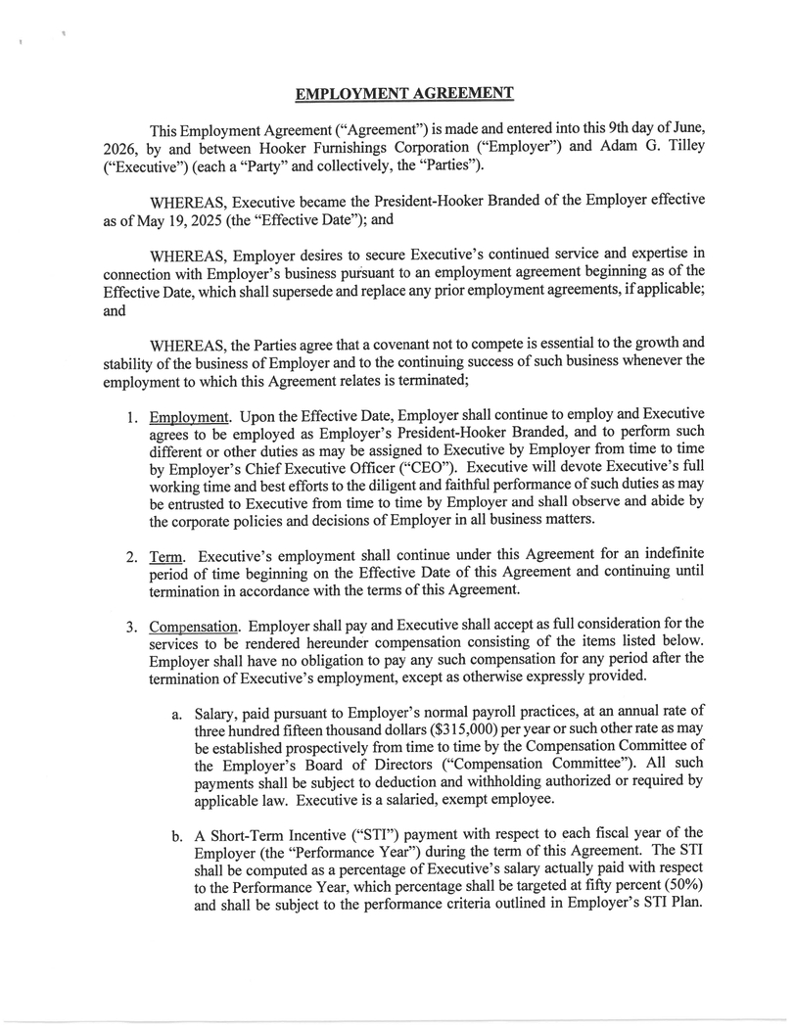
EMPLOYMENT AGREEMENT This Employment Agreement (“Agreement”) is made and entered into this 9 th day of June, 2026 , by and between Hooker Furnishings Corporation (“Employer”) and Adam G . Tilley (“Executive”) (each a “Party” and collectively, the “Parties”) . WHEREAS, Executive became the President - Hooker Branded of the Employer effective as of May 19 , 2025 (the “Effective Date”) ; and WHEREAS, Employer desires to secure Executive's continued service and expertise in connection with Employer's business pNsuant to an employment agreement beginning as of the Effective Date, which shall supersede and replace any prior employment agreements, if applicable ; and WHEREAS, the Parties agree that a covenant not to compete is essential to the growth and stability of the business of Employer and to the continuing success of such business whenever the employment to which this Agreement relates is terminated ; 1. Employment . Upon the Effective Date, Employer shall continue to employ and Executive agrees to be employed as Employer's President - Hooker Branded, and to perform such different or other duties as may be assigned to Executive by Employer from time to time by Employer's Chief Executive Officer (“CEO”) . Executive will devote Executive's full working time and best efforts to the diligent and faithful performance of such duties as may be entrusted to Executive from time to time by Employer and shall observe and abide by the corporate policies and decisions of Employer in all business matters . 2. Term . Executive's employment shall continue under this Agreement for an indefinite period of time beginning on the Effective Date of this Agreement and continuing until termination in accordance with the terms of this Agreement . 3. Compensation . Employer shall pay and Executive shall accept as full consideration for the services to be rendered hereunder compensation consisting of the items listed below . Employer shall have no obligation to pay any such compensation for any period after the termination of Executive's employment, except as otherwise expressly provided . a. Salary, paid pursuant to Employer's normal payroll practices, at an annual rate of three hundred fifteen thousand dollars ( $ 315 , 000 ) per year or such other rate as may be established prospectively from time to time by the Compensation Committee of the Employer's Board of Directors (“Compensation Committee”) . All such payments shall be subject to deduction and withholding authorized or required by applicable law . Executive is a salaried, exempt employee . b. A Short - Term Incentive (“STI”) payment with respect to each fiscal year of the Employer (the “Performance Year”) during the term of this Agreement . The STI shall be computed as a percentage of Executive's salary actually paid with respect to the Performance Year, which percentage shall be targeted at fifty percent ( 50 % ) and shall be subject to the performance criteria outlined in Employer's STI Plan .

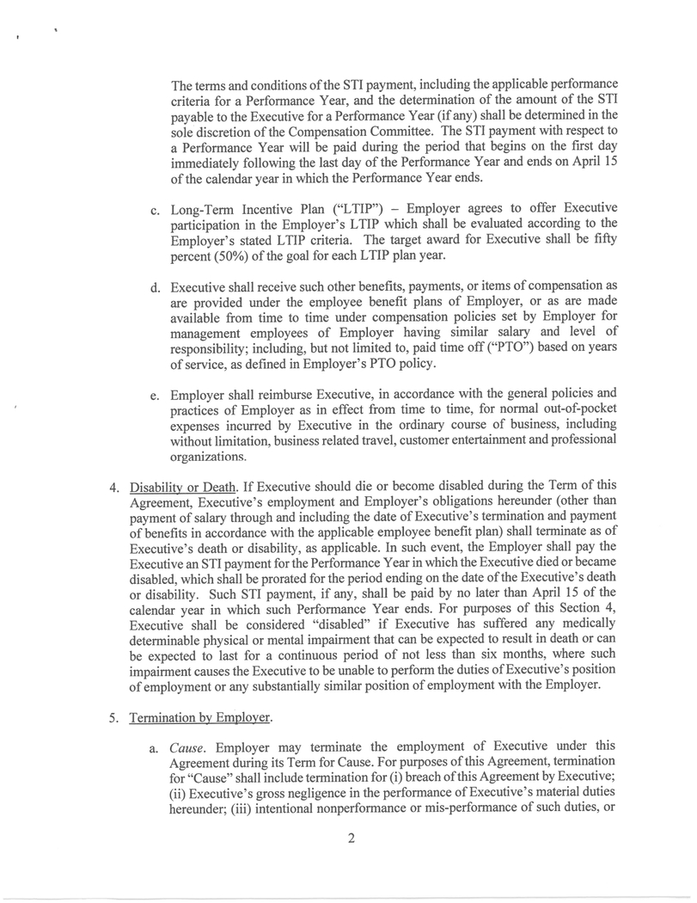
2 The terms and conditions of the STI payment, including the applicable performance criteria for a Performance Year, and the determination of the amount of the STI payable to the Executive for a Performance Year (if any) shall be determined in the sole discretion of the Compensation Committee . The STI payment with respect to a Performance Year will be paid during the period that begins on the first day immediately following the last day of the Performance Year and ends on April 15 of the calendar year in which the Performance Year ends . C . Long - Term Incentive Plan (“LTIP”) — Employer agrees to offer Executive participation in the Employer's LTIP which shall be evaluated according to the Employer's stated LTIP criteria . The target award for Executive shall be fifty percent ( 50 % ) of the goal for each LTIP plan year . d. Executive shall receive such other benefits, payments, or items of compensation as are provided under the employee benefit plans of Employer, or as are made available from time to time under compensation policies set by Employer for management employees of Employer having similar salary and level of responsibility ; including, but not limited to, paid time off(“PTO”) based on years of service, as defined in Employer's PTO policy . e. Employer shall reimburse Executive, in accordance with the general policies and practices of Employer as in effect from time to time, for normal out - of - pocket expenses incurred by Executive in the ordinary course of business, including without limitation, business related travel, customer entertainment and professional organizations . 4. Disability or Death . If Executive should die or become disabled during the Term of this Agreement, Executive's employment and Employer's obligations hereunder (other than payment of salary through and including the date of Executive's termination and payment of benefits in accordance with the applicable employee benefit plan) shall terminate as of Executive's death or disability, as applicable . In such event, the Employer shall pay the Executive an STI payment for the Performance Year in which the Executive died or became disabled, which shall be prorated for the period ending on the date of the Executive's death or disability . Such STI payment, if any, shall be paid by no later than April 15 of the calendar year in which such Performance Year ends . For purposes of this Section 4 , Executive shall be considered “disabled” if Executive has suffered any medically determinable physical or mental impairment that can be expected to result in death or can be expected to last for a continuous period of not less than six months, where such impairment causes the Executive to be unable to perform the duties of Executive's position of employment or any substantially similar position of employment with the Employer . 5. Termination be Employer. a. Cause . Employer may terminate the employment of Executive under this Agreement during its Term for Cause . For purposes of this Agreement, termination for “Cause” shall include termination for (i) breach ofthis Agreement by Executive ; (ii) Executive's gross negligence in the performance of Executive's material duties hereunder ; (iii) intentional nonperformance or mis - performance of such duties, or

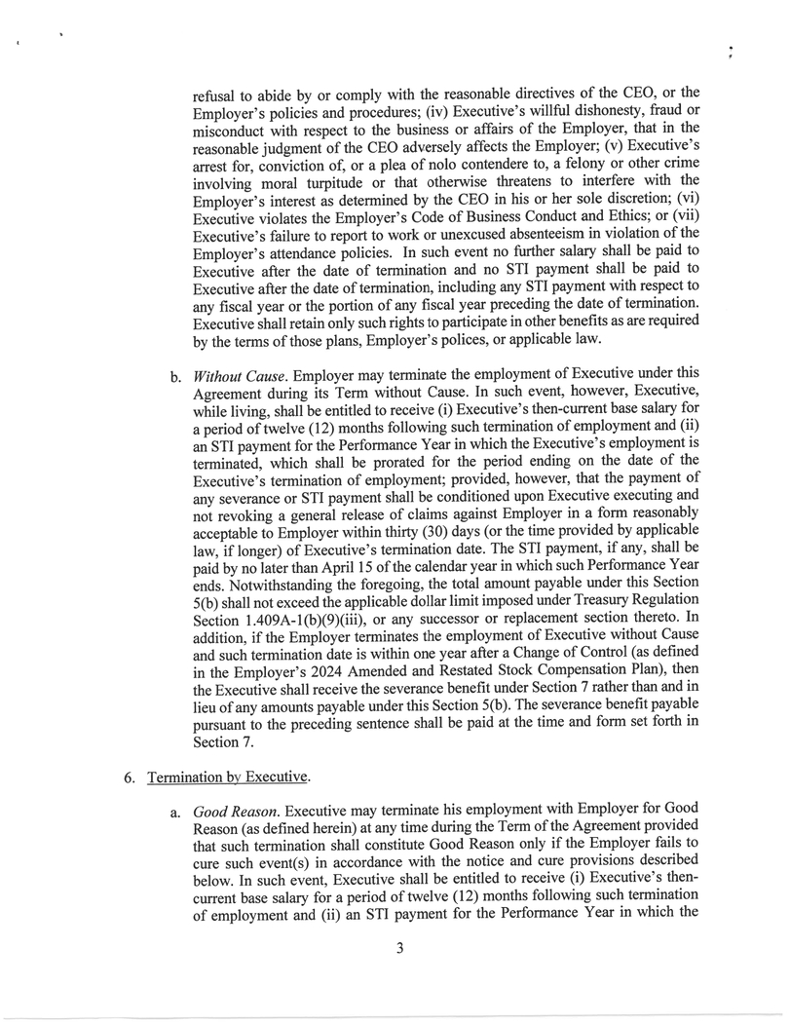
3 refusal to abide by or comply with the reasonable directives of the CEO, or the Employer's policies and procedures ; (iv) Executive's willful dishonesty, fraud or misconduct with respect to the business or affairs of the Employer, that in the reasonable judgment of the CEO adversely affects the Employer ; (v) Executive's arrest for, conviction of, or a plea of nolo contendere to, a felony or other crime involving moral turpitude or that otherwise threatens to interfere with the Employer's interest as determined by the CEO in his or her sole discretion ; (vi) Executive violates the Employer's Code of Business Conduct and Ethics ; or (vii) Executive's failure to report to work or unexcused absenteeism in violation of the Employer's attendance policies . In such event no further salary shall be paid to Executive after the date of termination and no STI payment shall be paid to Executive after the date of termination, including any STI payment with respect to any fiscal year or the portion of any fiscal year preceding the date of termination . Executive shall retain only such rights to participate in other benefits as are required by the terms of those plans, Employer's polices, or applicable law . b . Without Cause . Employer may terminate the employment of Executive under this Agreement during its Term without Cause . In such event, however, Executive, while living, shall be entitled to receive (i) Executive's then - current base salary for a period of twelve ( 12 ) months following such termination of employment and (ii) an STI payment for the Performance Year in which the Executive's employment is terminated, which shall be prorated for the period ending on the date of the Executive's termination of employment ; provided, however, that the payment of any severance or STI payment shall be conditioned upon Executive executing and not revoking a general release of claims against Employer in a form reasonably acceptable to Employer within thirty ( 30 ) days (or the time provided by applicable law, if longer) of Executive's termination date . The STI payment, if any, shall be paid by no later than April 15 of the calendar year in which such Performance Year ends . Notwithstanding the foregoing, the total amount payable under this Section 5 (b) shall not exceed the applicable dollar limit imposed under Treasury Regulation Section 1 . 409 A - 1 (b)( 9 )(iii), or any successor or replacement section thereto . In addition, if the Employer terminates the employment of Executive without Cause and such termination date is within one year after a Change of Control (as defined in the Employer's 2024 Amended and Restated Stock Compensation Plan), then the Executive shall receive the severance benefit under Section 7 rather than and in lieu of any amounts payable under this Section 5 (b) . The severance benefit payable pursuant to the preceding sentence shall be paid at the time and form set forth in Section 7 . 6. Termination by Executive. a. Good Reason . Executive may terminate his employment with Employer for Good Reason (as defined herein) at any time during the Term of the Agreement provided that such termination shall constitute Good Reason only if the Employer fails to cure such event(s) in accordance with the notice and cure provisions described below . In such event, Executive shall be entitled to receive (i) Executive's then - current base salary for a period of twelve ( 12 ) months following such termination of employment and (ii) an STI payment for the Performance Year in which the

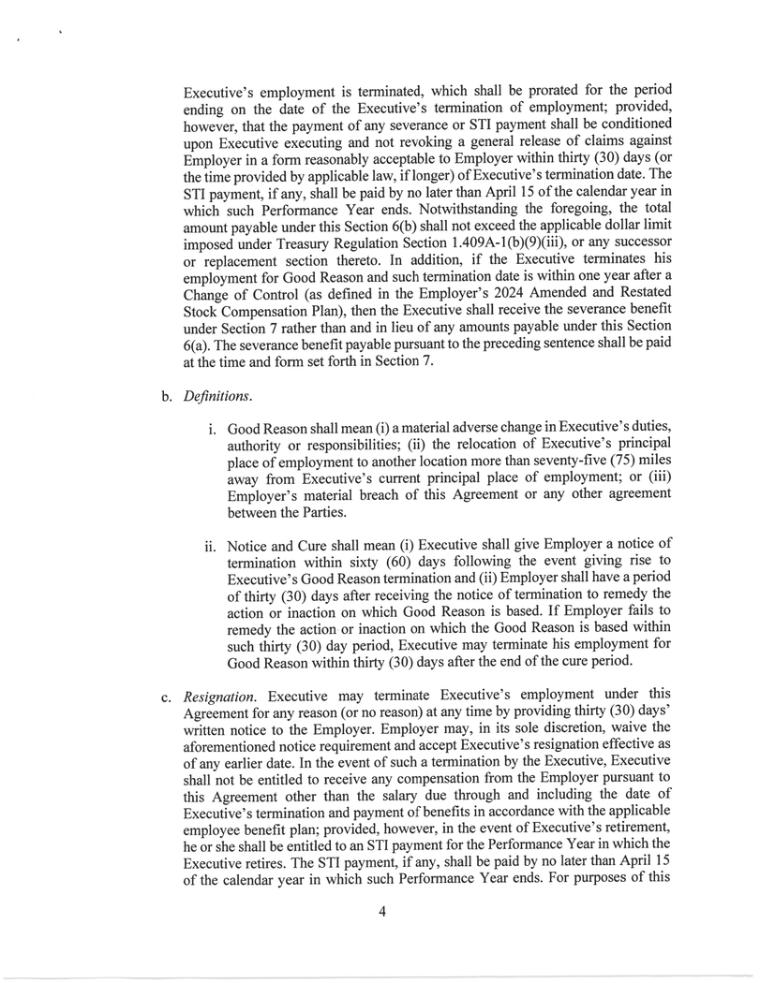
Executive's employment is terminated, which shall be prorated for the period ending on the date of the Executive's termination of employment ; provided, however, that the payment of any severance or STI payment shall be conditioned upon Executive executing and not revoking a general release of claims against Employer in a form reasonably acceptable to Employer within thirty ( 30 ) days (or the time provided by applicable law, if longer) of Executive's termination date . The STI payment, if any, shall be paid by no later than April 15 of the calendar year in which such Performance Year ends . Notwithstanding the foregoing, the total amount payable under this Section 6 (b) shall not exceed the applicable dollar limit imposed under Treasury Regulation Section 1 . 409 A - 1 (b)( 9 )(iii), or any successor or replacement section thereto . In addition, if the Executive terminates his employment for Good Reason and such termination date is within one year after a Change of Control (as defined in the Employer's 2024 Amended and Restated Stock Compensation Plan), then the Executive shall receive the severance benefit under Section 7 rather than and in lieu of any amounts payable under this Section 6 (a) . The severance benefit payable pursuant to the preceding sentence shall be paid at the time and form set forth in Section 7 . b. Definitions. Good Reason shall mean (i) a material adverse change in Executive's duties, authority or responsibilities ; (ii) the relocation of Executive's principal place of employment to another location more than seventy - five ( 75 ) miles away from Executive's current principal place of employment ; or (iii) Employer's material breach of this Agreement or any other agreement between the Parties . ii . Notice and Cure shall mean (i) Executive shall give Employer a notice of termination within sixty ( 60 ) days following the event giving rise to Executive's Good Reason termination and (ii) Employer shall have a period of thirty ( 30 ) days after receiving the notice of termination to remedy the action or inaction on which Good Reason is based . If Employer fails to remedy the action or inaction on which the Good Reason is based within such thirty ( 30 ) day period, Executive may terminate his employment for Good Reason within thirty ( 30 ) days after the end of the cure period . c. ResignatiDn . Executive may terminate Executive's employment under this Agreement for any reason (or no reason) at any time by providing thirty ( 30 ) days' written notice to the Employer . Employer may, in its sole discretion, waive the aforementioned notice requirement and accept Executive's resignation effective as of any earlier date . In the event of such a termination by the Executive, Executive shall not be entitled to receive any compensation from the Employer pursuant to this Agreement other than the salary due through and including the date of Executive's termination and payment of benefits in accordance with the applicable employee benefit plan ; provided, however, in the event of Executive's retirement, he or she shall be entitled to an STI payment for the Performance Year in which the Executive retires . The STI payment, if any, shall be paid by no later than April 15 of the calendar year in which such Performance Year ends. For purposes of this 4

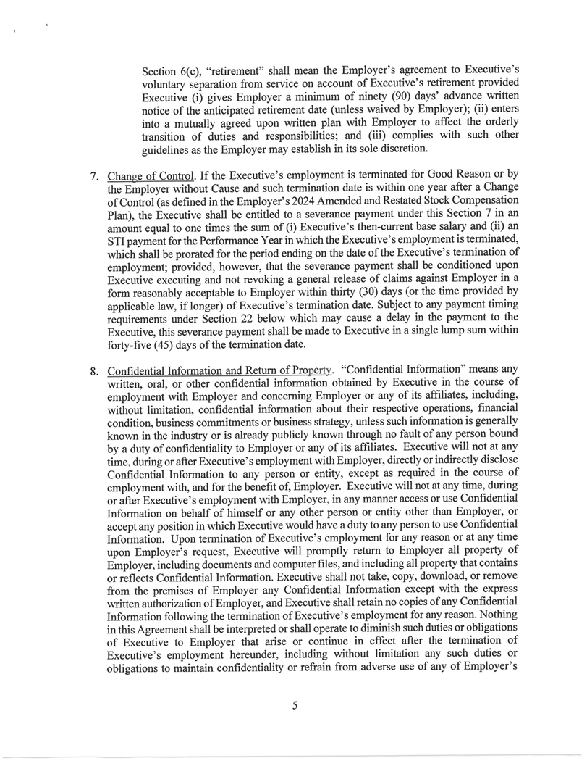
Section 6 (c), “retirement” shall mean the Employer's agreement to Executive's voluntary separation from service on account of Executive's retirement provided Executive (i) gives Employer a minimum of ninety ( 90 ) days' advance written notice of the anticipated retirement date (unless waived by Employer) ; (ii) enters into a mutually agreed upon written plan with Employer to affect the orderly transition of duties and responsibilities ; and (iii) complies with such other guidelines as the Employer may establish in its sole discretion . 7. Change of Control . If the Executive's employment is terminated for Good Reason or by the Employer without Cause and such termination date is within one year after a Change of Control (as defined in the Employer's 2024 Amended and Restated Stock Compensation Plan), the Executive shall be entitled to a severance payment under this Section 7 in an amount equal to one times the sum of (i) Executive's then - current base salary and (ii) an STI payment for the Performance Year in which the Executive's employment is terminated, which shall be prorated for the period ending on the date of the Executive's termination of employment ; provided, however, that the severance payment shall be conditioned upon Executive executing and not revoking a general release of claims against Employer in a form reasonably acceptable to Employer within thirty ( 30 ) days (or the time provided by applicable law, if longer) of Executive's termination date . Subject to any payment timing requirements under Section 22 below which may cause a delay in the payment to the Executive, this severance payment shall be made to Executive in a single lump sum within forty - five ( 45 ) days of the termination date . 8. Confidential Information and Return of Property . “Confidential Information” means any written, oral, or other confidential information obtained by Executive in the course of employment with Employer and concerning Employer or any of its affiliates, including, without limitation, confidential information about their respective operations, financial condition, business commitments or business strategy, unless such information is generally known in the industry or is already publicly known through no fault of any person bound by a duty of confidentiality to Employer or any of its affiliates . Executive will not at any time, during or after Executive's employment with Employer, directly or indirectly disclose Confidential Information to any person or entity, except as required in the course of employment with, and for the benefit of, Employer . Executive will not at any time, during or after Executive's employment with Employer, in any manner access or use Confidential Information on behalf of himself or any other person or entity other than Employer, or accept any position in which Executive would have a duty to any person to use Confidential Information . Upon termination of Executive's employment for any reason or at any time upon Employer's request, Executive will promptly return to Employer all property of Employer, including documents and computer files, and including all property that contains or reflects Confidential Information . Executive shall not take, copy, download, or remove from the premises of Employer any Confidential Information except with the express written authorization of Employer, and Executive shall retain no copies of any Confidential Information following the termination of Executive's employment for any reason . Nothing in this Agreement shall be interpreted or shall operate to diminish such duties or obligations of Executive to Employer that arise or continue in effect after the termination of Executive's employment hereunder, including without limitation any such duties or obligations to maintain confidentiality or refrain from adverse use of any of Employer's

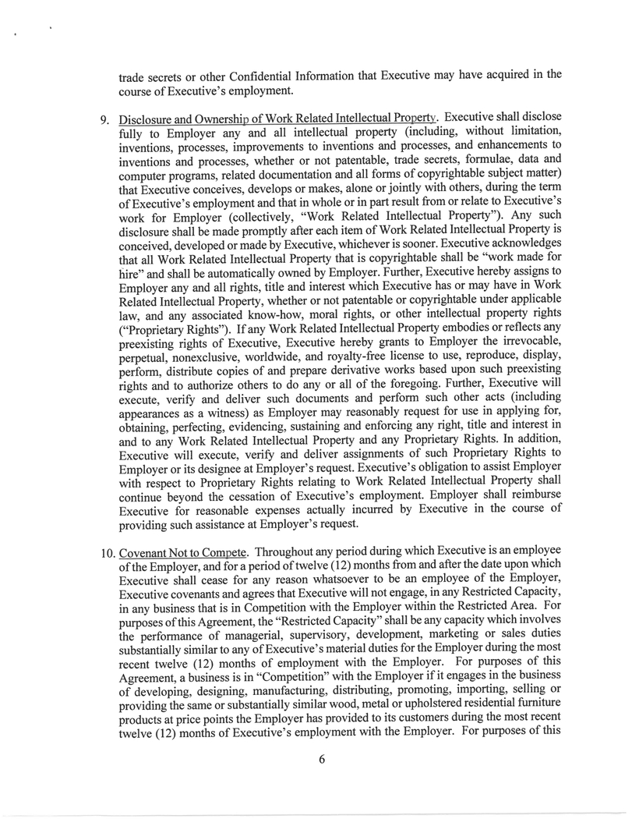
6 trade secrets or other Confidential Information that Executive may have acquired in the course of Executive's employment. 9. Disclosure and Ownership of Work Related Intellectual Property. Executive shall disclose fully to Employer any and all intellectual property (including, without limitation, inventions, processes, improvements to inventions and processes, and enhancements to inventions and processes, whether or not patentable, trade secrets, formulae, data and computer programs, related documentation and all forms of copyrightable subject matter) that Executive conceives, develops or makes, alone or jointly with others, during the term of Executive's employment and that in whole or in part result from or relate to Executive's work for Employer (collectively, “Work Related Intellectual Property”). Any such disclosure shall be made promptly after each item of Work Related Intellectual Property is conceived, developed or made by Executive, whichever is sooner. Executive acknowledges that all Work Related Intellectual Property that is copyrightable shall be “work made for hire” and shall be automatically owned by Employer. Further, Executive hereby assigns to Employer any and all rights, title and interest which Executive has or may have in Work Related Intellectual Property, whether or not patentable or copyrightable under applicable law, and any associated know - how, moral rights, or other intellectual property rights (“Proprietary Rights”). If any Work Related Intellectual Property embodies or reflects any preexisting rights of Executive, Executive hereby grants to Employer the irrevocable, perpetual, nonexclusive, worldwide, and royalty - free license to use, reproduce, display, perform, distribute copies of and prepare derivative works based upon such preexisting rights and to authorize others to do any or all of the foregoing. Further, Executive will execute, verify and deliver such documents and perform such other acts (including appearances as a witness) as Employer may reasonably request for use in applying for, obtaining, perfecting, evidencing, sustaining and enforcing any right, title and interest in and to any Work Related Intellectual Property and any Proprietary Rights. In addition, Executive will execute, verify and deliver assignments of such Proprietary Rights to Employer or its designee at Employer's request. Executive's obligation to assist Employer with respect to Proprietary Rights relating to Work Related Intellectual Property shall continue beyond the cessation of Executive's employment. Employer shall reimburse Executive for reasonable expenses actually incurred by Executive in the course of providing such assistance at Employer's request. 10. Covenant Not to Compete . Throughout any period during which Executive is an employee of the Employer, and for a period of twelve ( 12 ) months from and after the date upon which Executive shall cease for any reason whatsoever to be an employee of the Employer, Executive covenants and agrees that Executive will not engage, in any Restricted Capacity, in any business that is in Competition with the Employer within the Restricted Area . For purposes of this Agreement, the “Restricted Capacity” shall be any capacity which involves the performance of managerial, supervisory, development, marketing or sales duties substantially similar to any of Executive's material duties for the Employer during the most recent twelve ( 12 ) months of employment with the Employer . For purposes of this Agreement, a business is in “Competition” with the Employer if it engages in the business of developing, designing, manufacturing, distributing, promoting, importing, selling or providing the same or substantially similar wood, metal or upholstered residential furniture products at price points the Employer has provided to its customers during the most recent twelve ( 12 ) months of Executive's employment with the Employer . For purposes of this

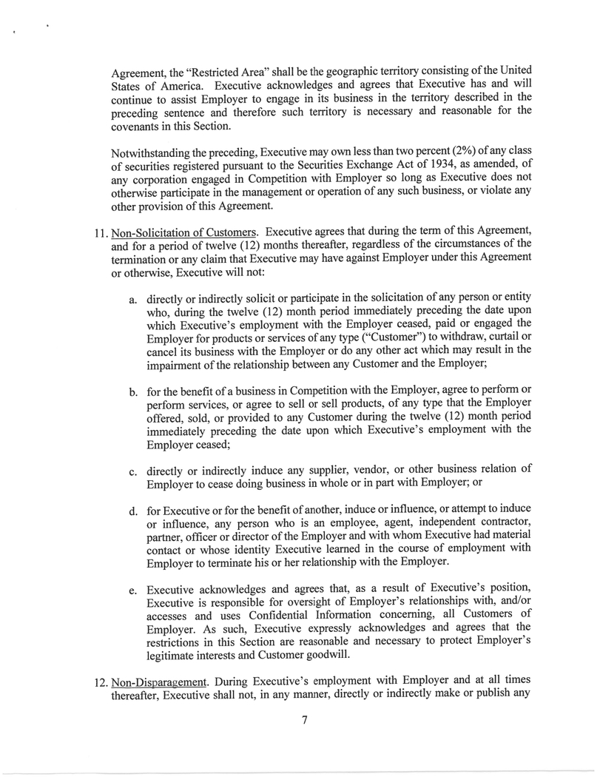
7 Agreement, the “Restricted Area” shall be the geographic territory consisting of the United States of America . Executive acknowledges and agrees that Executive has and will continue to assist Employer to engage in its business in the territory described in the preceding sentence and therefore such territory is necessary and reasonable for the covenants in this Section . Notwithstanding the preceding, Executive may own less than two percent ( 2 % ) of any class of securities registered pursuant to the Securities Exchange Act of 1934 , as amended, of any corporation engaged in Competition with Employer so long as Executive does not otherwise participate in the management or operation of any such business, or violate any other provision of this Agreement . 11. Non - Solicitation of Customers . Executive agrees that during the term of this Agreement, and for a period of twelve ( 12 ) months thereafter, regardless of the circumstances of the termination or any claim that Executive may have against Employer under this Agreement or otherwise, Executive will not : a. directly or indirectly solicit or participate in the solicitation of any person or entity who, during the twelve ( 12 ) month period immediately preceding the date upon which Executive's employment with the Employer ceased, paid or engaged the Employer for products or services of any type (“Customer”) to withdraw, curtail or cancel its business with the Employer or do any other act which may result in the impairment of the relationship between any Customer and the Employer ; b. for the benefit of a business in Competition with the Employer, agree to perform or perform services, or agree to sell or sell products, of any type that the Employer offered, sold, or provided to any Customer during the twelve ( 12 ) month period immediately preceding the date upon which Executive's employment with the Employer ceased ; c. directly or indirectly induce any supplier, vendor, or other business relation of Employer to cease doing business in whole or in part with Employer ; or d. for Executive or for the benefit of another, induce or influence, or attempt to induce or influence, any person who is an employee, agent, independent contractor, partner, officer or director of the Employer and with whom Executive had material contact or whose identity Executive learned in the course of employment with Employer to terminate his or her relationship with the Employer . e. Executive acknowledges and agrees that, as a result of Executive's position, Executive is responsible for oversight of Employer's relationships with, and/or accesses and uses Confidential Information concerning, all Customers of Employer . As such, Executive expressly acknowledges and agrees that the restrictions in this Section are reasonable and necessary to protect Employer's legitimate interests and Customer goodwill . 12. Non - Disparaaement . During Executive's employment with Employer and at all times thereafter, Executive shall not, in any manner, directly or indirectly make or publish any

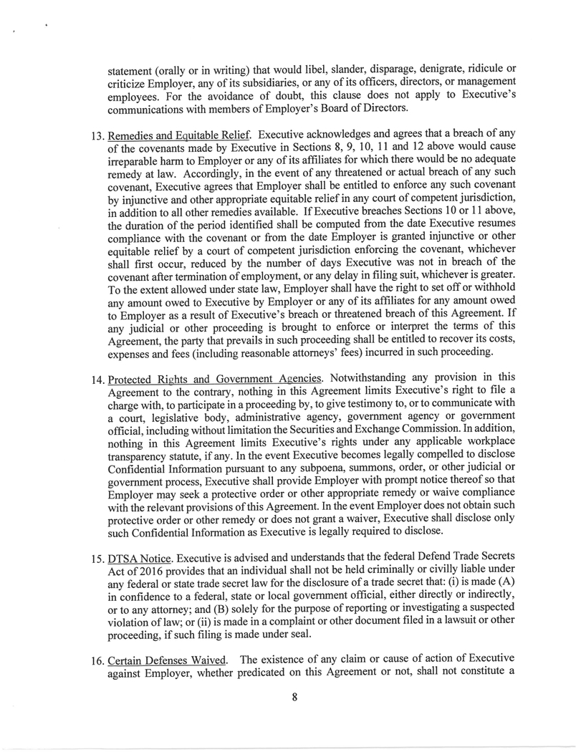
8 statement (orally or in writing) that would libel, slander, disparage, denigrate, ridicule or criticize Employer, any of its subsidiaries, or any of its officers, directors, or management employees . For the avoidance of doubt, this clause does not apply to Executive's communications with members of Employer's Board of Directors . 13. Remedies and Equitable Relief . Executive acknowledges and agrees that a breach of any of the covenants made by Executive in Sections 8 , 9 , 10 , 11 and 12 above would cause irreparable harm to Employer or any of its affiliates for which there would be no adequate remedy at law . Accordingly, in the event of any threatened or actual breach of any such covenant, Executive agrees that Employer shall be entitled to enforce any such covenant by injunctive and other appropriate equitable relief in any court of competent jurisdiction, in addition to all other remedies available . If Executive breaches Sections 10 or 11 above, the duration of the period identified shall be computed from the date Executive resumes compliance with the covenant or from the date Employer is granted injunctive or other equitable relief by a court of competent jurisdiction enforcing the covenant, whichever shall first occur, reduced by the number of days Executive was not in breach of the covenant after termination of employment, or any delay in filing suit, whichever is greater . To the extent allowed under state law, Employer shall have the right to set off or withhold any amount owed to Executive by Employer or any of its affiliates for any amount owed to Employer as a result of Executive's breach or threatened breach of this Agreement . If any judicial or other proceeding is brought to enforce or interpret the terms of this Agreement, the party that prevails in such proceeding shall be entitled to recover its costs, expenses and fees (including reasonable attorneys' fees) incurred in such proceeding . 14. Protected Rights and Government Agencies . Notwithstanding any provision in this Agreement to the contrary, nothing in this Agreement limits Executive's right to file a charge with, to participate in a proceeding by, to give testimony to, or to communicate with a court, legislative body, administrative agency, government agency or government official, including without limitation the Securities and Exchange Commission . In addition, nothing in this Agreement limits Executive's rights under any applicable workplace transparency statute, if any . In the event Executive becomes legally compelled to disclose Confidential Information pursuant to any subpoena, summons, order, or other judicial or government process, Executive shall provide Employer with prompt notice thereof so that Employer may seek a protective order or other appropriate remedy or waive compliance with the relevant provisions of this Agreement . In the event Employer does not obtain such protective order or other remedy or does not grant a waiver, Executive shall disclose only such Confidential Information as Executive is legally required to disclose . 15. DTSA Notice . Executive is advised and understands that the federal Defend Trade Secrets Act of 2016 provides that an individual shall not be held criminally or civilly liable under any federal or state trade secret law for the disclosure of a trade secret that : (i) is made (A) in confidence to a federal, state or local government official, either directly or indirectly, or to any attorney ; and (B) solely for the purpose of reporting or investigating a suspected violation of law ; or (ii) is made in a complaint or other document filed in a lawsuit or other proceeding, if such filing is made under seal . 16. Certain Defenses Waived . The existence of any claim or cause of action of Executive against Employer, whether predicated on this Agreement or not, shall not constitute a

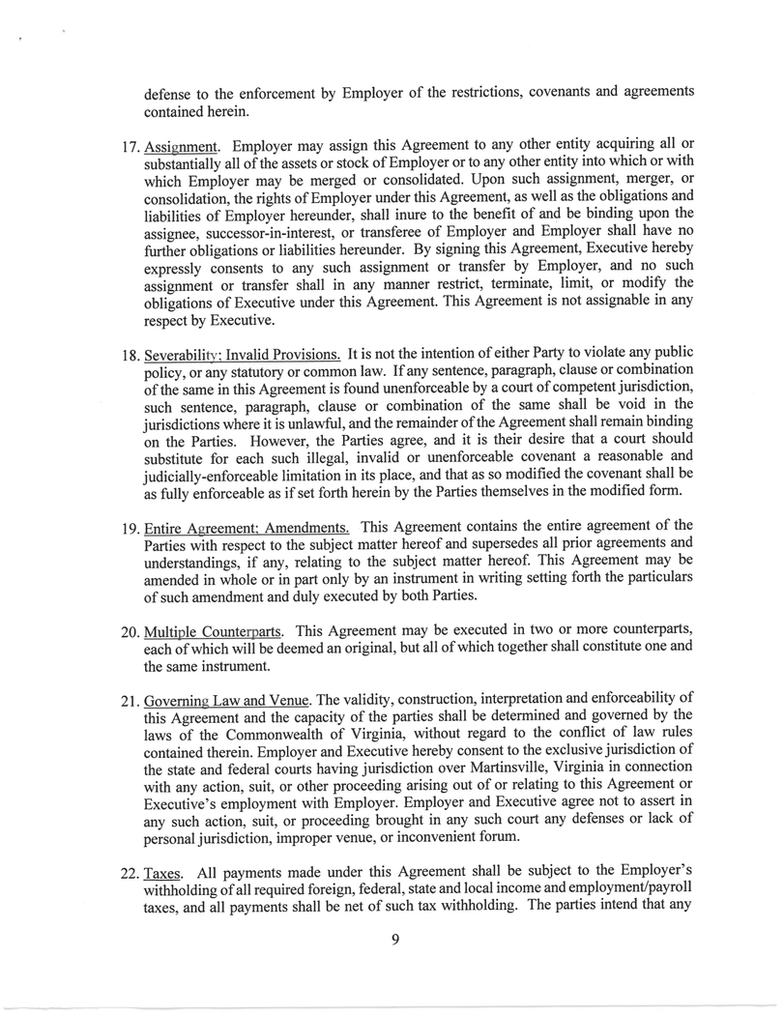
9 defense to the enforcement by Employer of the restrictions, covenants and agreements contained herein. 17. Assignment . Employer may assign this Agreement to any other entity acquiring all or substantially all of the assets or stock of Employer or to any other entity into which or with which Employer may be merged or consolidated . Upon such assignment, merger, or consolidation, the rights of Employer under this Agreement, as well as the obligations and liabilities of Employer hereunder, shall inure to the benefit of and be binding upon the assignee, successor - in - interest, or transferee of Employer and Employer shall have no further obligations or liabilities hereunder . By signing this Agreement, Executive hereby expressly consents to any such assignment or transfer by Employer, and no such assignment or transfer shall in any manner restrict, terminate, limit, or modify the obligations of Executive under this Agreement . This Agreement is not assignable in any respect by Executive . 18. Severabili 0 ' : Invalid Provisions . It is not the intention of either Party to violate any public policy, or any statutory or common law . If any sentence, paragraph, clause or combination of the same in this Agreement is found unenforceable by a court of competent jurisdiction, such sentence, paragraph, clause or combination of the same shall be void in the jurisdictions where it is unlawful, and the remainder of the Agreement shall remain binding on the Parties . However, the Parties agree, and it is their desire that a court should substitute for each such illegal, invalid or unenforceable covenant a reasonable and judicially - enforceable limitation in its place, and that as so modified the covenant shall be as fully enforceable as if set forth herein by the Parties themselves in the modified form . 19. Entire Agreement : Amendments . This Agreement contains the entire agreement of the Parties with respect to the subject matter hereof and supersedes all prior agreements and understandings, if any, relating to the subject matter hereof . This Agreement may be amended in whole or in part only by an instrument in writing setting forth the particulars of such amendment and duly executed by both Parties . 20. Multiple Counterparts . This Agreement may be executed in two or more counterparts, each of which will be deemed an original, but all of which together shall constitute one and the same instrument . 21. Governing Law and Venue . The validity, construction, interpretation and enforceability of this Agreement and the capacity of the parties shall be determined and governed by the laws of the Commonwealth of Virginia, without regard to the conflict of law rules contained therein . Employer and Executive hereby consent to the exclusive jurisdiction of the state and federal courts having jurisdiction over Martinsville, Virginia in connection with any action, suit, or other proceeding arising out of or relating to this Agreement or Executive's employment with Employer . Employer and Executive agree not to assert in any such action, suit, or proceeding brought in any such court any defenses or lack of personal jurisdiction, improper venue, or inconvenient forum . 22. Taxes . All payments made under this Agreement shall be subject to the Employer's withholding of all required foreign, federal, state and local income and employment/payroll taxes, and all payments shall be net of such tax withholding . The parties intend that any

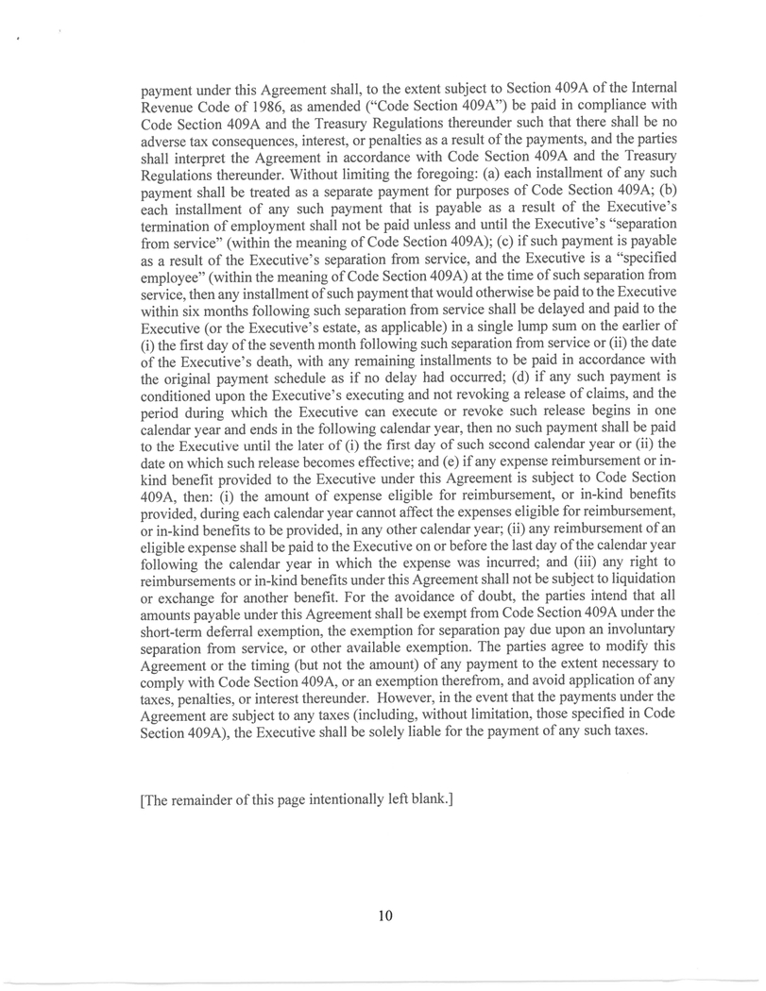
10 payment under this Agreement shall, to the extent subject to Section 409 A of the Internal Revenue Code of 1986 , as amended (“Code Section 409 A”) be paid in compliance with Code Section 409 A and the Treasury Regulations thereunder such that there shall be no adverse tax consequences, interest, or penalties as a result of the payments, and the parties shall interpret the Agreement in accordance with Code Section 409 A and the Treasury Regulations thereunder . Without limiting the foregoing : (a) each installment of any such payment shall be treated as a separate payment for purposes of Code Section 409 A ; (b) each installment of any such payment that is payable as a result of the Executive's termination of employment shall not be paid unless and until the Executive's “separation from service” (within the meaning of Code Section 409 A) ; (c) if such payment is payable as a result of the Executive's separation from service, and the Executive is a “specified employee” (within the meaning of Code Section 409 A) at the time of such separation from service, then any installment of such payment that would otherwise be paid to the Executive within six months following such separation from service shall be delayed and paid to the Executive (or the Executive's estate, as applicable) in a single lump sum on the earlier of (i) the first day of the seventh month following such separation from service or (ii) the date of the Executive's death, with any remaining installments to be paid in accordance with the original payment schedule as if no delay had occurred ; (d) if any such payment is conditioned upon the Executive's executing and not revoking a release of claims, and the period during which the Executive can execute or revoke such release begins in one calendar year and ends in the following calendar year, then no such payment shall be paid to the Executive until the later of (i) the first day of such second calendar year or (ii) the date on which such release becomes effective ; and (e) if any expense reimbursement or in - kind benefit provided to the Executive under this Agreement is subject to Code Section 409 A, then : (i) the amount of expense eligible for reimbursement, or in - kind benefits provided, during each calendar year cannot affect the expenses eligible for reimbursement, or in - kind benefits to be provided, in any other calendar year ; (ii) any reimbursement of an eligible expense shall be paid to the Executive on or before the last day of the calendar year following the calendar year in which the expense was incurred ; and (iii) any right to reimbursements or in - kind benefits under this Agreement shall not be subject to liquidation or exchange for another benefit . For the avoidance of doubt, the parties intend that all amounts payable under this Agreement shall be exempt from Code Section 409 A under the short - term deferral exemption, the exemption for separation pay due upon an involuntary separation from service, or other available exemption . The parties agree to modify this Agreement or the timing (but not the amount) of any payment to the extent necessary to comply with Code Section 409 A, or an exemption therefrom, and avoid application of any taxes, penalties, or interest thereunder . However, in the event that the payments under the Agreement are subject to any taxes (including, without limitation, those specified in Code Section 409 A), the Executive shall be solely liable for the payment of any such taxes . [The remainder of this page intentionally left blank.]

IN WITNESS WHEREOF, the parties hereto have executed and delivered this Agreement as of the date first written above.

 | Employer
 | By: | /s/ Jeremy R. Hoff

Executive
/s/ Adam G. Tilley

11

Exhibit 10.2

EMPLOYMENT AGREEMENT

This Employment Agreement (“Agreement”) is made and entered into this 9th day of June, 2026, by and between Hooker Furnishings Corporation (“Employer”) and Richard L. Vest (“Executive”) (each a “Party” and collectively, the “Parties”).

WHEREAS, Executive became the President-Domestic Upholstery & Hospitality of the Employer effective as of August 1, 2025 (the “Effective Date”); and

WHEREAS, Employer desires to secure Executive’s continued service and expertise in connection with Employer’s business pursuant to an employment agreement beginning as of the Effective Date, which shall supersede and replace any prior employment agreements, if applicable; and

WHEREAS, the Parties agree that a covenant not to compete is essential to the growth and stability of the business of Employer and to the continuing success of such business whenever the employment to which this Agreement relates is terminated;

 | 1. | Employment. Upon the Effective Date, Employer shall continue to employ and Executive agrees to be employed as Employer’s President-Domestic Upholstery & Hospitality, and to perform such different or other duties as may be assigned to Executive by Employer from time to time by Employer’s Chief Executive Officer (“CEO”). Executive will devote Executive’s full working time and best efforts to the diligent and faithful performance of such duties as may be entrusted to Executive from time to time by Employer and shall observe and abide by the corporate policies and decisions of Employer in all business matters.

 | 2. | Term. Executive’s employment shall continue under this Agreement for an indefinite period of time beginning on the Effective Date of this Agreement and continuing until termination in accordance with the terms of this Agreement.

 | 3. | Compensation. Employer shall pay and Executive shall accept as full consideration for the services to be rendered hereunder compensation consisting of the items listed below. Employer shall have no obligation to pay any such compensation for any period after the termination of Executive’s employment, except as otherwise expressly provided.

 | a. | Salary, paid pursuant to Employer’s normal payroll practices, at an annual rate of three hundred fifteen thousand dollars ($315,000) per year or such other rate as may be established prospectively from time to time by the Compensation Committee of the Employer’s Board of Directors (“Compensation Committee”). All such payments shall be subject to deduction and withholding authorized or required by applicable law. Executive is a salaried, exempt employee.

 | b. | A Short-Term Incentive (“STI”) payment with respect to each fiscal year of the Employer (the “Performance Year”) during the term of this Agreement. The STI shall be computed as a percentage of Executive’s salary actually paid with respect to the Performance Year, which percentage shall be targeted at fifty percent (50%) and shall be subject to the performance criteria outlined in Employer’s STI Plan. The terms and conditions of the STI payment, including the applicable performance criteria for a Performance Year, and the determination of the amount of the STI payable to the Executive for a Performance Year (if any) shall be determined in the sole discretion of the Compensation Committee. The STI payment with respect to a Performance Year will be paid during the period that begins on the first day immediately following the last day of the Performance Year and ends on April 15 of the calendar year in which the Performance Year ends.

 | c. | Long-Term Incentive Plan (“LTIP”) – Employer agrees to offer Executive participation in the Employer’s LTIP which shall be evaluated according to the Employer’s stated LTIP criteria. The target award for Executive shall be fifty percent (50%) of the goal for each LTIP plan year.

 | d. | Executive shall receive such other benefits, payments, or items of compensation as are provided under the employee benefit plans of Employer, or as are made available from time to time under compensation policies set by Employer for management employees of Employer having similar salary and level of responsibility; including, but not limited to, paid time off (“PTO”) based on years of service, as defined in Employer’s PTO policy.

 | e. | Employer shall reimburse Executive, in accordance with the general policies and practices of Employer as in effect from time to time, for normal out-of-pocket expenses incurred by Executive in the ordinary course of business, including without limitation, business related travel, customer entertainment and professional organizations.

 | 4. | Disability or Death. If Executive should die or become disabled during the Term of this Agreement, Executive’s employment and Employer’s obligations hereunder (other than payment of salary through and including the date of Executive’s termination and payment of benefits in accordance with the applicable employee benefit plan) shall terminate as of Executive’s death or disability, as applicable. In such event, the Employer shall pay the Executive an STI payment for the Performance Year in which the Executive died or became disabled, which shall be prorated for the period ending on the date of the Executive’s death or disability. Such STI payment, if any, shall be paid by no later than April 15 of the calendar year in which such Performance Year ends. For purposes of this Section 4, Executive shall be considered “disabled” if Executive has suffered any medically determinable physical or mental impairment that can be expected to result in death or can be expected to last for a continuous period of not less than six months, where such impairment causes the Executive to be unable to perform the duties of Executive’s position of employment or any substantially similar position of employment with the Employer.

 | 5. | Termination by Employer.

 | a. | Cause. Employer may terminate the employment of Executive under this Agreement during its Term for Cause. For purposes of this Agreement, termination for “Cause” shall include termination for (i) breach of this Agreement by Executive; (ii) Executive’s gross negligence in the performance of Executive’s material duties hereunder; (iii) intentional nonperformance or mis-performance of such duties, or refusal to abide by or comply with the reasonable directives of the CEO, or the Employer’s policies and procedures; (iv) Executive’s willful dishonesty, fraud or misconduct with respect to the business or affairs of the Employer, that in the reasonable judgment of the CEO adversely affects the Employer; (v) Executive’s arrest for, conviction of, or a plea of nolo contendere to, a felony or other crime involving moral turpitude or that otherwise threatens to interfere with the Employer’s interest as determined by the CEO in his or her sole discretion; (vi) Executive violates the Employer’s Code of Business Conduct and Ethics; or (vii) Executive’s failure to report to work or unexcused absenteeism in violation of the Employer’s attendance policies. In such event no further salary shall be paid to Executive after the date of termination and no STI payment shall be paid to Executive after the date of termination, including any STI payment with respect to any fiscal year or the portion of any fiscal year preceding the date of termination. Executive shall retain only such rights to participate in other benefits as are required by the terms of those plans, Employer’s polices, or applicable law.

2

 | b. | Without Cause. Employer may terminate the employment of Executive under this Agreement during its Term without Cause. In such event, however, Executive, while living, shall be entitled to receive (i) Executive’s then-current base salary for a period of twelve (12) months following such termination of employment and (ii) an STI payment for the Performance Year in which the Executive’s employment is terminated, which shall be prorated for the period ending on the date of the Executive’s termination of employment; provided, however, that the payment of any severance or STI payment shall be conditioned upon Executive executing and not revoking a general release of claims against Employer in a form reasonably acceptable to Employer within thirty (30) days (or the time provided by applicable law, if longer) of Executive’s termination date. The STI payment, if any, shall be paid by no later than April 15 of the calendar year in which such Performance Year ends. Notwithstanding the foregoing, the total amount payable under this Section 5(b) shall not exceed the applicable dollar limit imposed under Treasury Regulation Section 1.409A-1(b)(9)(iii), or any successor or replacement section thereto. In addition, if the Employer terminates the employment of Executive without Cause and such termination date is within one year after a Change of Control (as defined in the Employer’s 2024 Amended and Restated Stock Compensation Plan), then the Executive shall receive the severance benefit under Section 7 rather than and in lieu of any amounts payable under this Section 5(b). The severance benefit payable pursuant to the preceding sentence shall be paid at the time and form set forth in Section 7.

 | 6. | Termination by Executive.

 | a. | Good Reason. Executive may terminate his employment with Employer for Good Reason (as defined herein) at any time during the Term of the Agreement provided that such termination shall constitute Good Reason only if the Employer fails to cure such event(s) in accordance with the notice and cure provisions described below. In such event, Executive shall be entitled to receive (i) Executive’s then-current base salary for a period of twelve (12) months following such termination of employment and (ii) an STI payment for the Performance Year in which the Executive’s employment is terminated, which shall be prorated for the period ending on the date of the Executive’s termination of employment; provided, however, that the payment of any severance or STI payment shall be conditioned upon Executive executing and not revoking a general release of claims against Employer in a form reasonably acceptable to Employer within thirty (30) days (or the time provided by applicable law, if longer) of Executive’s termination date. The STI payment, if any, shall be paid by no later than April 15 of the calendar year in which such Performance Year ends. Notwithstanding the foregoing, the total amount payable under this Section 6(b) shall not exceed the applicable dollar limit imposed under Treasury Regulation Section 1.409A-1(b)(9)(iii), or any successor or replacement section thereto. In addition, if the Executive terminates his employment for Good Reason and such termination date is within one year after a Change of Control (as defined in the Employer’s 2024 Amended and Restated Stock Compensation Plan), then the Executive shall receive the severance benefit under Section 7 rather than and in lieu of any amounts payable under this Section 6(a). The severance benefit payable pursuant to the preceding sentence shall be paid at the time and form set forth in Section 7.

 | b. | Definitions.

 | i. | Good Reason shall mean (i) a material adverse change in Executive’s duties, authority or responsibilities; (ii) the relocation of Executive’s principal place of employment to another location more than seventy-five (75) miles away from Executive’s current principal place of employment; or (iii) Employer’s material breach of this Agreement or any other agreement between the Parties.

 | ii. | Notice and Cure shall mean (i) Executive shall give Employer a notice of termination within sixty (60) days following the event giving rise to Executive’s Good Reason termination and (ii) Employer shall have a period of thirty (30) days after receiving the notice of termination to remedy the action or inaction on which Good Reason is based. If Employer fails to remedy the action or inaction on which the Good Reason is based within such thirty (30) day period, Executive may terminate his employment for Good Reason within thirty (30) days after the end of the cure period.

3

 | c. | Resignation. Executive may terminate Executive’s employment under this Agreement for any reason (or no reason) at any time by providing thirty (30) days’ written notice to the Employer. Employer may, in its sole discretion, waive the aforementioned notice requirement and accept Executive’s resignation effective as of any earlier date. In the event of such a termination by the Executive, Executive shall not be entitled to receive any compensation from the Employer pursuant to this Agreement other than the salary due through and including the date of Executive’s termination and payment of benefits in accordance with the applicable employee benefit plan; provided, however, in the event of Executive’s retirement, he or she shall be entitled to an STI payment for the Performance Year in which the Executive retires. The STI payment, if any, shall be paid by no later than April 15 of the calendar year in which such Performance Year ends. For purposes of this Section 6(c), “retirement” shall mean the Employer’s agreement to Executive’s voluntary separation from service on account of Executive’s retirement provided Executive (i) gives Employer a minimum of ninety (90) days’ advance written notice of the anticipated retirement date (unless waived by Employer); (ii) enters into a mutually agreed upon written plan with Employer to affect the orderly transition of duties and responsibilities; and (iii) complies with such other guidelines as the Employer may establish in its sole discretion.

 | 7. | Change of Control. If the Executive’s employment is terminated for Good Reason or by the Employer without Cause and such termination date is within one year after a Change of Control (as defined in the Employer’s 2024 Amended and Restated Stock Compensation Plan), the Executive shall be entitled to a severance payment under this Section 7 in an amount equal to one times the sum of (i) Executive’s then-current base salary and (ii) an STI payment for the Performance Year in which the Executive’s employment is terminated, which shall be prorated for the period ending on the date of the Executive’s termination of employment; provided, however, that the severance payment shall be conditioned upon Executive executing and not revoking a general release of claims against Employer in a form reasonably acceptable to Employer within thirty (30) days (or the time provided by applicable law, if longer) of Executive’s termination date. Subject to any payment timing requirements under Section 22 below which may cause a delay in the payment to the Executive, this severance payment shall be made to Executive in a single lump sum within forty-five (45) days of the termination date.

 | 8. | Confidential Information and Return of Property. “Confidential Information” means any written, oral, or other confidential information obtained by Executive in the course of employment with Employer and concerning Employer or any of its affiliates, including, without limitation, confidential information about their respective operations, financial condition, business commitments or business strategy, unless such information is generally known in the industry or is already publicly known through no fault of any person bound by a duty of confidentiality to Employer or any of its affiliates. Executive will not at any time, during or after Executive’s employment with Employer, directly or indirectly disclose Confidential Information to any person or entity, except as required in the course of employment with, and for the benefit of, Employer. Executive will not at any time, during or after Executive’s employment with Employer, in any manner access or use Confidential Information on behalf of himself or any other person or entity other than Employer, or accept any position in which Executive would have a duty to any person to use Confidential Information. Upon termination of Executive’s employment for any reason or at any time upon Employer’s request, Executive will promptly return to Employer all property of Employer, including documents and computer files, and including all property that contains or reflects Confidential Information. Executive shall not take, copy, download, or remove from the premises of Employer any Confidential Information except with the express written authorization of Employer, and Executive shall retain no copies of any Confidential Information following the termination of Executive’s employment for any reason. Nothing in this Agreement shall be interpreted or shall operate to diminish such duties or obligations of Executive to Employer that arise or continue in effect after the termination of Executive’s employment hereunder, including without limitation any such duties or obligations to maintain confidentiality or refrain from adverse use of any of Employer’s trade secrets or other Confidential Information that Executive may have acquired in the course of Executive’s employment.

4

 | 9. | Disclosure and Ownership of Work Related Intellectual Property. Executive shall disclose fully to Employer any and all intellectual property (including, without limitation, inventions, processes, improvements to inventions and processes, and enhancements to inventions and processes, whether or not patentable, trade secrets, formulae, data and computer programs, related documentation and all forms of copyrightable subject matter) that Executive conceives, develops or makes, alone or jointly with others, during the term of Executive’s employment and that in whole or in part result from or relate to Executive’s work for Employer (collectively, “Work Related Intellectual Property”). Any such disclosure shall be made promptly after each item of Work Related Intellectual Property is conceived, developed or made by Executive, whichever is sooner. Executive acknowledges that all Work Related Intellectual Property that is copyrightable shall be “work made for hire” and shall be automatically owned by Employer. Further, Executive hereby assigns to Employer any and all rights, title and interest which Executive has or may have in Work Related Intellectual Property, whether or not patentable or copyrightable under applicable law, and any associated know-how, moral rights, or other intellectual property rights (“Proprietary Rights”). If any Work Related Intellectual Property embodies or reflects any preexisting rights of Executive, Executive hereby grants to Employer the irrevocable, perpetual, nonexclusive, worldwide, and royalty-free license to use, reproduce, display, perform, distribute copies of and prepare derivative works based upon such preexisting rights and to authorize others to do any or all of the foregoing. Further, Executive will execute, verify and deliver such documents and perform such other acts (including appearances as a witness) as Employer may reasonably request for use in applying for, obtaining, perfecting, evidencing, sustaining and enforcing any right, title and interest in and to any Work Related Intellectual Property and any Proprietary Rights. In addition, Executive will execute, verify and deliver assignments of such Proprietary Rights to Employer or its designee at Employer’s request. Executive’s obligation to assist Employer with respect to Proprietary Rights relating to Work Related Intellectual Property shall continue beyond the cessation of Executive’s employment. Employer shall reimburse Executive for reasonable expenses actually incurred by Executive in the course of providing such assistance at Employer’s request.

 | 10. | Covenant Not to Compete. Throughout any period during which Executive is an employee of the Employer, and for a period of twelve (12) months from and after the date upon which Executive shall cease for any reason whatsoever to be an employee of the Employer, Executive covenants and agrees that Executive will not engage, in any Restricted Capacity, in any business that is in Competition with the Employer within the Restricted Area. For purposes of this Agreement, the “Restricted Capacity” shall be any capacity which involves the performance of managerial, supervisory, development, marketing or sales duties substantially similar to any of Executive’s material duties for the Employer during the most recent twelve (12) months of employment with the Employer. For purposes of this Agreement, a business is in “Competition” with the Employer if it engages in the business of developing, designing, manufacturing, distributing, promoting, importing, selling or providing the same or substantially similar wood, metal or upholstered residential furniture products at price points the Employer has provided to its customers during the most recent twelve (12) months of Executive’s employment with the Employer. For purposes of this Agreement, the “Restricted Area” shall be the geographic territory consisting of the United States of America. Executive acknowledges and agrees that Executive has and will continue to assist Employer to engage in its business in the territory described in the preceding sentence and therefore such territory is necessary and reasonable for the covenants in this Section.

Notwithstanding the preceding, Executive may own less than two percent (2%) of any class of securities registered pursuant to the Securities Exchange Act of 1934, as amended, of any corporation engaged in Competition with Employer so long as Executive does not otherwise participate in the management or operation of any such business, or violate any other provision of this Agreement.

 | 11. | Non-Solicitation of Customers. Executive agrees that during the term of this Agreement, and for a period of twelve (12) months thereafter, regardless of the circumstances of the termination or any claim that Executive may have against Employer under this Agreement or otherwise, Executive will not:

 | a. | directly or indirectly solicit or participate in the solicitation of any person or entity who, during the twelve (12) month period immediately preceding the date upon which Executive’s employment with the Employer ceased, paid or engaged the Employer for products or services of any type (“Customer”) to withdraw, curtail or cancel its business with the Employer or do any other act which may result in the impairment of the relationship between any Customer and the Employer;

5

 | b. | for the benefit of a business in Competition with the Employer, agree to perform or perform services, or agree to sell or sell products, of any type that the Employer offered, sold, or provided to any Customer during the twelve (12) month period immediately preceding the date upon which Executive’s employment with the Employer ceased;

 | c. | directly or indirectly induce any supplier, vendor, or other business relation of Employer to cease doing business in whole or in part with Employer; or

 | d. | for Executive or for the benefit of another, induce or influence, or attempt to induce or influence, any person who is an employee, agent, independent contractor, partner, officer or director of the Employer and with whom Executive had material contact or whose identity Executive learned in the course of employment with Employer to terminate his or her relationship with the Employer.

 | e. | Executive acknowledges and agrees that, as a result of Executive’s position, Executive is responsible for oversight of Employer’s relationships with, and/or accesses and uses Confidential Information concerning, all Customers of Employer. As such, Executive expressly acknowledges and agrees that the restrictions in this Section are reasonable and necessary to protect Employer’s legitimate interests and Customer goodwill.

 | 12. | Non-Disparagement. During Executive’s employment with Employer and at all times thereafter, Executive shall not, in any manner, directly or indirectly make or publish any statement (orally or in writing) that would libel, slander, disparage, denigrate, ridicule or criticize Employer, any of its subsidiaries, or any of its officers, directors, or management employees. For the avoidance of doubt, this clause does not apply to Executive’s communications with members of Employer’s Board of Directors.

 | 13. | Remedies and Equitable Relief. Executive acknowledges and agrees that a breach of any of the covenants made by Executive in Sections 8, 9, 10, 11 and 12 above would cause irreparable harm to Employer or any of its affiliates for which there would be no adequate remedy at law. Accordingly, in the event of any threatened or actual breach of any such covenant, Executive agrees that Employer shall be entitled to enforce any such covenant by injunctive and other appropriate equitable relief in any court of competent jurisdiction, in addition to all other remedies available. If Executive breaches Sections 10 or 11 above, the duration of the period identified shall be computed from the date Executive resumes compliance with the covenant or from the date Employer is granted injunctive or other equitable relief by a court of competent jurisdiction enforcing the covenant, whichever shall first occur, reduced by the number of days Executive was not in breach of the covenant after termination of employment, or any delay in filing suit, whichever is greater. To the extent allowed under state law, Employer shall have the right to set off or withhold any amount owed to Executive by Employer or any of its affiliates for any amount owed to Employer as a result of Executive’s breach or threatened breach of this Agreement. If any judicial or other proceeding is brought to enforce or interpret the terms of this Agreement, the party that prevails in such proceeding shall be entitled to recover its costs, expenses and fees (including reasonable attorneys’ fees) incurred in such proceeding.

 | 14. | Protected Rights and Government Agencies. Notwithstanding any provision in this Agreement to the contrary, nothing in this Agreement limits Executive’s right to file a charge with, to participate in a proceeding by, to give testimony to, or to communicate with a court, legislative body, administrative agency, government agency or government official, including without limitation the Securities and Exchange Commission. In addition, nothing in this Agreement limits Executive’s rights under any applicable workplace transparency statute, if any. In the event Executive becomes legally compelled to disclose Confidential Information pursuant to any subpoena, summons, order, or other judicial or government process, Executive shall provide Employer with prompt notice thereof so that Employer may seek a protective order or other appropriate remedy or waive compliance with the relevant provisions of this Agreement. In the event Employer does not obtain such protective order or other remedy or does not grant a waiver, Executive shall disclose only such Confidential Information as Executive is legally required to disclose.

6

 | 15. | DTSA Notice. Executive is advised and understands that the federal Defend Trade Secrets Act of 2016 provides that an individual shall not be held criminally or civilly liable under any federal or state trade secret law for the disclosure of a trade secret that: (i) is made (A) in confidence to a federal, state or local government official, either directly or indirectly, or to any attorney; and (B) solely for the purpose of reporting or investigating a suspected violation of law; or (ii) is made in a complaint or other document filed in a lawsuit or other proceeding, if such filing is made under seal.

 | 16. | Certain Defenses Waived. The existence of any claim or cause of action of Executive against Employer, whether predicated on this Agreement or not, shall not constitute a defense to the enforcement by Employer of the restrictions, covenants and agreements contained herein.

 | 17. | Assignment. Employer may assign this Agreement to any other entity acquiring all or substantially all of the assets or stock of Employer or to any other entity into which or with which Employer may be merged or consolidated. Upon such assignment, merger, or consolidation, the rights of Employer under this Agreement, as well as the obligations and liabilities of Employer hereunder, shall inure to the benefit of and be binding upon the assignee, successor-in-interest, or transferee of Employer and Employer shall have no further obligations or liabilities hereunder. By signing this Agreement, Executive hereby expressly consents to any such assignment or transfer by Employer, and no such assignment or transfer shall in any manner restrict, terminate, limit, or modify the obligations of Executive under this Agreement. This Agreement is not assignable in any respect by Executive.

 | 18. | Severability; Invalid Provisions. It is not the intention of either Party to violate any public policy, or any statutory or common law. If any sentence, paragraph, clause or combination of the same in this Agreement is found unenforceable by a court of competent jurisdiction, such sentence, paragraph, clause or combination of the same shall be void in the jurisdictions where it is unlawful, and the remainder of the Agreement shall remain binding on the Parties. However, the Parties agree, and it is their desire that a court should substitute for each such illegal, invalid or unenforceable covenant a reasonable and judicially-enforceable limitation in its place, and that as so modified the covenant shall be as fully enforceable as if set forth herein by the Parties themselves in the modified form.

 | 19. | Entire Agreement; Amendments. This Agreement contains the entire agreement of the Parties with respect to the subject matter hereof and supersedes all prior agreements and understandings, if any, relating to the subject matter hereof. This Agreement may be amended in whole or in part only by an instrument in writing setting forth the particulars of such amendment and duly executed by both Parties.

 | 20. | Multiple Counterparts. This Agreement may be executed in two or more counterparts, each of which will be deemed an original, but all of which together shall constitute one and the same instrument.

 | 21. | Governing Law and Venue. The validity, construction, interpretation and enforceability of this Agreement and the capacity of the parties shall be determined and governed by the laws of the Commonwealth of Virginia, without regard to the conflict of law rules contained therein. Employer and Executive hereby consent to the exclusive jurisdiction of the state and federal courts having jurisdiction over Martinsville, Virginia in connection with any action, suit, or other proceeding arising out of or relating to this Agreement or Executive’s employment with Employer. Employer and Executive agree not to assert in any such action, suit, or proceeding brought in any such court any defenses or lack of personal jurisdiction, improper venue, or inconvenient forum.

7

 | 22. | Taxes. All payments made under this Agreement shall be subject to the Employer’s withholding of all required foreign, federal, state and local income and employment/payroll taxes, and all payments shall be net of such tax withholding. The parties intend that any payment under this Agreement shall, to the extent subject to Section 409A of the Internal Revenue Code of 1986, as amended (“Code Section 409A”) be paid in compliance with Code Section 409A and the Treasury Regulations thereunder such that there shall be no adverse tax consequences, interest, or penalties as a result of the payments, and the parties shall interpret the Agreement in accordance with Code Section 409A and the Treasury Regulations thereunder. Without limiting the foregoing: (a) each installment of any such payment shall be treated as a separate payment for purposes of Code Section 409A; (b) each installment of any such payment that is payable as a result of the Executive’s termination of employment shall not be paid unless and until the Executive’s “separation from service” (within the meaning of Code Section 409A); (c) if such payment is payable as a result of the Executive’s separation from service, and the Executive is a “specified employee” (within the meaning of Code Section 409A) at the time of such separation from service, then any installment of such payment that would otherwise be paid to the Executive within six months following such separation from service shall be delayed and paid to the Executive (or the Executive’s estate, as applicable) in a single lump sum on the earlier of (i) the first day of the seventh month following such separation from service or (ii) the date of the Executive’s death, with any remaining installments to be paid in accordance with the original payment schedule as if no delay had occurred; (d) if any such payment is conditioned upon the Executive’s executing and not revoking a release of claims, and the period during which the Executive can execute or revoke such release begins in one calendar year and ends in the following calendar year, then no such payment shall be paid to the Executive until the later of (i) the first day of such second calendar year or (ii) the date on which such release becomes effective; and (e) if any expense reimbursement or in-kind benefit provided to the Executive under this Agreement is subject to Code Section 409A, then: (i) the amount of expense eligible for reimbursement, or in-kind benefits provided, during each calendar year cannot affect the expenses eligible for reimbursement, or in-kind benefits to be provided, in any other calendar year; (ii) any reimbursement of an eligible expense shall be paid to the Executive on or before the last day of the calendar year following the calendar year in which the expense was incurred; and (iii) any right to reimbursements or in-kind benefits under this Agreement shall not be subject to liquidation or exchange for another benefit. For the avoidance of doubt, the parties intend that all amounts payable under this Agreement shall be exempt from Code Section 409A under the short-term deferral exemption, the exemption for separation pay due upon an involuntary separation from service, or other available exemption. The parties agree to modify this Agreement or the timing (but not the amount) of any payment to the extent necessary to comply with Code Section 409A, or an exemption therefrom, and avoid application of any taxes, penalties, or interest thereunder. However, in the event that the payments under the Agreement are subject to any taxes (including, without limitation, those specified in Code Section 409A), the Executive shall be solely liable for the payment of any such taxes.

[The remainder of this page intentionally left blank.]

8

IN WITNESS WHEREOF, the parties hereto have executed and delivered this Agreement as of the date first written above.

 | Employer
 | By: | /s/ Jeremy R. Hoff

Executive
/s/Richard L. Vest

9

Exhibit 31.1

Form 10-Q for the Quarterly Period Ended August 2, 2026
SECTION 13a-14(a) CERTIFICATION

I, Jeremy R. Hoff, certify that:

 | 1. | I have reviewed this quarterly report on Form 10-Q of Hooker Furnishings Corporation;

 | 2. | Based on my knowledge, this report does not contain any untrue statement of a material fact or omit to state a material fact necessary to make the statements made, in light of the circumstances under which such statements were made, not misleading with respect to the period covered by this report;

 | 3. | Based on my knowledge, the financial statements, and other financial information included in this report, fairly present in all material respects the financial condition, results of operations and cash flows of the registrant as of, and for, the periods presented in this report;

 | 4. | The registrant’s other certifying officer and I are responsible for establishing and maintaining disclosure controls and procedures (as defined in Exchange Act Rules 13a-15(e) and 15d-15(e)) and internal control over financial reporting (as defined in Exchange Act Rules 13a-15(f) and 15d-15(f)) for the registrant and have:

 | (a) | Designed such disclosure controls and procedures, or caused such disclosure controls and procedures to be designed under our supervision, to ensure that material information relating to the registrant, including its consolidated subsidiaries, is made known to us by others within those entities, particularly during the period in which this report is being prepared;

 | (b) | Designed such internal control over financial reporting, or caused such internal control over financial reporting to be designed under our supervision, to provide reasonable assurance regarding the reliability of financial reporting and the preparation of financial statements for external purposes in accordance with generally accepted accounting principles;

 | (c) | Evaluated the effectiveness of the registrant’s disclosure controls and procedures and presented in this report our conclusions about the effectiveness of the disclosure controls and procedures, as of the end of the period covered by this report based on such evaluation; and

 | (d) | Disclosed in this report any change in the registrant’s internal control over financial reporting that occurred during the registrant’s most recent fiscal quarter (the registrant’s fourth fiscal quarter in the case of an annual report) that has materially affected, or is reasonably likely to materially affect, the registrant’s internal control over financial reporting; and

 | 5. | The registrant’s other certifying officer and I have disclosed, based on our most recent evaluation of internal control over financial reporting, to the registrant’s auditors and the audit committee of the registrant’s board of directors (or persons performing the equivalent functions):

 | (a) | All significant deficiencies and material weaknesses in the design or operation of internal control over financial reporting which are reasonably likely to adversely affect the registrant’s ability to record, process, summarize and report financial information; and

 | (b) | Any fraud, whether or not material, that involves management or other employees who have a significant role in the registrant’s internal control over financial reporting.

Date: September 11, 2026 | By: | /s/ Jeremy R. Hoff
 |  | Jeremy R. Hoff
 |  | Chief Executive Officer and Director
Exhibit 31.2

Form 10-Q for the Quarterly Period Ended August 2, 2026
SECTION 13a-14(a) CERTIFICATION

I, C. Earl Armstrong III, certify that:

 | 1. | I have reviewed this quarterly report on Form 10-Q of Hooker Furnishings Corporation;

 | 2. | Based on my knowledge, this report does not contain any untrue statement of a material fact or omit to state a material fact necessary to make the statements made, in light of the circumstances under which such statements were made, not misleading with respect to the period covered by this report;

 | 3. | Based on my knowledge, the financial statements, and other financial information included in this report, fairly present in all material respects the financial condition, results of operations and cash flows of the registrant as of, and for, the periods presented in this report;

 | 4. | The registrant’s other certifying officer and I are responsible for establishing and maintaining disclosure controls and procedures (as defined in Exchange Act Rules 13a-15(e) and 15d-15(e)) and internal control over financial reporting (as defined in Exchange Act Rules 13a-15(f) and 15d-15(f)) for the registrant and have:

 | (a) | Designed such disclosure controls and procedures, or caused such disclosure controls and procedures to be designed under our supervision, to ensure that material information relating to the registrant, including its consolidated subsidiaries, is made known to us by others within those entities, particularly during the period in which this report is being prepared;

 | (b) | Designed such internal control over financial reporting, or caused such internal control over financial reporting to be designed under our supervision, to provide reasonable assurance regarding the reliability of financial reporting and the preparation of financial statements for external purposes in accordance with generally accepted accounting principles;

 | (c) | Evaluated the effectiveness of the registrant’s disclosure controls and procedures and presented in this report our conclusions about the effectiveness of the disclosure controls and procedures, as of the end of the period covered by this report based on such evaluation; and

 | (d) | Disclosed in this report any change in the registrant’s internal control over financial reporting that occurred during the registrant’s most recent fiscal quarter (the registrant’s fourth fiscal quarter in the case of an annual report) that has materially affected, or is reasonably likely to materially affect, the registrant’s internal control over financial reporting; and

 | 5. | The registrant’s other certifying officer and I have disclosed, based on our most recent evaluation of internal control over financial reporting, to the registrant’s auditors and the audit committee of the registrant’s board of directors (or persons performing the equivalent functions):

 | (a) | All significant deficiencies and material weaknesses in the design or operation of internal control over financial reporting which are reasonably likely to adversely affect the registrant’s ability to record, process, summarize and report financial information; and

 | (b) | Any fraud, whether or not material, that involves management or other employees who have a significant role in the registrant’s internal control over financial reporting.

Date: September 11, 2026 | By: | /s/ C. Earl Armstrong III
 |  | C. Earl Armstrong III
 |  | Senior Vice President - Finance and
 |  | Chief Financial Officer
Exhibit 32.1

CERTIFICATION PURSUANT TO 18 U.S.C. SECTION 1350,
AS ADOPTED PURSUANT TO
SECTION 906 OF THE SARBANES-OXLEY ACT OF 2002

In connection with the Hooker Furnishings Corporation (the “Company”) Quarterly Report on Form 10-Q for the quarterly period ended August 2, 2026, as filed with the Securities and Exchange Commission on the date hereof (the “Report”), each of the undersigned certifies pursuant to 18 U.S.C. Section 1350, as adopted pursuant to Section 906 of the Sarbanes-Oxley Act of 2002, that, to the best of his knowledge:

 | a. | The Report fully complies with the requirements of Section 13(a) or 15(d) of the Securities Exchange Act of 1934, as amended; and

 | b. | The information contained in the Report fairly presents, in all material respects, the financial condition and results of operations of the Company.

Date: September 11, 2026 | By: | /s/ Jeremy R. Hoff
 |  | Jeremy R. Hoff
 |  | Chief Executive Officer and Director
 | By: | /s/ C. Earl Armstrong III
 |  | C. Earl Armstrong III
 |  | Senior Vice President – Finance and
 |  | Chief Financial Officer

